MANUSCRIPT TEXT

## Introduction

Asian Americans represent the fastest-growing racial group in the United States, yet their experiences with discrimination and identity formation remain underex-plored in economic research.1 Unlike other minority groups, Asian Americans occupy a distinctive position in America’s racial hierarchy—simultaneously ex-periencing discrimination and being labeled as “perpetual foreigners” while also being characterized through the ‘model minority’ stereotype (Fouka, Mazumder, and Tabellini 2022). This dual status creates complex incentives around racial identity choices that fundamentally differ from other groups’ experiences. Un-derstanding how both anti-Asian bias and socioeconomic status influence racial identity decisions is crucial, as the selection could systematically distort the true enumeration of Asian in the US, the empirical assessments of Asian American outcomes and the true extent of discrimination they face.

An extensive literature has documented Asian-White gaps in various outcomes (Arabsheibani and Wang 2010; Chiswick 1983; Duleep and Sanders 2012; Hilger 2016), yet the role of identity selection in shaping these disparities remains under-studied. The challenge lies in defining and measuring racial identity, particularly when individuals possess agency in how they racially self-identify. If reporting

1. The 2020 Census counted more than 20 million Asian Americans—6.4 percent of the popula-tion—nearly double the number counted two decades earlier (Flood, King, et al., Integrated Public Use Microdata Series, Current Population Survey). The Asian American population numbers are based on the author’s calculations from the Current Population Survey and US Census data.

Asian racial identity represents a strategic choice influenced by local discrimina-tion, measured gaps may systematically vary across geographic contexts in ways that previous research has not fully explored.

Various contextual factors, including anti-Asian sentiment and stereotypes, can influence how individuals navigate their racial identity choices. The COVID-19 pandemic have brought renewed attention to how external hostility shapes Asian American experiences (Gover, Harper, and Langton 2020). In this paper, I examine the determinants of Asian racial identity reporting and analyze how Asian Americans strategically select between Asian and White racial identities. Specifically, I investigate how anti-Asian bias, education, and family income shape decisions to identify racially as Asian American. I also break down the analysis by generation and family structure (interracial versus endogamous parents) and examine what racial identities individuals with objective Asian ancestry report (Asian only, White only, multiracial, etc.).

This paper has important implications for public policy and economic research for several reasons. First, if individuals respond to prejudice by avoiding Asian racial identification, conventional analyses of racial gaps may systematically un-derestimate disparities in the most prejudiced areas. This would lead to misunder-standing of both the extent and geographic distribution of discrimination against Asian Americans. Second, identity choices may influence measured labor market trajectories among racial groups, potentially making Asian American integration appear more successful than reality suggests, thereby reinforcing model minority stereotypes that obscure genuine barriers faced by Asian American communities.

Third, strategic identity reporting affects the enumeration of Asian American pop-ulations, with implications for political representation, resource allocation, and the design of policies aimed at addressing racial inequities.

I explore how individual characteristics and societal attitudes toward Asian Americans influence racial identity reporting. I use identity and ancestry data from the Current Population Survey (CPS) combined with measures of anti-Asian bias derived from Harvard’s Project Implicit Association Test (IAT), the Ameri-can National Election Studies (ANES), and hate crimes targeting Asian Ameri-cans.2 I ground my analysis in the theoretical framework of Akerlof and Kranton

(2000), explicitly modeling how external prejudice creates differential utility from identity choices and establishing conditions under which individuals strategically modify their racial self-presentation. I also use Current Population Survey (CPS) data to study the effect of education (parental and individual) and family income on Asian racial identity reporting.

Measuring identity choices outside of lab settings is challenging, requiring both objective ancestry indicators and subjective identity measures. I leverage birthplace and ancestry data to construct objective Asian ancestry measures, then analyze deviations between objective ancestry and subjective racial identity. I find that racial identity reporting responds to both individual characteristics and envi-ronmental factors reflecting local discrimination levels.

I document that heightened anti-Asian bias correlates with reduced Asian racial

1. The IAT data comes from Harvard’s Project Implicit (Greenwald, McGhee, and Schwartz 1998). Implicit bias measures have gained prominence in economics, with IAT scores correlating with economic outcomes (Chetty et al. 2020; Glover, Pallais, and Pariente 2017), voting patterns (Friese, Bluemke, and Wänke 2007), and health disparities (Leitner et al. 2016).

identity reporting among individuals with Asian ancestry. Specifically, a one stan-dard deviation increase in bias corresponds to a statistically significant 9 percent-age point decrease in Asian racial identification among all generations combined. When examined by generation, the effects show a 5 percentage point decrease among first-generation immigrants (statistically insignificant), an 8 percentage point decrease among second-generation individuals, and an 8 percentage point decrease among third-generation Asian Americans.

When analyzing the heterogeneity results by family structure, I find that: bias effects are strongest among children from mixed-race families. A one standard deviation bias increase leads to a 15 percentage point decrease in Asian racial identity among children of Asian fathers and White mothers and a 10 percentage point decrease among children of White fathers and Asian mothers. Among adult samples, these patterns are even more pronounced, with second-generation adults from White father-Asian mother families showing 24 percentage point decreases in Asian racial identity in response to bias increases.

Notably, I find that more educated and wealthy Asian Americans are more likely to maintain their Asian racial identity, with college-educated parents and higher household incomes positively correlating with Asian racial identity. This selective retention of Asian identity among successful individuals creates a mea-surement bias: when researchers use self-reported racial identity to study Asian American outcomes, they inadvertently oversample high-achieving Asians while missing those who have strategically adopted non-Asian identities in response to bias. Consequently, studies may overestimate Asian American success and under-

estimate the speed of apparent assimilation, as successful Asians remain visible in the data while struggling Asians disappear into other racial categories.

Multinomial logit analyses reveal that anti-Asian bias fundamentally reshapes racial identity choices. Among adult Asian father-White mother respondents, a one standard deviation increase in bias shifts reporting toward “White only” (about +0.14) and away from multiracial identity (about –0.11); White father-Asian mother adults move out of “Asian only” (about –0.13) into multiracial (about

+0.09) and slightly “White only” (about +0.05). Third-generation respondents with two Asian grandparents similarly shift away from “Asian only” (about – 0.10) toward both alternatives (“White only” about +0.05; “Asian and White” about +0.06), while bias effects are small and imprecise when only one grandpar-ent is Asian. Parental education exerts modest, composition-specific effects—e.g., maternal education boosts “Asian only” for some groups and paternal education can reduce “White only”—but these shifts are much smaller than the bias-driven movements. These patterns underscore that local prejudice, more than socioeco-nomic resources, drives strategic identity choices and can distort measured Asian-White gaps in highly prejudiced areas.

This research contributes to multiple bodies of scholarly literature in economics. First, it extends the economics of identity framework by examining how racial stereotypes—both positive and negative—influence identity choices (Akerlof and Kranton 2000). Building on Charness and Chen (2020) and Atkin, Colson-Sihra, and Shayo (2021), I show that Asian Americans face a complex utility landscape where Asian identity can simultaneously signal competence (in educational con-

texts) and foreignness (in social settings). The analysis connects to stratification economics research examining how racial hierarchies shape economic outcomes (Darity 2022; Darity, Mason, and Stewart 2006). This framework extends to Asian American experiences, where model minority stereotypes create unique forms of racialization distinct from other groups’ experiences (Diette et al. 2015; Goldsmith, Hamilton, and Darity 2007; Hamilton, Goldsmith, and Darity 2009).

While Akerlof and Kranton (2000) theoretical model that I use provides a log-ical framework for understanding how bias affects racial identity, the behavioral literature on racial identity and assimilation offers crucial empirical insights that complement this theoretical approach. Research in this tradition emphasizes how racial identity is not merely a cognitive construct but is actively performed, nego-tiated, and reconstructed through daily interactions and life experiences (Waters 1990). Telles and Ortiz (2008)’s study of Mexican Americans demonstrates how in-dividuals strategically adapt their racial presentations across different social con-texts while maintaining core identity elements across generations.

Similarly, behavioral studies have documented how discrimination experiences shape identity salience and group attachment, with individuals developing adap-tive strategies that range from ethnic distancing to reactive ethnicity depending on situational factors (Zhou 1997). This behavioral perspective reveals that racial identity operates as both a response to external categorization and an active pro-cess of boundary maintenance (Cornell and Hartmann 2006). While this litera-ture has primarily relied on qualitative observations and ethnographic methods to document identity flexibility, the present analysis advances this understanding by

quantifying these strategic choices through systematic comparison of objective an-cestry measures with subjective racial identification across varying environmental contexts.

My paper also contributes to research on discrimination in economic contexts. Bertrand and Mullainathan (2004) and Charles and Guryan (2008) demonstrate how prejudice affects labor market outcomes, while recent work by Bursztyn et al. (2022) explores how long-term exposure shapes attitudes. My analysis extends this literature by examining how discrimination influences the fundamental ques-tion of racial self-identification.

Within immigration and integration research, this work builds on studies ex-amining how Asian Americans navigate assimilation processes (Abramitzky, Bous-tan, and Eriksson 2014, 2016). Unlike European immigrant groups, Asian Ameri-cans face persistent “perpetual foreigner” stereotypes that complicate integration patterns regardless of generational status (Fouka, Mazumder, and Tabellini 2022). The model minority myth creates additional complexity, as Asian racial identity may carry both benefits and costs depending on context (Meng and Gregory 2005).

This paper most closely relates to recent economic research on racial identity fluidity and strategic racial identity (Antman and Duncan 2015, 2021; Antman, Duncan, and Trejo 2016; Hadah 2024). However, while previous work focused primarily on Hispanic ethnic attrition, Asian American identity choices operate through different economic mechanisms due to distinct stereotypes, discrimina-tion patterns, and socioeconomic profiles. The concept of “racial identity flexi-bility” among Asian Americans reflects both the economic advantages and con-

straints of model minority positioning.

Recent work in behavioral economics provides additional context for under-standing these identity choices. Bordalo et al. (2016) demonstrate how stereotypes influence economic decision-making, while Bonomi, Gennaioli, and Tabellini (2021) show how identity affects political and economic preferences. My analysis con-tributes to this literature by showing how external discrimination shapes the fun-damental choice of racial identity.

Recognizing the identity flexibility that characterizes Asian American expe-riences, I investigate the economic determinants driving racial self-identification decisions. I examine how personal and environmental factors influence the com-plexity of endogenous racial identity among Asian Americans, recognizing that the model minority stereotype creates unique economic incentive structures not

present for other groups. The empirical analysis documents how observable characteristics—individual traits and societal attitudes—affect racial identity reporting among Asian Americans. These findings have important implications for measuring racial eco-

nomic disparities and understanding how discrimination operates in modern la-bor markets.

## Theoretical Framework

I develop a theoretical framework for understanding racial identity choice that extends Akerlof and Kranton (2000) to incorporate stereotype-specific costs and benefits. Unlike generic minority identification models, this framework recog-

nizes that Asian Americans face unique utility trade-offs where racial identity can signal both positive attributes (academic achievement, work ethic) and negative characteristics (foreignness, social exclusion).

Formally, individual i belongs to racial group ri *∈* {A, W}, where A represents Asian and W represents White. Agent i’s utility depends on their actions and how those actions interact with their chosen racial identity Ii:

Ui = Ui(**ai**, **a−i**, Ii) (1)

Individual identity Ii reflects personal actions, others’ behaviors toward them, and societal expectations associated with their racial group:

Ii = Ii(**ai**, **a−i**; **S**ri) (2)

where **ai** represents individual i’s actions, **a−i** captures others’ actions affect-ing i’s identity (including anti-Asian bias), and **S**ri denotes societal stereotypes and expectations associated with racial group membership.3

The key insight for Asian Americans is that **S**A includes both positive stereo-types (academic excellence, economic success) and negative ones (perpetual for-eigner status, social exclusion). This creates context-dependent utility from Asian identification—beneficial in some settings (academic achievement contexts) but costly in others (social acceptance, political inclusion).

Individual i selects actions **ai** to maximize utility given their racial group ri,

1. This extends Akerlof and Kranton (2000)’s prescription concept to encompass both negative stereotypes and positive model minority expectations.

associated stereotypes **S**ri, and others’ actions **a−i**. The first-order condition be-comes:

∂Ui + ∂Ui *·* dIi = 0 (3)

∂**ai** ∂Ii d**ai**

The solution a*⋆* yields utility U*⋆*. Now suppose individuals can strategically

i i

choose their racial identity at cost c. They will switch identities when U˜i*⋆* ⩾ U*⋆* +

i

c, where U˜i*⋆* represents utility under the alternative racial identity.

Identity switching occurs when benefits U˜i*⋆* − U*⋆* exceed costs c. These net

i

benefits are non-zero only when dIi

d**a**

**i**

*̸*= 0 and ∂Ui

i

∂I

*̸*= 0. This framework suggests

empirical analysis should focus on: (1) individual characteristics affecting optimal actions under different racial identities, (2) contextual factors (anti-Asian bias) cre-ating differential treatment by racial group, (3) populations with low switching costs c, and (4) groups whose utility significantly depends on racial identity.

In the empirical analysis, I investigate characteristics affecting individual ac-tions under different identity choices from point (1). These characteristics in-clude immigrant generation, mixed-race versus mono-racial family structure, etc. I also examine how anti-Asian bias influences identity choices. Finally, restrict-ing analysis to individuals with low identity switching costs c ensures the sample excludes populations unlikely to modify racial identification—for example, non-Asian Whites without Asian ancestry.

The model predicts that anti-Asian bias increases the utility differential be-tween White and Asian racial identity, making identity switching more attractive. Mixed-race individuals face lower switching costs due to phenotypic ambiguity,

while later-generation Asian Americans may find identity switching more feasible due to cultural assimilation.

## Data Sources and Measurement Strategy

In this section, I describe the datasets I use in the analysis. To examine re-lationships between social attitudes and Asian racial identity reporting, I need both subjective and objective Asian identity measures for identifying appropri-ate Asian American subgroups. I use the Integrated Public Use Microdata Series (IPUMS) Current Population Survey (CPS) (Flood, King, et al., Integrated Pub-lic Use Microdata Series, Current Population Survey) with ancestry information through the places of birth of individuals, their parents, and grandparents to con-struct objective identity measures. I develop composite anti-Asian bias measures using Lubotsky and Wittenberg (2006)’s multiple proxy regression method to re-duce attenuation bias.

### Measuring Asian Racial Identity

I measure Asian racial identity using Current Population Survey (CPS) data from 2004–2021, enabling construction of objective Asian ancestry measures for minors living with parents. Following Antman, Duncan, and Trejo (2016) and Antman, Duncan, and Trejo (2020), I utilize birthplace information for individu-als, parents, and grandparents to create objective Asian ancestry indicators.4 The

1. This approach parallels previous research but focuses on racial rather than ethnic categoriza-tion.

methodology allows for the identification of first-, second-, and third-generation Asian Americans (see Figure 1 for visual representation). This approach enables me to construct objective Asian ancestry measures for minors under age 17 liv-ing with parents. I also use another CPS sample of adults aged 18+ to examine whether their racial identity reporting patterns differ from minors. For the adult sample, I can only identify first- and second-generation.5

The objective ancestry measure—distinct from subjective racial identification where respondents select “Asian” as their race—depends on birthplaces across three generations.6 The three identifiable generations include: 1) first-generation immigrants born in Asian countries with both parents also born in Asian coun-tries, 2) second-generation individuals who are US-born citizens with at least one parent born in an Asian country, and 3) third-generation Asian Americans who

are US-born citizens with two US-born parents and at least one grandparent born in an Asian country.

Note that while the ancestry measure provides an objective assessment of Asian heritage, it may not capture all nuances of racial identity. For instance, White individuals with Asian ancestry born to non-Asian parents in Asia, such as on American military bases, may be classified as Asian in the data. To avoid poten-tial misclassification, I remove individuals who report that they were born abroad of American parents. The final sample includes Asian Americans, first-, second-,

1. Since adults still living with parents might not be representative of the overall adult popula-tion and is a rare occurrence, I do not link adults to their parents.
2. For this analysis, Asian countries comprise East Asian and Southeast Asian nations, includ-ing China, Hong Kong, Taiwan, Japan, Korea, Mongolia, Cambodia, Indonesia, Laos, Malaysia, Philippines, Singapore, Thailand, and Vietnam, but exclude South Asian and Middle Eastern countries, consistent with standard demographic classifications.

and third-generation immigrants aged 17 and younger living with parents be-tween 2004 and 2021. I present the summary statistics in Table (1). The adult sample includes first- and second-generation Asian American immigrants aged 18 and older between 2004 and 2021. I show the summary statistics for the adult sample in Table (2).

While CPS relies on household respondents (parents or caregivers) to report children’s racial identity, this proxy reporting likely reflects children’s actual iden-tity since parents significantly influence identity formation. Antman, Duncan, and Trejo (2020) supports this perspective, noting that parental reporting likely un-derestimates rather than overestimates ethnic attrition, as children may be more likely to drop ethnic identities once they establish separate households as adults. They also cite evidence that children’s observed rates of Mexican identification do not vary systematically with which household member serves as respondent.

My data shows consistent Asian identity reporting regardless of whether mother (72%), father (72%), or child/other caregiver (87%) serves as respondent, as shown in Table 3.7 Furthermore, ethnic attrition patterns among adults align with those observed in children, as shown in Table (4) for children versus Table (5) for adults, suggesting that proxy reporting aligns with individuals’ self-identification.

The overall sample comprises 49% females, with 65% self-reporting Asian racial identity—answering affirmatively to “what is your race.” Average age is 8.4 years. Approximately 52% of mothers and 52% of fathers hold college degrees. Addi-

1. According to CPS guidelines, household respondents must be at least 15 years old with suf-ficient household knowledge. When the proxy is ‘self,’ the respondent ranges from 15 to 17 years old. Since my analysis compares high and low bias states, estimates remain valid provided report-ing patterns do not systematically differ between these contexts.

tional summary statistics for the overall sample and each generation appear in Table (1).

Using parental and grandparental birthplaces, I objectively identify ethnic an-cestry and categorize different family types. For second-generation children, parental birthplaces create three objective categories:

1. Objectively Asian-father-Asian-mother (AA)
2. Objectively Asian-father-White-mother (AW)
3. Objectively White-father-Asian-mother (WA)

Similarly, grandparental birthplaces create 15 objective categories for third-generation children: (1) objectively Asian paternal grandfather-Asian paternal grandmother-Asian maternal grandfather-Asian maternal grandmother (AAAA);

(2) objectively White paternal grandfather-Asian paternal grandmother-Asian ma-ternal grandfather-Asian maternal grandmother (WAAA); (3) objectively Asian paternal grandfather-White paternal grandmother-Asian maternal grandfather-Asian maternal grandmother (AWAA), etc.

My analysis employs a subsample of the US population; Tables 4 and 2 demon-strate sufficient observations across generations for both adults and children. Con-sistent with literature on ethnic and racial identity fluidity among Asian and His-panic Americans, I document significant attrition among third-generation Asian Americans.8

1. Antman, Duncan, and Trejo (2016), Antman, Duncan, and Trejo (2020), and Duncan and Trejo

(2018a, 2018b) document substantial identity attrition among various groups.

### Measuring Anti-Asian Sentiment

I construct anti-Asian sentiment measures using implicit association tests, Amer-ican National Election Studies, and hate crimes targeting Asian Americans from 2004–2021.

The implicit association test measures conceptual associations—for example, linking Asian Americans with negative stereotypes—and evaluative responses. Respondents rapidly categorize words into screen-displayed categories. Figure (A.1) shows examples from Harvard’s Project Implicit skin tone test.

I employ Asian-focused implicit association test data to construct anti-Asian prejudice proxies (Greenwald, McGhee, and Schwartz 1998). This measure has ex-tensive social science applications, particularly in psychology. Previous research demonstrates the difficulty of manipulating IAT scores (Egloff and Schmukle 2002). The IAT measures bias direction and magnitude while capturing unconscious bi-ases individuals may be unwilling to report. A meta-analysis of over 122 IAT studies by Greenwald, McGhee, and Schwartz (1998) finds significantly higher predictive validity for IAT compared to self-report measures. Research correlates IAT tests with economic outcomes (Chetty et al. 2020; Glover, Pallais, and Pariente

2017), voting behavior (Friese, Bluemke, and Wänke 2007), and health (Leitner et al. 2016).9

However, some research questions IAT predictive validity claims. Implicit As-sociation Tests may not reliably measure or predict implicit prejudice or biased be-

1. IAT participation is voluntary, potentially creating selection bias. However, IAT-reflected bias serves as a proxy for prejudiced attitudes (Chetty et al. 2020).

haviors. Research shows implicit biases experience minor, temporary intervention-induced changes. Additionally, implicit bias fails to predict dictator game con-tributions or social pressure susceptibility, highlighting distinctions between im-plicit bias and biased actions (Arkes and Tetlock 2004; Forscher et al. 2019; Lee 2018). Therefore, I supplement IAT with explicit bias measures from American National Election Studies (ANES) and hate crimes against Asian individuals to construct a composite bias measure.

Using the ANES survey, I develop another racial animus proxy using ANES surveys measuring discrimination against racial groups (American National Elec-tion Studies 2021). ANES, conducted since 1948, is widely used in political science research. The survey examines attitudes toward different racial groups, voting intentions, and political questions. I employ several 2004–2020 ANES questions measuring racial animus. The racial animus index averages responses across mul-

tiple animus-measuring questions.10 While the ANES racial animus questions

primarily focus on attitudes toward Black Americans, research demonstrates that racial prejudices are highly correlated across different minority groups, with indi-viduals who express bias toward one racial minority typically holding similar at-titudes toward others (Almasalkhi 2023; Mora and Paschel 2020). These measures therefore capture broader patterns of racial animus that extend beyond anti-Black sentiment specifically. When combined with the Asian-focused IAT measures and hate crimes against Asian Americans in my composite index, this multi-proxy ap-

1. Questions parallel those used by Charles and Guryan (2008): (1) “Conditions Make it Difficult for Blacks to Succeed”, (2) “Blacks Should Not Have Special Favors to Succeed”, (3) “Blacks Must Try Harder to Succeed”, (4) “Blacks Gotten Less than They Deserve Over the Past Few Years”, and

(5) “Feeling Thermometer Toward Asians.”

proach weights the bias measure more heavily toward Asian-specific prejudice while still capturing the general racial climate.

Finally, I incorporate Uniform Crime Reports (UCR) data quantifying hate crimes against Asian Americans (Bureau of Justice Statistics 2023). Hate crime data provides tangible measures of racially-motivated aggression and discrimina-tion. Combined with implicit and explicit bias measures, this enables a compre-hensive understanding of prejudice across states. This multidimensional approach—implicit bias, explicit bias, and hate crime statistics—offers a fuller understanding of the racial prejudice landscape.

To reduce attenuation bias and measurement error, I follow Lubotsky and Wit-tenberg (2006) in constructing composite bias measures using IAT, ANES racial animus measures, and hate crimes against Asian Americans.11 Figure (2a) graph-ically represents bias measures over time in the most and least biased locations. Figure (2b) shows Asian racial identity reporting in the two most and least biased locations. Lower scores indicate less bias; higher scores indicate greater racial an-

imus. One standard deviation bias increase is equivalent to moving from Wash-ington, DC, or Vermont to North Dakota in 2020. State-level average bias over time appears in Figure (3), with overall 2004–2021 averages in Figure (4).

1. Additional methodological details appear in the Data Online Appendix, Section 7.

## From the Data: Asian Racial Identity and Attrition

Table (4) displays racial attrition patterns across generations. Among first-generation Asian Americans, 96% self-report Asian racial identity. This drops to 73% among second-generation and 31% among third-generation Asian Ameri-cans. Attrition is driven primarily by children from interracial families. Among second-generation children, those with two Asian parents report 97% Asian racial identity, while those with one Asian and one White parent report only 33%. Simi-larly, among third-generation children, 94% of those with four Asian grandparents report Asian racial identity compared to 25% overall. Adult samples show similar patterns (Table 5). Among second-generation adults, those with two Asian par-ents report 95% Asian racial identity, while those with one Asian and one White parent report 37%.

Figures 5–8 display racial identity choices among objectively Asian children by generation and family structure.12 Among all objectively Asian children (Figure 5), 63% report Asian only identity, 15% White only, and 15% Asian and White/Pacific Islander. First-generation children overwhelmingly report Asian only identity (94%, Figure 6). Family structure strongly predicts second-generation identity choices (Figure 7). Children with two Asian parents overwhelmingly report Asian

only identity (96%), while those from interracial families show substantially lower rates: 36% for Asian father-White mother families and 29% for White father-Asian

1. Beginning in 2003, the CPS allowed respondents to report multiple racial identities. I catego-

rize responses into six classifications: (1) Asian only, (2) White only, (3) Asian and White/Pacific Islander, (4) other non-Asian multiracial combinations, (5) Asian combined with other races, and

(6) Asian/Pacific Islander.

mother families.

Third-generation patterns reveal increasing identity fluidity (Figure 8). White only identity becomes most common overall (35%), followed by Asian only (29%), Asian and White/Pacific Islander (29%), and other multiracial identities (7%). The number of Asian grandparents strongly predicts choices: those with one Asian grandparent report 54% White only, while those with four Asian grandparents report 92% Asian only.

These patterns demonstrate that racial identity becomes increasingly fluid across generations, with endogamous Asian families maintaining high rates of Asian racial identity while interracial family structures significantly increase non-Asian identity choices. These findings highlight the importance of distinguishing be-tween ancestral background and self-reported racial identity when analyzing Asian American outcomes.

## Empirical Approach and Findings

To understand associations between Asian racial self-identification and anti-Asian bias, I estimate regressions of the following form for each generation g:

Ag = βgAntiAsianBiasst + βgDadCollegeGradist + βgMomCollegeGradist

ist 1 2 3

+ βgWomenist + Xg π + γrt + εist; where g *∈* {1, 2, 3} (4)

4 ist

where Ag represents self-reported Asian racial identity of person i in state s

ist

at interview time t, AntiAsianBiasst represents average anti-Asian bias in state s at time t, DadCollegeGradist and MomCollegeGradist are indicator variables equaling one if father or mother graduated college, Womenist indicates sex, and Xist represents a control vector.13 Additionally, γrt represents region-time fixed effects controlling for region *×* year specific shocks.14 Region *×* year controls also account for systematic regional differences in overall Asian American populations and anti-Asian bias, even with temporal variation. Throughout the analysis, I cluster standard errors at the state level, accounting for correlation of the error term εist within states over time.

Since specifications include region *×* year fixed effects γrt, the βg coefficient summarizes individual i’s responsiveness to anti-Asian bias changes in their state of residence. In other words, βg captures associations between Asian racial iden-tity reporting and anti-Asian bias across states within Census division regions. Additionally, γrt fixed effects account for regional and national bias trends over time. Consequently, βg provides correlations between Asian racial identity report-ing and anti-Asian bias beyond national and regional bias trends. If individuals in states within the same region responded similarly to bias changes, then βg would

1

1

1

1

equal zero.

Moreover, to further understand how explanatory variables affect Asian racial identity reporting, I estimate a multinomial logit model replacing the depMore-over, to further understand how explanatory variables affect Asian racial identity

1. Controls include quartic age, Asian population fraction in state s, parent types (WA, AW, or AA), grandparent types (AAAA, AAAW, etc.), and generation dummy variables.
2. I exclude state fixed effects due to insufficient within-state bias variation.

reporting, I estimate a multinomial logit model replacing the dependent variable

g ist

A

with categorical racial identity choices: (1) Asian only, (2) White only, (3)

Asian and White/Pacific Islander. The equation is as follows:

P(Yg = j) g g

log

g

ist

= β1jAntiAsianBiasst + β2jDadCollegeGradist

P(Yist = Asian only)

+ βg MomCollegeGradist + βg Femaleist + Xg πj

3j 4j

ist

+ γrtj + εistj; j *∈* {White only, Asian and White}

(5)

where Yist represents the categorical racial identity of person i in state s at in-terview time t, j indexes the identity categories, with “Asian only” as the reference

category, P(Yg = j) denotes the probability of person i in state s at time t choos-

ist

ing identity j, **X**g represents the vector of controls that include quartic age, Asian

ist

population fraction, parent types, grandparent types, and generation dummies, **β**g denotes the coefficient vector for outcome j and generation g, and J indexes the three identity categories. Finally, γrtj represents region-time fixed effects that would control for region *×* year specific shocks affecting identity choice j, and εistj is the error term.

j

The model specification allows the effects of anti-Asian bias and other covari-

ates to vary across identity choices. For instance, βg captures how anti-

1,White only

Asian bias affects the log-odds of choosing “White only” versus “Asian only”

g

identity, while β

1,Asian and White

measures the bias effect on choosing “Asian and

White” versus “Asian only.” This framework enables analysis of how bias, sex, and parental education differentially influence various identity strategies avail-able to individuals with Asian ancestry.

The coefficients of interest are βg , βg , βg , and βg , which capture how anti-

1j 2j 3j 4j

Asian bias, parental education, and sex influence the likelihood of selecting each identity category relative to “Asian only.” I estimate separate models for each gen-eration g *∈* {1, 2, 3} to assess whether these relationships differ across generational status.

The multinomial specification proves particularly appropriate for analyzing Asian American identity choices because it accounts for the distinct utility indi-viduals may derive from different identity options. Unlike binary choice mod-els, the multinomial framework recognizes that choosing “White only” identity represents a fundamentally different strategy than selecting “Asian and White” multiracial identity, even though both are alternatives to “Asian only” that may respond to anti-Asian bias. This distinction is particularly important for mixed-ancestry individuals, who may strategically choose between complete ethnic dis-tancing (reporting “White only”) and maintaining partial ethnic connection through multiracial identity (“Asian and White”).

Since log odds coefficients from multinomial logit models are difficult to inter-pret directly, I compute the predicted probabilities of each identity choice at dif-ferent anti-Asian bias levels, holding other covariates constant and summarizing results with the median across 1,000 bootstrap resamples (with percentile-based 95% confidence intervals). This approach provides more intuitive insights into

how bias influences the likelihood of selecting each identity category and is easier to understand.

### Results

* + 1. **Dichotomous Asian Racial Identity Reporting and Anti-Asian Bias**

Anti-Asian bias negatively correlates with Asian racial identity reporting, with the strongest effects among mixed-race individuals and later-generation Asian Americans.

I report main results from estimating equation (4) in Figure (9), showing re-sults for all generations (panel A) and separately by generation (panels B-D). A one standard deviation increase in anti-Asian bias correlates with a 9 percent-age point decrease in Asian racial identity reporting across all generations. By generation, the effects are 5 percentage points for first-generation (statistically in-significant), 8 percentage points for second-generation, and 8 percentage points for third-generation Asian Americans. College-educated parents increase Asian racial identity reporting by approximately 1 percentage point among all objec-

tively Asian individuals.15 Gender shows minimal effects on Asian identity re-

porting across most specifications, while parental education effects vary by gener-ation, with stronger positive associations among second-generation immigrants.

Adult samples show similar patterns (Figure 10).16 A one standard devia-

1. Results using county-level and MSA-level anti-Asian bias measures show similar patterns (Figures A.2, A.3, A.4, and A.5). Marginal effects from logit and probit models closely align with linear probability model coefficients across all generations (Tables A.1–A.4).
2. For adults with Asian ancestry, I can only observe birthplaces of the person and their parents, not grandparents, limiting analysis to first- and second-generation individuals.

tion increase in anti-Asian bias correlates with a 5 percentage point decrease in Asian racial identity reporting across all adults, with a 2 percentage point de-crease among first-generation adults (statistically insignificant) and a 13 percent-age point decrease among second-generation adults. Higher household income and years of education both positively correlate with Asian identity reporting, with each additional year of education associated with approximately 1–2 per-centage point increases.

Results by family structure (Figure 11) reveal stronger bias effects among chil-dren from interracial families. Among second-generation children, a one standard deviation increase in anti-Asian bias correlates with statistically insignificant 5 percentage point decrease for those with endogamous Asian parents (panel B), but significant 15 percentage point decrease for Asian father-White mother chil-dren (panel C) and 10 percentage point decrease for White father-Asian mother children (panel D). Maternal college education consistently shows positive ef-fects on Asian identity reporting in endogamous families and Asian father-White mother families, with particularly strong associations (approximately 11 percent-age points) in the latter group.

Adult second-generation results show even larger heterogeneity by family struc-ture (Figure 12). A one standard deviation increase in anti-Asian bias correlates with a 13 percentage point decrease across all second-generation adults, with the largest effect among White father-Asian mother adults (24 percentage points, panel D). Notably, higher education positively correlates with Asian identity re-porting among mixed-race adults but shows no effect in endogamous families,

suggesting that more educated individuals with Asian ancestry are more likely to maintain their Asian racial identity. This selective retention implies that studies using self-reported racial identity may overestimate Asian American success and underestimate assimilation speed, as successful Asians remain visible in the data while less successful Asians attrit to other racial categories.

Third-generation results by number of Asian grandparents (Table 6) show mostly statistically insignificant bias effects, except among children with three Asian grand-parents, where a one standard deviation increase in anti-Asian bias correlates with

a 69 percentage point decrease in Asian racial identity reporting. Parental educa-tion effects are strongest among those with two Asian grandparents, where mater-nal college education increases Asian identity reporting by 7 percentage points.17

* + 1. **Multinomial Logit Results: Racial Identity Choices and Anti-Asian Bias**

This section presents results from the multinomial logit analysis, revealing how anti-Asian bias differentially affects the probability of choosing “Asian only,” “White only,” or “Asian and White” racial identity. The effects prove particularly pronounced among mixed-race Asian Americans, on whom I focus the discus-sion. Because multinomial logit models express coefficients in log-odds form, I present average marginal effects showing how each explanatory variable affects

1. Interaction models examining how bias effects vary by individual characteristics within mixed-race families reveal some heterogeneity (Figures A.6 and A.7). Among Asian father-White mother adults, negative effects of above-average state bias are more pronounced for those with college-educated mothers, while effects are more uniform among White father-Asian mother adults. Among third-generation individuals, interaction effects are generally small and statisti-cally insignificant, except among those with three Asian grandparents where maternal education shows stronger moderating effects.

the probability of choosing each racial identity, as displayed in Figures 13–15.18

**Second-Generation Subsample by Parental Composition.** Parental compo-sition reveals substantial differences between Asian father-White mother (AW) and White father-Asian mother (WA) families (Figure 13). Among AW families, an increase of one standard deviation in anti-Asian bias from the mean increases the probability of reporting “Asian only” identity by 13 percentage points and de-creases the probability of reporting “White only” identity by 20 percentage points. Among WA families, a one standard deviation increase in bias decreases the prob-ability of reporting “Asian only” by 12 percentage points and increases the prob-ability of reporting “White only” identity by 10 percentage points.

Gender exerts minimal effects in both family types. Parental education oper-ates differently by family structure. Among AW families, maternal college educa-tion increases the probability of reporting “Asian only” and decreases the prob-ability of reporting “White only.” Paternal college education increases the prob-ability of reporting “Asian and White” and decreases the probability of report-ing “Asian only.” Among WA families, maternal education produces virtually no change across identity categories, while paternal college education increases the probability of reporting “Asian and White” identity and decreases the probability of reporting “White only” identity.

Adult second-generation marginal effects (Figure 14) show similar directional patterns but with wide confidence intervals. Among AW adults, higher anti-Asian bias pushes identity toward “White only” (about +0.14) and away from “Asian

1. I present the predicted probabilities from the multinomial logit regressions in the online ap-pendix in Figures A.8–A.13.

and White” (about –0.11), with a small, imprecise decline for “Asian only.” Years of education increase the probability of reporting “Asian only” (roughly +0.02) and reduce “White only” reporting (about –0.02), while household income shows near-zero effects across categories. Gender effects remain modest: females tilt slightly toward “Asian and White” with offsetting small declines in the other cat-egories.

Among WA adults, anti-Asian bias markedly reduces “Asian only” identifi-cation (about –0.13) and shifts probability toward multiracial (about +0.09) and, to a lesser extent, “White only” (about +0.05), though estimates are imprecise. Education again nudges responses toward “Asian only” (about +0.02) and away from “White only” (about –0.02), with negligible change in multiracial report-ing. Household income reduces “Asian only” (about –0.02) and modestly raises “Asian and White” identity (about +0.02). Gender effects are small and statisti-cally indistinguishable from zero.

**Third-Generation Subsample by Grandparent Composition.** Third-generation identity choices vary systematically with the number of Asian grandparents (Fig-ure 15). Anti-Asian bias has small, imprecise effects for those with one Asian grandparent, tilting probability modestly toward multiracial identity (about +0.04) and away from both “Asian only” and “White only” (about –0.02 each). With two Asian grandparents, higher bias more clearly pulls respondents away from “Asian only” (about –0.10) toward both “White only” (+0.05) and “Asian and White” (+0.06).

Parental education matters differently by grandparent composition. Among

those with one Asian grandparent, maternal college completion shifts identity toward “Asian and White” (about +0.09) and away from “White only” (about – 0.10), with little effect on “Asian only.” Paternal college shows the same pattern but slightly smaller magnitudes (“Asian and White” about +0.07; “White only” about –0.03; “Asian only” about –0.03). Among those with two Asian grand-parents, maternal college markedly raises “Asian only” (about +0.07) and lowers “Asian and White” (about –0.07), with negligible change in “White only.” Pater-nal college reduces “White only” (about –0.11) and increases multiracial reporting (about +0.12), leaving “Asian only” unchanged. Gender effects remain small in both groups.

Taken together, the multinomial results show that anti-Asian bias moves iden-tity away from “Asian only” toward “White only” or multiracial options, espe-cially among mixed-ancestry adults and third-generation respondents with two Asian grandparents. Education and income partially offset this drift for some groups (e.g., AW adults, WA adults, and third-generation individuals with two Asian grandparents), while parental education often shifts mixed-ancestry respon-dents toward maintaining at least partial Asian identification. This selective re-tention underscores that studies relying on self-reported racial identity may over-state Asian American socioeconomic success and understate assimilation speed, as individuals with more resources and education are more likely to keep Asian identification visible in the data.

## Robustness Checks and Alternative Explanations

This section explores empirical relationships between anti-Asian bias and in-terracial marriage and migration patterns among second-generation Asian Amer-icans as robustness checks for the main analysis and to address proxy response effects. I examine how anti-Asian bias affects interracial marriage likelihood and Asian American migration decisions within the United States.

I investigate relationships between anti-Asian bias and interracial marriages using the following regression specification:

interracial2 = β2AntiAsianBiasst + X2 π + γrt + εist (6)

ist 1

ist

where interracial2 indicates interracial couples, i.e., Asian husband-White

ist

wife or White husband-Asian wife, AntiAsianBiasst represents average anti-

Asian bias in state s at time t, and X2 represents partner-specific controls affect-

ist

ing marriage matching, including wife’s and husband’s education, age, and years since US immigration.

I present estimation results for equation (6) in Table (8). A one standard devia-tion increase in anti-Asian bias raises interracial parent probabilities by 4 percent-age points. Breaking down by couple ethnicity: a one standard deviation increase in anti-Asian bias associates with a 1 percentage point decrease in Asian husband-White wife marriage likelihood and a 3 percentage point increase in Asian wife-White husband marriage likelihood. The positive correlation between anti-Asian

bias and interracial marriage may result from Asian Americans in high-bias states aiming to reduce the likelihood that their children signal Asian ethnicity. For ex-ample, Asian American women in high-bias states might marry non-Asian White husbands, providing children non-Asian surnames.

I also investigate relationships between anti-Asian bias and migration. Since CPS does not report birth states, I use 2004–2021 Censuses to construct second-generation Asian American samples (Flood, Ronald, et al., Integrated Public Use Microdata Series, USA). I construct mover variables indicating whether second-generation Asian Americans moved from birth states to other states. I use the following models to estimate relationships between anti-Asian bias and migra-tion:

BirthPlaceMigration2 = β2AntiAsianBiasst + X2

π + γrt + εist (7)

ist 1

ist

BirthPlaceMigration2 = β2AntiAsianBiaslb + X2

π + γlb + εilb (8)

ilb 1

ilb

where BirthPlaceMigration2

ist

indicates whether person i in state s at inter-

view time t lives in a state different from their birth state, and BirthPlaceMigration2

ilb

indicates whether person i born in state l in year b currently lives in a different state. The analysis, restricted to second-generation Asian Americans with both Asian-born parents, uses equations (7) and (8).

I employ two approaches to define bias variables when studying relationships between bias and migration. The first specification from equation (7) estimates re-

lationships between average bias at interview time t in state s and BirthPlaceMigration2 .

ist

The second specification from equation (8) estimates relationships between aver-

age bias in birth state l at birth year b and BirthPlaceMigration2 .

ilb

I also estimate whether Asian-identifying individuals tend to move from high-bias to low-bias states using:

Yist = β0 + β2Asianist + X2

π + εist (9)

1 ist

where Yist *≡* AntiAsianBiasist − AntiAsianBiasilb, AntiAsianBiasist rep-resents person i’s anti-Asian bias in state s at interview time t, and AntiAsianBiasilb represents person i’s anti-Asian bias in birth state l at birth year b. The analysis re-stricts to second-generation Asian Americans with both Asian-born parents who migrated from birth state l to another state s.

I show the results of estimating Equations (7), (8), and (9) in Table (7) columns (1), (2), and (3), respectively. Among second-generation immigrants, no signifi-cant correlations exist between anti-Asian bias and migration decisions. Among second-generation Asian American movers, those self-reporting Asian racial iden-tity live in states with 0.06 standard deviations greater bias than their birth states. While this result shows selection into more biased states among Asian-identifying second-generation immigrants, it does not affect the main results showing corre-lations between anti-Asian bias and Asian racial identity reporting. Since Asian-identifying individuals are moving to higher-bias states, my assessment of the re-lationship between bias and Asian racial identity reporting might underestimate

bias effects.

Several concerns merit discussion. First, CPS self-reported identity comes from household respondents—parents or adult caregivers. I view parent- or caregiver-reported identity as an accurate representation of children’s identity since parents essentially shape children’s self-concepts. Moreover, since my analysis compares high- and low-bias states, estimates remain valid provided reporting patterns do not systematically differ between these contexts.

Moreover, Duncan and Trejo (2011) show that reported Hispanic racial iden-tity does not vary with household respondent identity. Consistent with this, Table

(3) shows that Asian racial identity reporting equals 72 percentage points when mothers or fathers serve as proxies and 87 percentage points when children or other caregivers serve as household respondents.19 To further address this con-cern, I examine adult Asian American samples where individuals self-report racial identity. I find similar patterns of ethnic attrition and bias effects among adults (Table 5 and Figures 10–12).

Another concern involves reverse causality between larger Asian American or Black populations in states and bias levels. Greater Asian American popula-tions might affect resident bias levels. To demonstrate this is not occurring, Figure (A.14) plots self-reported Asian American state percentages against average anti-Asian bias in those states. I find no correlations between anti-Asian bias and Asian American state populations, making reverse causality unlikely.

1. According to CPS guidelines, household respondents must be at least 15 years old with suf-ficient household knowledge. When the proxy is ‘self,’ respondents range from 15 to 17 years old.

Finally, bias and Asian racial identity reporting relationship estimates could be biased if non-Asian-identifying individuals migrate to more prejudiced states. I have shown above this is not occurring (Table 7). I find no evidence of rela-tionships between migration decisions and anti-Asian bias. Additionally, those reporting Asian racial identity moved from less biased birthplaces and lived in more biased states at survey times. Thus, my results might underestimate rela-tionships between anti-Asian bias and Asian racial identity reporting.

## Conclusion

As American society becomes increasingly multiracial, racial identity choices will significantly influence political representation, resource allocation, and social cohesion. Understanding the determinants of identity is particularly important for researchers studying discrimination’s role in racial economic gaps. This paper demonstrates how individual characteristics and anti-Asian sentiment influence racial identity reporting among Asian Americans.

I find that individuals with Asian ancestry are significantly less likely to racially identify as Asian in states with heightened anti-Asian bias. Across all generations, a one standard deviation increase in bias correlates with a statistically significant 9 percentage point decrease in Asian racial identity reporting. When examined by generation, the relationships show a one standard deviation increase in bias corre-lating with a 5 percentage point decrease among first-generation immigrants (sta-tistically insignificant), an 8 percentage point decrease among second-generation

immigrants, and an 8 percentage point decrease among third-generation Asian Americans.

Anti-Asian bias produces substantially larger effects among individuals with greater identity flexibility. Among second-generation immigrant children from mixed-race families, a one standard deviation increase in anti-Asian bias corre-lates with a 15 percentage point decrease in Asian racial identity reporting among children of Asian fathers and White mothers, and a 10 percentage point decrease among children of White fathers and Asian mothers. Adult samples reveal even more pronounced patterns, with second-generation adults from White father-Asian mother families showing 24 percentage point decreases in response to bias in-creases.

Using multinomial logit analysis, I show that anti-Asian bias fundamentally reshapes racial identity. A one standard deviation increase in bias nudges adult Asian father-White mother respondents toward “White only” identity (about +0.14) and away from multiracial identity (about –0.11), while White father-Asian mother adults exit “Asian only” (about –0.13) toward multiracial (about +0.09) and, to a lesser extent, “White only” (about +0.05). Among third-generation respondents with two Asian grandparents, higher bias shifts reporting away from “Asian only” (about –0.10) toward both “White only” (+0.05) and “Asian and White” (+0.06), with much smaller, imprecise changes when only one grandparent is Asian. These strategic identity adjustments highlight that bias pressures are most pronounced for mixed-ancestry families and later-generation individuals with greater identity flexibility.

These results have important consequences for Asian American enumeration, assimilation patterns, and social mobility. Since anti-Asian bias negatively corre-lates with Asian racial identity reporting, most race and ethnicity research relying on self-reported identity measures may systematically misestimate racial gaps. If individuals whose identities are most affected by bias are also the most educated, racial gaps will be overestimated in the most biased states. Furthermore, identity decisions likely profoundly affect people’s choices, investments, and well-being.

This study encourages further research into relationships between bias and self-reported identities for other groups. Similar analysis could examine bias ef-fects on sexual minority identities and other ethnic and racial minorities such as Black, Native American, and Arab American populations in the United States. Researchers could also explore outcome differences between ethnic and racial mi-norities who self-report versus those who do not using restricted administrative data.

The research opens several avenues for future investigation. First, scholars could examine how recent anti-Asian violence following the COVID-19 pandemic has influenced identity patterns, providing natural experiments in bias effects. Second, researchers might explore identity choices in specific institutional con-texts like college admissions or workplace advancement, where model minority stereotypes create complex incentive structures. Third, analysis could extend to other Asian American subgroups, recognizing that Chinese, Korean, Vietnamese, and other communities face distinct stereotypes and discrimination patterns. Fourth, more granular geographic analysis at the county or zip-code level could provide

more precise measures of local bias, though data limitations prevent this in the current analysis.

Understanding strategic racial identification among Asian Americans is essen-tial for designing effective anti-discrimination policies and accurately measuring racial equity progress. As debates over affirmative action, immigration, and racial justice continue to evolve, recognizing how Asian Americans navigate identity choices becomes increasingly critical for promoting inclusive and equitable out-comes.

## References for Manuscript

Abramitzky, Ran, Leah Platt Boustan, and Katherine Eriksson. 2014. “A Nation of Immigrants: Assimilation and Economic Outcomes in the Age of Mass Mi-gration.” *Journal of Political Economy* 122, no. 3 (June): 467–506. [https://doi.](https://doi.org/10.1086/675805) [org/10.1086/675805](https://doi.org/10.1086/675805).

. 2016. “Cultural Assimilation during the Age of Mass Migration.” Pre-published, July. Working Paper. <https://doi.org/10.3386/w22381>. National Bureau of Economic Research: <22381>.

Akerlof, George A., and Rachel E. Kranton. 2000. “Economics and Identity.” *Quar-terly Journal of Economics* 115, no. 3 (August): 715–753. [https://doi.org/10.](https://doi.org/10.1162/003355300554881) [1162/003355300554881](https://doi.org/10.1162/003355300554881).

Almasalkhi, Nadia. 2023. “Links between Anti-Immigrant Bias and Racial Preju-dice in California.”

American National Election Studies. 2021. *ANES 2020 Time Series Study Full Release [Dataset and Documentation].* [https://www.electionstudies.org](https://www.electionstudies.org/).

Antman, Francisca, and Brian Duncan. 2015. “Incentives to Identify: Racial Iden-tity in the Age of Affirmative Action.” *Review of Economics & Statistics* 97, no. 3 (July): 710–713. <https://doi.org/10.1162/REST_a_00527>.

. 2021. “American Indian Casinos and Native American Self-Identification” (August 29, 2021).

Antman, Francisca, Brian Duncan, and Stephen J. Trejo. 2016. “Ethnic Attrition and the Observed Health of Later-Generation Mexican Americans.” *The Amer-ican Economic Review* 106 (5): 467–471. [http://www.jstor.org/stable/4386106](http://www.jstor.org/stable/43861065)

[5](http://www.jstor.org/stable/43861065).

Antman, Francisca M., Brian Duncan, and Stephen J. Trejo. 2020. “Ethnic Attrition, Assimilation, and the Measured Health Outcomes of Mexican Americans.” *Journal of Population Economics* (Heidelberg, Netherlands) 33, no. 4 (October): 1499–1522. https://doi.org/[https://doi-](https://doi/)org.ezproxy.lib.uh.edu/10.1007/ s00148-020-00772-8.

Arabsheibani, G Reza, and Jie Wang. 2010. “Asian-white male wage differentials in the United States.” *Applied Economics Letters* 17 (1): 37–43.

Arkes, Hal R., and Philip E. Tetlock. 2004. “Attributions of Implicit Prejudice, or "Would Jesse Jackson ’Fail’ the Implicit Association Test?"” *Psychological In-quiry* (US) 15 (4): 257–278. <https://doi.org/10.1207/s15327965pli1504_01>.

Atkin, David, Eve Colson-Sihra, and Moses Shayo. 2021. “How Do We Choose Our Identity? A Revealed Preference Approach Using Food Consumption.” *Journal of Political Economy* 129, no. 4 (April): 1193–1251. [https://doi.org/10.](https://doi.org/10.1086/712761) [1086/712761](https://doi.org/10.1086/712761).

Bertrand, Marianne, and Sendhil Mullainathan. 2004. “Are Emily and Greg More Employable Than Lakisha and Jamal? A Field Experiment on Labor Market Discrimination.” *American Economic Review* 94, no. 4 (September): 991–1013. <https://doi.org/10.1257/0002828042002561>.

Bonomi, Giampaolo, Nicola Gennaioli, and Guido Tabellini. 2021. “Identity, Be-liefs, and Political Conflict*.” *The Quarterly Journal of Economics* 136, no. 4 (November 1, 2021): 2371–2411. <https://doi.org/10.1093/qje/qjab034>.

Bordalo, Pedro, Katherine Coffman, Nicola Gennaioli, and Andrei Shleifer. 2016. “Stereotypes*.” *The Quarterly Journal of Economics* 131, no. 4 (November 1, 2016): 1753–1794. <https://doi.org/10.1093/qje/qjw029>.

Bureau of Justice Statistics. 2023. *Uniform Crime Reporting Program Data Series [Dataset].* <https://catalog.data.gov/dataset/uniform-crime-reporting-program-data-series-16edb>.

Bursztyn, Leonardo, Thomas Chaney, Tarek A. Hassan, and Aakash Rao. 2022. “The Immigrant Next Door: Long-Term Contact, Generosity, and Prejudice.” Pre-published, March 31, 2022. SSRN Scholarly Paper. [https://doi.org/10.](https://doi.org/10.2139/ssrn.3781974) [2139/ssrn.3781974](https://doi.org/10.2139/ssrn.3781974).

Charles, Kerwin Kofi, and Jonathan Guryan. 2008. “Prejudice and Wages: An Em-pirical Assessment of Becker’s The Economics of Discrimination.” *Journal of Political Economy* 116, no. 5 (October): 773–809. [https://doi.org/10.1086/](https://doi.org/10.1086/593073) [593073](https://doi.org/10.1086/593073).

Charness, Gary, and Yan Chen. 2020. “Social Identity, Group Behavior, and Teams.” *Annual Review of Economics* 12 (1): 691–713. [https : / / doi . org / 10 . 1146 /](https://doi.org/10.1146/annurev-economics-091619-032800) [annurev-economics-091619-032800](https://doi.org/10.1146/annurev-economics-091619-032800).

Chetty, Raj, Nathaniel Hendren, Maggie R Jones, and Sonya R Porter. 2020. “Race and Economic Opportunity in the United States: An Intergenerational Per-spective*.” *The Quarterly Journal of Economics* 135, no. 2 (May 1, 2020): 711–

783. <https://doi.org/10.1093/qje/qjz042>.

Chiswick, Barry R. 1983. “An analysis of the earnings and employment of Asian-American men.” *Journal of Labor Economics* 1 (2): 197–214.

Cornell, Stephen, and Douglas Hartmann. 2006. *Ethnicity and race: Making identities in a changing world.* Sage Publications.

Darity, William A. 2022. “Position and Possessions: Stratification Economics and Intergroup Inequality.” *Journal of Economic Literature* 60, no. 2 (June 1, 2022):

400–426. <https://doi.org/10.1257/jel.20211690>.

Darity, William A., Patrick L. Mason, and James B. Stewart. 2006. “The Economics of Identity: The Origin and Persistence of Racial Identity Norms.” *Journal of Economic Behavior & Organization* 60, no. 3 (July 1, 2006): 283–305. [https://doi.](https://doi.org/10.1016/j.jebo.2004.09.005) [org/10.1016/j.jebo.2004.09.005](https://doi.org/10.1016/j.jebo.2004.09.005).

Diette, Timothy M., Arthur H. Goldsmith, Darrick Hamilton, and William Dar-ity. 2015. “Skin Shade Stratification and the Psychological Cost of Unemploy-ment: Is There a Gradient for Black Females?” *The Review of Black Political Economy* 42, nos. 1-2 (January 1, 2015): 155–177. [https://doi.org/10.1007/](https://doi.org/10.1007/s12114-014-9192-z) [s12114-014-9192-z](https://doi.org/10.1007/s12114-014-9192-z).

Duleep, Harriet Orcutt, and Seth G Sanders. 2012. “The economic status of Asian Americans before and after the Civil Rights Act.”

Duncan, B., and S. J. Trejo. 2011. “Intermarriage and the Intergenerational Trans-mission of Ethnic Identity and Human Capital for Mexican Americans.” *J Labor Econ* 29.

Duncan, Brian, and Stephen J. Trejo. 2018a. “Identifying the Later-Generation De-scendants of U.S. Immigrants: Issues Arising from Selective Ethnic Attrition.” *The ANNALS of the American Academy of Political and Social Science* 677, no. 1 (May 1, 2018): 131–138. <https://doi.org/10.1177/0002716218763293>.

. 2018b. *Socioeconomic Integration of U.S. Immigrant Groups over the Long Term: The Second Generation and Beyond.* Working Paper, Working Paper Series 24394. National Bureau of Economic Research, March. [https://doi.org/10.3386/](https://doi.org/10.3386/w24394) [w24394](https://doi.org/10.3386/w24394).

Egloff, Boris, and Stefan C. Schmukle. 2002. “Predictive Validity of an Implicit Association Test for Assessing Anxiety.” *Journal of Personality and Social Psy-chology* (US) 83:1441–1455. <https://doi.org/10.1037/0022-3514.83.6.1441>.

Flood, Sarah, Miriam King, Renae Rodgers, Steven Ruggles, J. Robert Warren, and Michael Westberry. 2021. (Integrated Public Use Microdata Series, Current Population Survey: Version 9.0. V. 9.0). <https://doi.org/10.18128/D030.V9.0>.

Flood, Sarah, Goeken Ronald, Schouweiler Megan, and Sobek Matthew. 2021. (In-tegrated Public Use Microdata Series, USA: Version 12.0. V. 9.0). [https://doi.](https://doi.org/10.18128/D030.V9.0) [org/10.18128/D030.V9.0](https://doi.org/10.18128/D030.V9.0).

Forscher, Patrick S., Calvin K. Lai, Jordan R. Axt, Charles R. Ebersole, Michelle Herman, Patricia G. Devine, and Brian A. Nosek. 2019. “A Meta-Analysis of Procedures to Change Implicit Measures.” *Journal of Personality and Social Psychology* (US) 117 (3): 522–559. <https://doi.org/10.1037/pspa0000160>.

Fouka, Vasiliki, Soumyajit Mazumder, and Marco Tabellini. 2022. “From Immi-grants to Americans: Race and Assimilation during the Great Migration.” *The Review of Economic Studies* 89, no. 2 (March 1, 2022): 811–842. [https://doi.org/](https://doi.org/10.1093/restud/rdab038) [10.1093/restud/rdab038](https://doi.org/10.1093/restud/rdab038).

Friese, Malte, Matthias Bluemke, and Michaela Wänke. 2007. “Predicting Voting Behavior with Implicit Attitude Measures: The 2002 German Parliamentary Election.” *Experimental Psychology* (Germany) 54 (4): 247–255. [https://doi.](https://doi.org/10.1027/1618-3169.54.4.247) [org/10.1027/1618-3169.54.4.247](https://doi.org/10.1027/1618-3169.54.4.247).

Glover, Dylan, Amanda Pallais, and William Pariente. 2017. “Discrimination as a Self-Fulfilling Prophecy: Evidence from French Grocery Stores.” *Quarterly Journal of Economics* 132, no. 3 (August): 1219–1260. [https://doi.org/10.1093/](https://doi.org/10.1093/qje/qjx006) [qje/qjx006](https://doi.org/10.1093/qje/qjx006).

Goldsmith, Arthur H., Darrick Hamilton, and William Darity. 2007. “From Dark to Light: Skin Color and Wages among African-Americans.” *The Journal of Human Resources* 42 (4): 701–738. <https://www.jstor.org/stable/40057327>.

Gover, Angela R., Shannon B. Harper, and Lynn Langton. 2020. “Anti-Asian Hate Crime During the COVID-19 Pandemic: Exploring the Reproduction of In-equality.” *American Journal of Criminal Justice* 45 (4): 647–667.

Greenwald, Anthony G., Debbie E. McGhee, and Jordan L. K. Schwartz. 1998. “Measuring Individual Differences in Implicit Cognition: The Implicit Asso-ciation Test.” *Journal of Personality and Social Psychology* (US) 74 (6): 1464–1480. <https://doi.org/10.1037/0022-3514.74.6.1464>.

Hadah, Hussain. 2024. “The effect of racial and ethnic attitudes on Hispanic iden-tity in the United States.” *Southern Economic Journal.*

Hamilton, Darrick, Arthur H. Goldsmith, and William Darity. 2009. “Shedding “Light” on Marriage: The Influence of Skin Shade on Marriage for Black Fe-males.” *Journal of Economic Behavior & Organization* 72, no. 1 (October 1, 2009):

30–50. <https://doi.org/10.1016/j.jebo.2009.05.024>.

Hilger, Nathaniel. 2016. *Upward mobility and discrimination: The case of Asian Amer-icans.* Technical report. National Bureau of Economic Research.

Lee, Daniel J. 2018. “Does Implicit Bias Predict Dictator Giving?” *Games* 9, no. 4

(4): 73. <https://doi.org/10.3390/g9040073>.

Leitner, Jordan B., Eric Hehman, Ozlem Ayduk, and Rodolfo Mendoza-Denton. 2016. “Racial Bias Is Associated with Ingroup Death Rate for Blacks and Whites: Insights from Project Implicit.” *Social Science & Medicine* 170 (December 1, 2016): 220–227. <https://doi.org/10.1016/j.socscimed.2016.10.007>.

Lubotsky, Darren, and Martin Wittenberg. 2006. “Interpretation of Regressions with Multiple Proxies.” *The Review of Economics and Statistics* 88, no. 3 (Au-gust 1, 2006): 549–562. <https://doi.org/10.1162/rest.88.3.549>.

Meng, Xin, and Robert G. Gregory. 2005. “Intermarriage and the Economic Assim-ilation of Immigrants.” *Journal of Labor Economics* 23, no. 1 (January): 135–174. <https://doi.org/10.1086/425436>.

Mora, G Cristina, and Tianna S Paschel. 2020. “Antiblackness as a logic for anti-immigrant resentment: Evidence from California.” In *Sociological Forum,* 35:918–940. Wiley Online Library.

Telles, Edward E, and Vilma Ortiz. 2008. *Generations of exclusion: Mexican-Americans, assimilation, and race.* Russell Sage Foundation.

Waters, Mary C. 1990. “Ethnic Options: Choosing Identities in America.” (Berke-ley).

Zhou, Min. 1997. “Segmented assimilation: Issues, controversies, and recent re-search on the new second generation.” *International migration review* 31 (4): 975–1008.

Table 1: CPS Summary Statistics

**Overall By Generation**

**Characteristic**

|  |  |  |  |  |  |
| --- | --- | --- | --- | --- | --- |
|  | | N = 318,404 | N=40,033 | N=199,294 | N=79,077 |
| Female |  | 0.49 | 0.53 | 0.49 | 0.49 |
| Asian |  | 0.65 | 0.96 | 0.73 | 0.31 |
| Age |  | 8.4 (5.1) | 10.9 (4.5) | 8.3 (5.1) | 7.7 (5.0) |
| College Graduate: | Father | 0.52 | 0.59 | 0.52 | 0.50 |
| College Graduate: | Mother | 0.52 | 0.56 | 0.51 | 0.52 |
| Total Family Income (1999 dollars) | | 87,031 (84,797) | 75,815 (74,489) | 88,295 (88,411) | 89,436 (80,051) |

**All Sample**

**First**

**Second**

**Third**

1 The samples include children ages 17 and below who live in intact families. First-generation Asian im-migrant children that were born in a Asian country. Native-born second-generation Asian immigrant children with at least one parent born in a Asian country. Finally, native-born third generation Asian immigrant children with native-born parents and at least one grand parent born in a Asian country.

42

2 Data source is the 2004-2021 Current Population Survey.

Table 2: Current Population Survey (CPS) Summary Statistics

**Overall By Generation**

|  |  |  |  |  |
| --- | --- | --- | --- | --- |
| **Characteristic** | **All Sample**  N = 48,153 |  | **First**  N=35,728 | **Second**  N=12,425 |
| Female | 0.56 |  | 0.58 | 0.50 |
| Asian | 0.90 |  | 0.96 | 0.73 |
| Age | 46 (17) |  | 49 (16) | 38 (17) |
| Years of Education | 14.0 (3.5) |  | 13.9 (3.8) | 14.5 (2.5) |
| Total Family Income | (1999 dollars) 68,121 (71,266) |  | 66,093 (70,444) | 73,950 (73,269) |

1 The samples include people of Asian ancestry ages 18 and above. First-generation Asian immigrants were born in a Asian country. Native-born second-generation Asian immigrants have at least one parent born in a Asian country.

2 Data source is the 2004-2021 Current Population Survey.

Table 3: Main Effect of Proxy on Second-Generation’s Asian Self-identification

|  |  |  |  |  |
| --- | --- | --- | --- | --- |
| Parents Type | All | Asian-Asian | Asian-White | White-Asian |
| **Proxy:** |  |  |  |  |
| **Mother** | 0.72 | 0.97 | 0.37 | 0.3 |
| **Father** | 0.72 | 0.97 | 0.39 | 0.29 |
| **Self** | 0.87 | 0.97 | 0.23 | 0.31 |
| **Others** | 0.88 | 0.96 | 0.6 | 0.54 |

1 The samples include children ages 17 and below who live in intact families. A proxy is the person that answered the Current Population Survey questionnaire.

2 Data source is the 1994-2021 Current Population Survey.

Table 4: Asian Self-identification by Generation

|  |  |  |  |  |
| --- | --- | --- | --- | --- |
|  | Self-identify as Asian | Self-identify as non-Asian | % Self-identify as Asian | % Self-identify as non-Asian |
| **1st Gen.** | 14,811 | 688 | 0.96 | 0.04 |
| **2nd Gen.**  **Asian on:** | 58,756 | 21,381 | 0.73 | 0.27 |
| **Both Sides** | 49,118 | 1,717 | 0.97 | 0.03 |
| **One Side** | 9,638 | 19,664 | 0.33 | 0.67 |
| **3rd Gen.**  **Asian on:** | 10,394 | 23,048 | 0.31 | 0.69 |
| **Both Sides** | 5,428 | 316 | 0.94 | 0.06 |
| **One Side** | 3,030 | 9,213 | 0.25 | 0.75 |

1 The samples include children ages 17 and below who live in intact families. First-generation Asian immigrant children that were born in a Asian country. Native-born second-generation Asian immigrant children with at least one parent born in a Asian country. Finally, native-born third-generation Asian immigrant children with native-born parents and at least one grandparent born in a Asian country.

2 Data source is the 2004-2021 Current Population Survey.

Table 5: Asian Self-identification by Generation

|  |  |  |  |  |
| --- | --- | --- | --- | --- |
|  | Self-identify as Asian | Self-identify as non-Asian | % Self-identify as Asian | % Self-identify as non-Asian |
| **1st Gen.** | 275,516 | 11,037 | 0.96 | 0.04 |
| **2nd Gen.**  **Asian on:** | 74,345 | 28,027 | 0.73 | 0.27 |
| **Both Sides** | 59,880 | 2,935 | 0.95 | 0.05 |
| **One Side** | 14,465 | 25,092 | 0.37 | 0.63 |

1 The samples include people of Asian ancestry ages 18 and above. First-generation Asian immigrants were born in a Asian country. Native-born second-generation Asian immigrants have at least one parent born in a Asian country.

2 Data source is the 2004-2021 Current Population Survey.

Table 6: Relationship Between Bias and Self-Reported Asian identity Among Third-Generation Asian Immigrants: By Grandparental Type

Number of Asian Grandparents

|  |  |  |  |  |  |
| --- | --- | --- | --- | --- | --- |
|  | (1) | (2) | (3) | (4) |  |
| One | Two | Three | Four |
| Bias | -0.01 | -0.09 | -0.69** | -0.11 |  |
|  | (0.04) | (0.08) | (0.32) | (0.06) |  |
| Female | -0.01 | -0.01 | -0.04 | -0.03** |  |
|  | (0.01) | (0.02) | (0.06) | (0.01) |  |
| College Graduate: Mother | 0.01 | 0.07** | 0.08 | 0.00 |  |
|  | (0.01) | (0.03) | (0.09) | (0.03) |  |
| College Graduate: Father | -0.04*** | 0.00 | -0.07 | 0.00 |  |
|  | (0.01) | (0.04) | (0.08) | (0.01) |  |
| Observations | 14,453 | 12,678 | 567 | 5,744 |  |
| Year *×* Region FE | X | X | X | X |  |

* p < 0.1, ** p < 0.05, *** p < 0.01

1 Each column is an estimation of equation (4) restricted to third-generation Asian immigrants by number of Asian grandparents with region × year fixed effects. I include controls for sex, quartic age, fraction of Asians in a state, and parental education. Standard errors are clustered on the state level.

2 The samples include third-generation Asian children ages 17 and below

who live in intact families. Native-born third-generation Asian immi-grant children with at least one grandparent born in a Asian country.

3 Data source is the 2004-2021 Current Population Survey.

Table 7: Relationship Between Bias and Migration

|  |  |  |  |
| --- | --- | --- | --- |
|  | (1)  Migrated from | (2)  (3)  Migrated from | |
| Birth Place | Birth Place | Biasist − Biasilb |
| Biasst | 0.13* (0.07) |  |  |
| Biaslb |  | -0.03 |  |
|  |  | (0.17) |  |
| Asian |  |  | 0.02 |
|  |  |  | (0.04) |
| Female | 0.00 | -0.01 | 0.00 |
|  | (0.00) | (0.00) | (0.02) |
| College Graduate: Mother | 0.01*** | 0.00 | -0.01 |
|  | (0.00) | (0.01) | (0.03) |
| College Graduate: Father | -0.03*** | -0.03*** | 0.03 |
|  | (0.01) | (0.01) | (0.02) |
| Observations | 73,563 | 41,641 | 2,075 |
| Mean | 0.15 | 0.15 | -0.1 |
| Year *×* Region FE | X |  |  |
| Birthyear *×* Birth Region FE |  | X |  |

* p < 0.1, ** p < 0.05, *** p < 0.01

1 Each column is an estimation of equations (7) in column (1), (8) in column (2), and (9) in column (3).

2 Column (1) is a regression where the left hand side variable is a dummy variable that is equal to

one if a person migrated from the state were born in and the right hand side variable is bias the year of survey. Column (2) is a regression where the left hand side variable is a dummy variable that is equal to one if a person migrated from the state were born in and the right hand side variable is bias the year of birth in the state of birth. Column (3) is a regression where the left hand side variable is the difference between state-level bias during the year of the survey in the current state the respondent is living in, and state-level bias during the year of birth in the state of birth and the right hand side variable is self-reported Asian identity. This regression captures the selection of those that self-reported Asian identity into states with different levels of bias. I include controls for sex, quartic age, parental education, fraction of Asians in a state, and region × year fixed effects. Standard errors are clustered on the state level.

3 The samples include children ages 17 and below who live in intact families. Native-born second-

generation Asian immigrant children with both parents born in a Asian country. The sample in the column (3) regression is further restricted to only those that migrated from their birth state.

4 Data source is the 2004-2021 Census Data. 47

Table 8: Relationship Between Bias and Interracial Marriages

|  |  |  |  |  |  |
| --- | --- | --- | --- | --- | --- |
|  |  | Asian Men |  | Asian Women |  |
| (1) | (2) |  | (3) |
| Interracial | Interracial |  | Interracial |
| Bias | 0.04*** | −0.01 |  | 0.03** |  |
|  | (0.01) | (0.01) |  | (0.01) |  |
| College Graduate: Wife | 0.04*** | 0.04*** |  | 0.05*** |  |
| College Graduate: Husband | (0.00)  −0.01* | (0.01)  −0.01 |  | (0.00)  −0.02*** |  |
|  | (0.00) | (0.01) |  | (0.00) |  |
| Observations | 69, 800 | 52, 103 |  | 60, 214 |  |
| Year *×* Region FE | X | X |  | X |  |

* p < 0.1, ** p < 0.05, *** p < 0.01

1 This is the result to estimating (6) as a linear probability model.

2 I include controls for partners’ sex, age, education, and years since immigrating to the United States. Standard errors are clustered on the household level.

3 Data source is the 2004-2020 Current Population Survey Data.

Figure 1: Diagram of the Three Different Generations of Asian Immigrants.

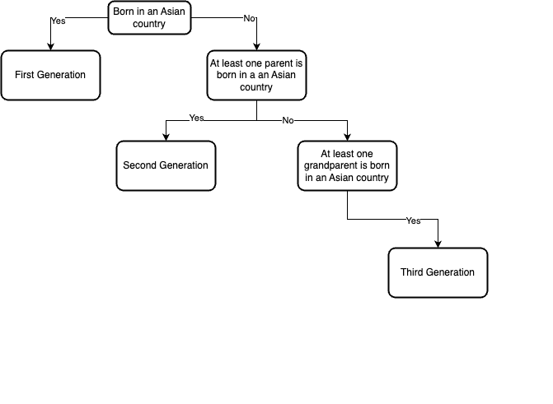

Figure 2: Bias and Self-reported Asian Identity in the Least and Most Biased Places

1. Bias Over Time

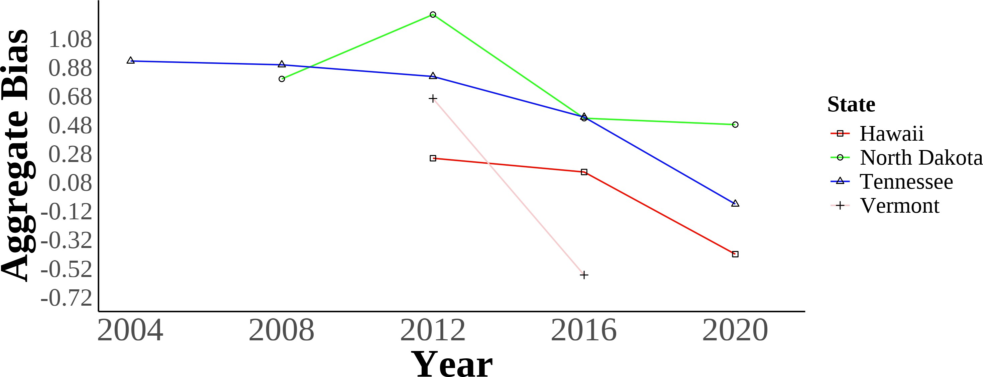

1. Self-reported Asian Identity Over Time

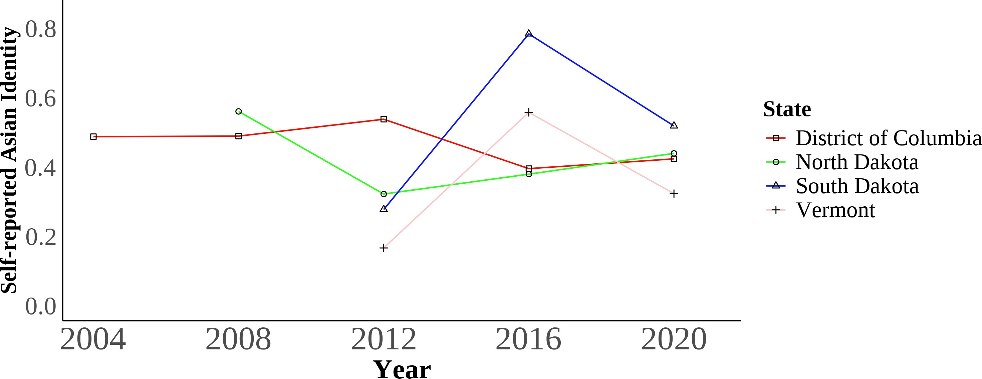

These two panels show the trends in bias (panel a) and self-reported Asian identity among Asian immigrants (panel b) of the least and most biased places in the data. The District of Colombia is the least biased geographical area, and North Dakota is the most biased. The bias units are in stan-dard deviations. Self-reported Asian identity is among first, second, and third-generation Asian immigrants aged 17 and younger still living in intact families.

Bias data is from the 2004–2021 Harvard’s Project Implicit Association Test scores, American Na-tional Election Studies (ANES), and state-level hate crimes against Asians. Identity data is from the 2004–2021 Current Population Survey (CPS).

Figure 3: Maps of State-level Association Test Bias Over Time Measure with Cen-sus Division Regional Boundaries

(a) State-level Bias in 2004 (b) State-level Bias in 2008

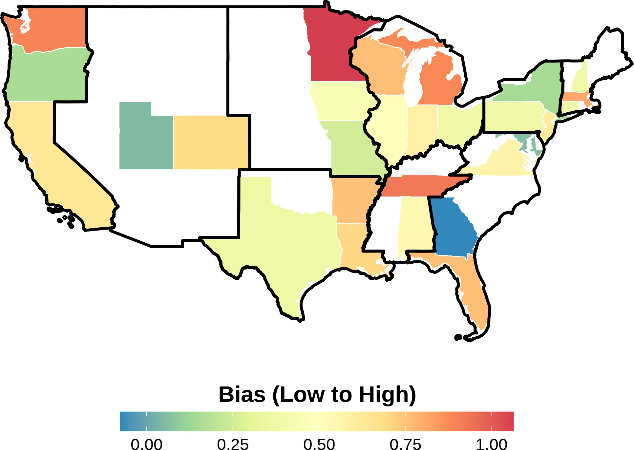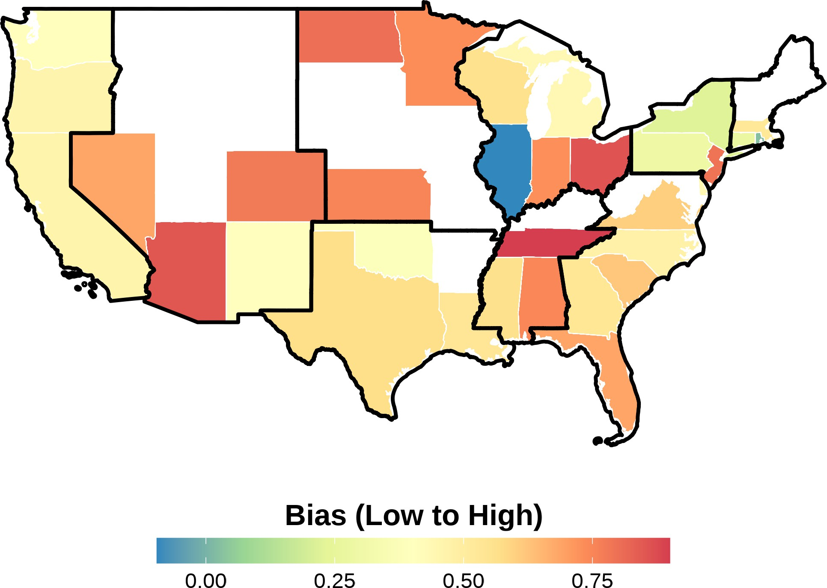

1. State-level Bias in 2012 (d) State-level Bias in 2016

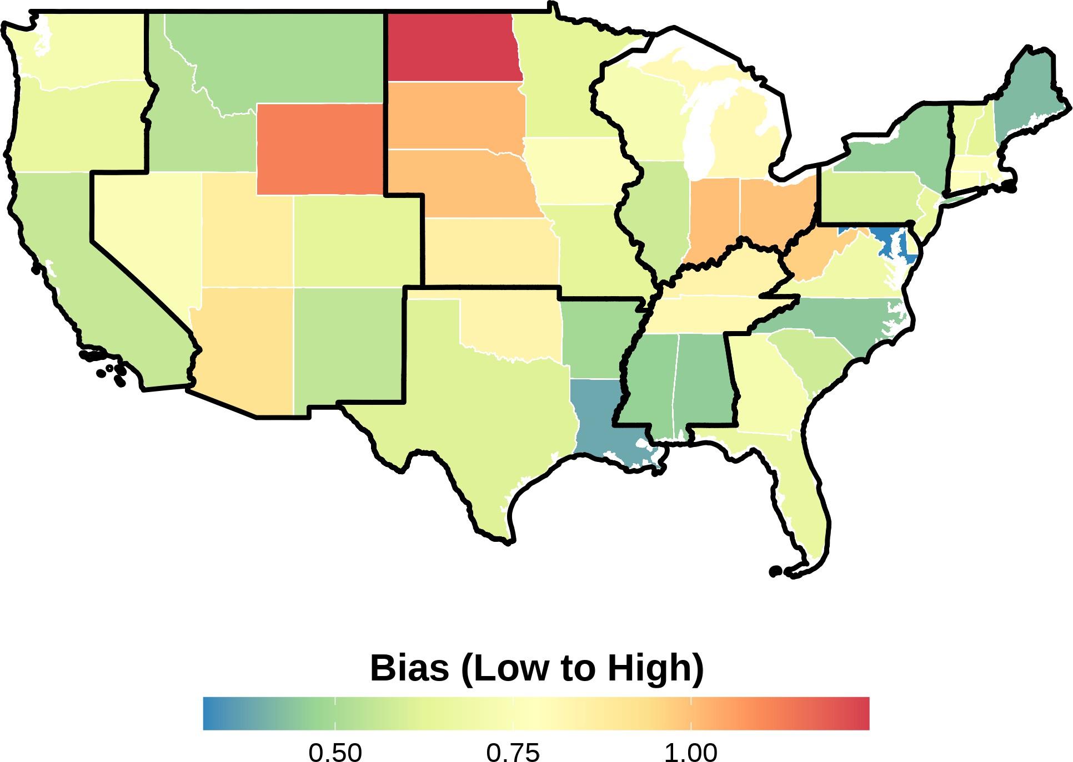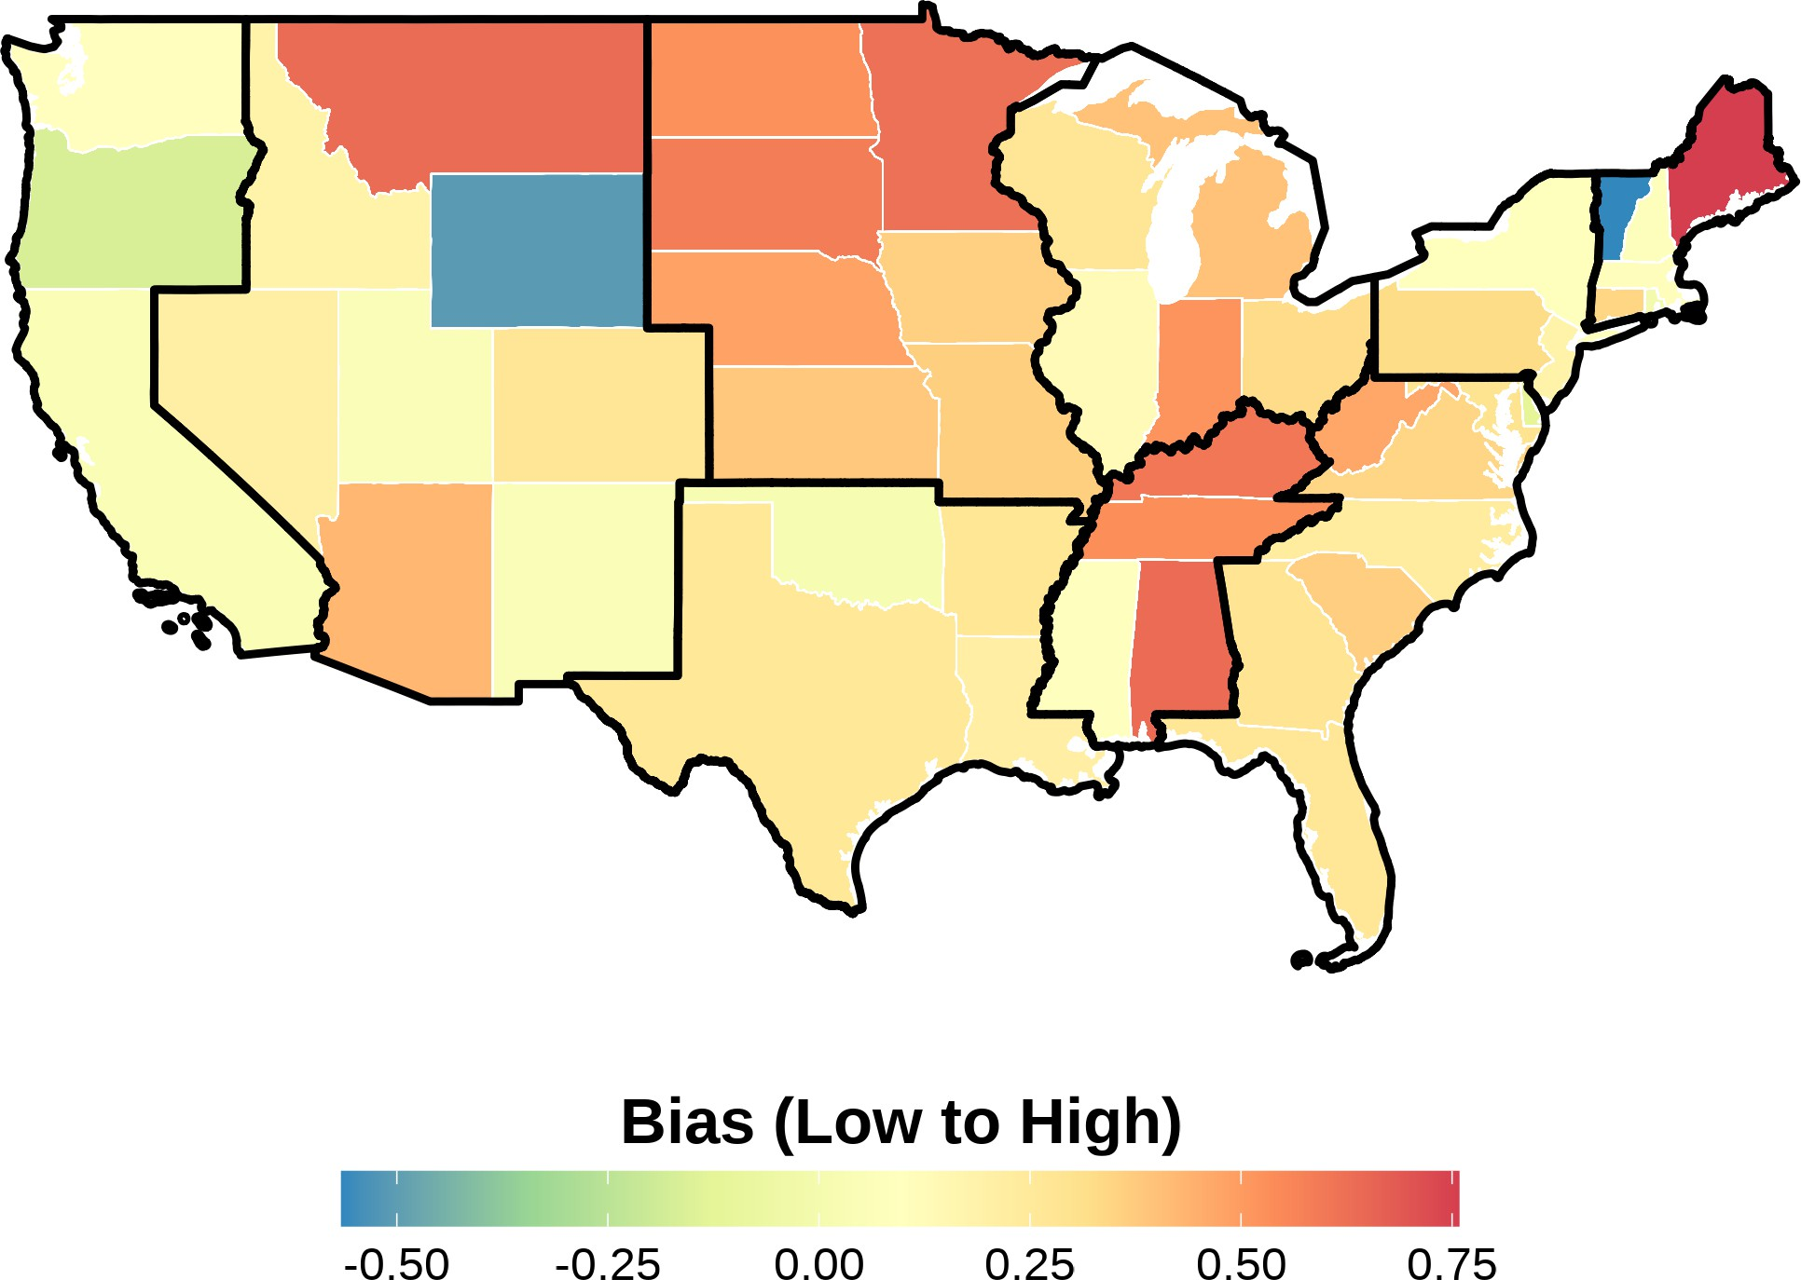

This figure shows the state-level bias index in different years in the sample. The bias units are in standard deviations and ranges from low to high bias. Bias index is constructed following Lubotsky and Wittenberg (2006). The data is from the 2004–2021 Harvard’s Project Implicit Asso-ciation Test scores, American National Election Studies (ANES), and state-level hate crimes against Asians. Each panel presents state-level bias during a certain year. The boundaries in black rep-resent the different Census divisions in the United States. Notice how there is a variation across states within a region.

Figure 4: Maps of State-level Bias 2004–2021 Measure with Census Division Re-gional Boundaries

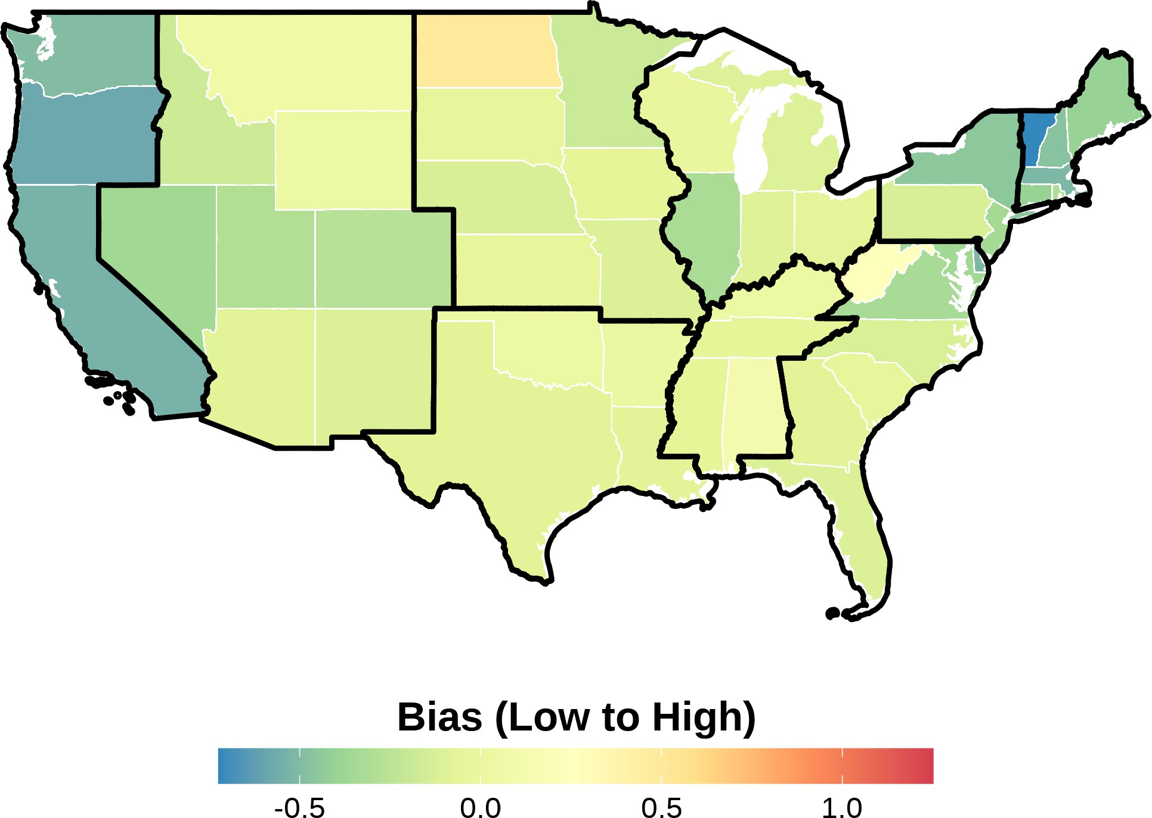

This figure shows the state-level bias index in the sample from 2004 to 2021. The bias units are in standard deviations and ranges from low to high bias. Bias index is constructed following Lubotsky and Wittenberg (2006). The data is from the 2004–2021 Harvard’s Project Implicit Asso-ciation Test scores, American National Election Studies (ANES), and state-level hate crimes against Asians. The boundaries in black represent the different Census divisions in the United States. No-tice how there is a variation across states within a region.

Figure 5: Asian Racial Identity

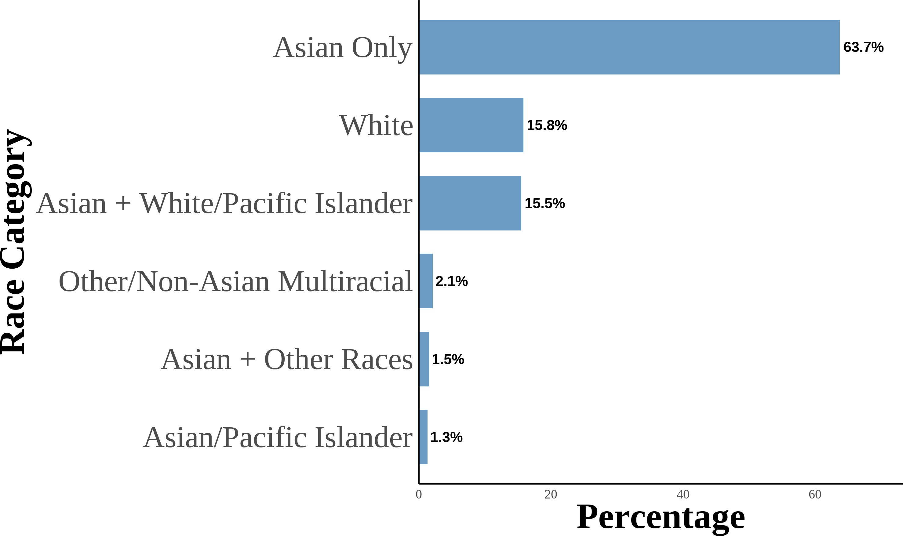

This figure shows the distribution of Asian racial identity among respondents. The data is aggre-gated from the 2004–2021 Current Population Survey (CPS). The sample includes first-, second-, and third-generation objectively Asian Americans. Following Antman, Duncan, and Trejo (2016) and Antman, Duncan, and Trejo (2020), I utilize birthplace information for individuals, parents, and grandparents to create objective Asian ancestry indicators.

Figure 6: Asian Racial Identity: First Generation

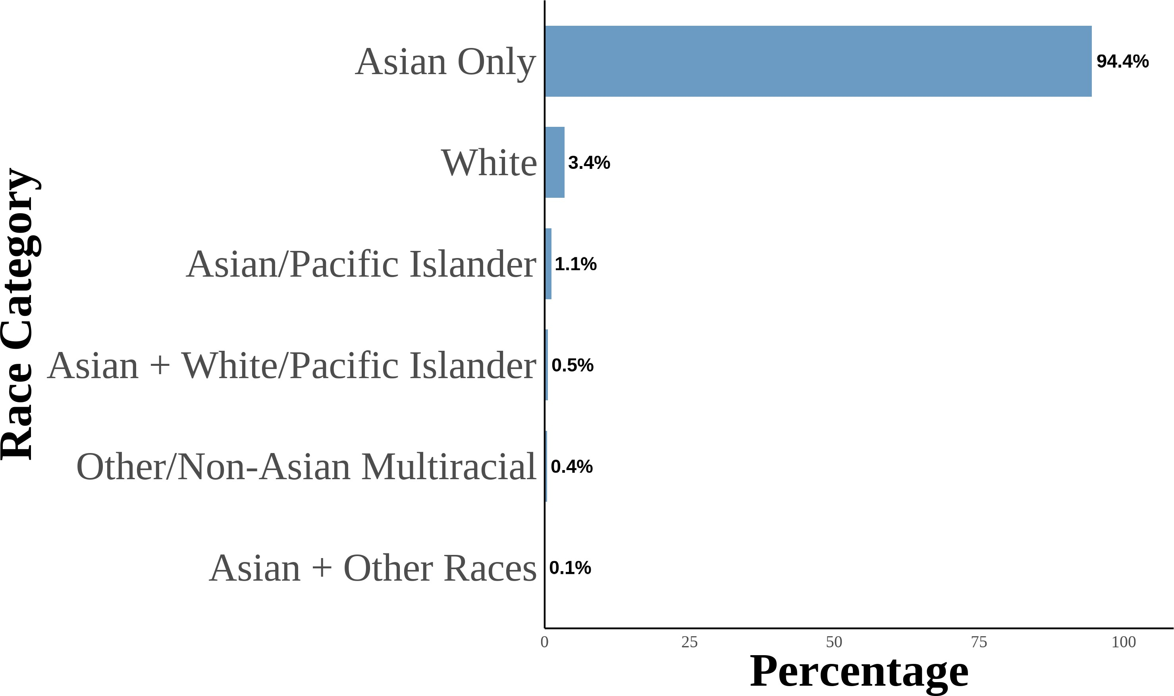

This figure shows the distribution of Asian racial identity among respondents. The data is aggre-gated from the 2004–2021 Current Population Survey (CPS). The sample includes first-generation objectively Asian Americans. Following Antman, Duncan, and Trejo (2016) and Antman, Dun-can, and Trejo (2020), I utilize birthplace information for individuals, parents, and grandparents to create objective Asian ancestry indicators. A first-generation Asian American is defined as an individual born in an Asian country and is not a US citizen born to US citizen parents abroad.

Figure 7: Asian Racial Identity: Second Generation

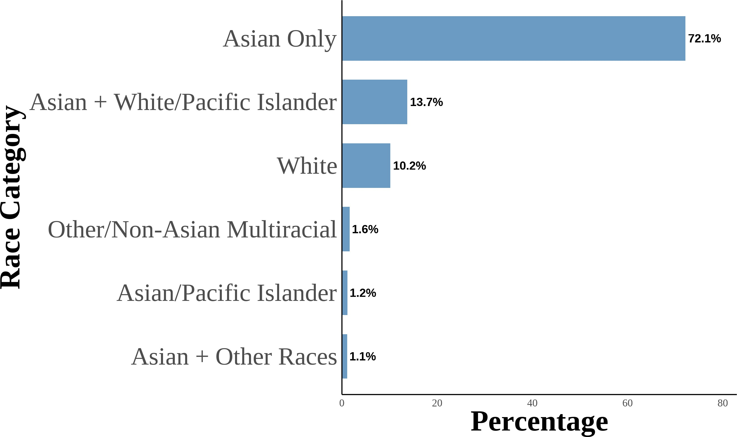(a) All Second Generation (b) Second Generation: Asian Fathers-Asian Mothers

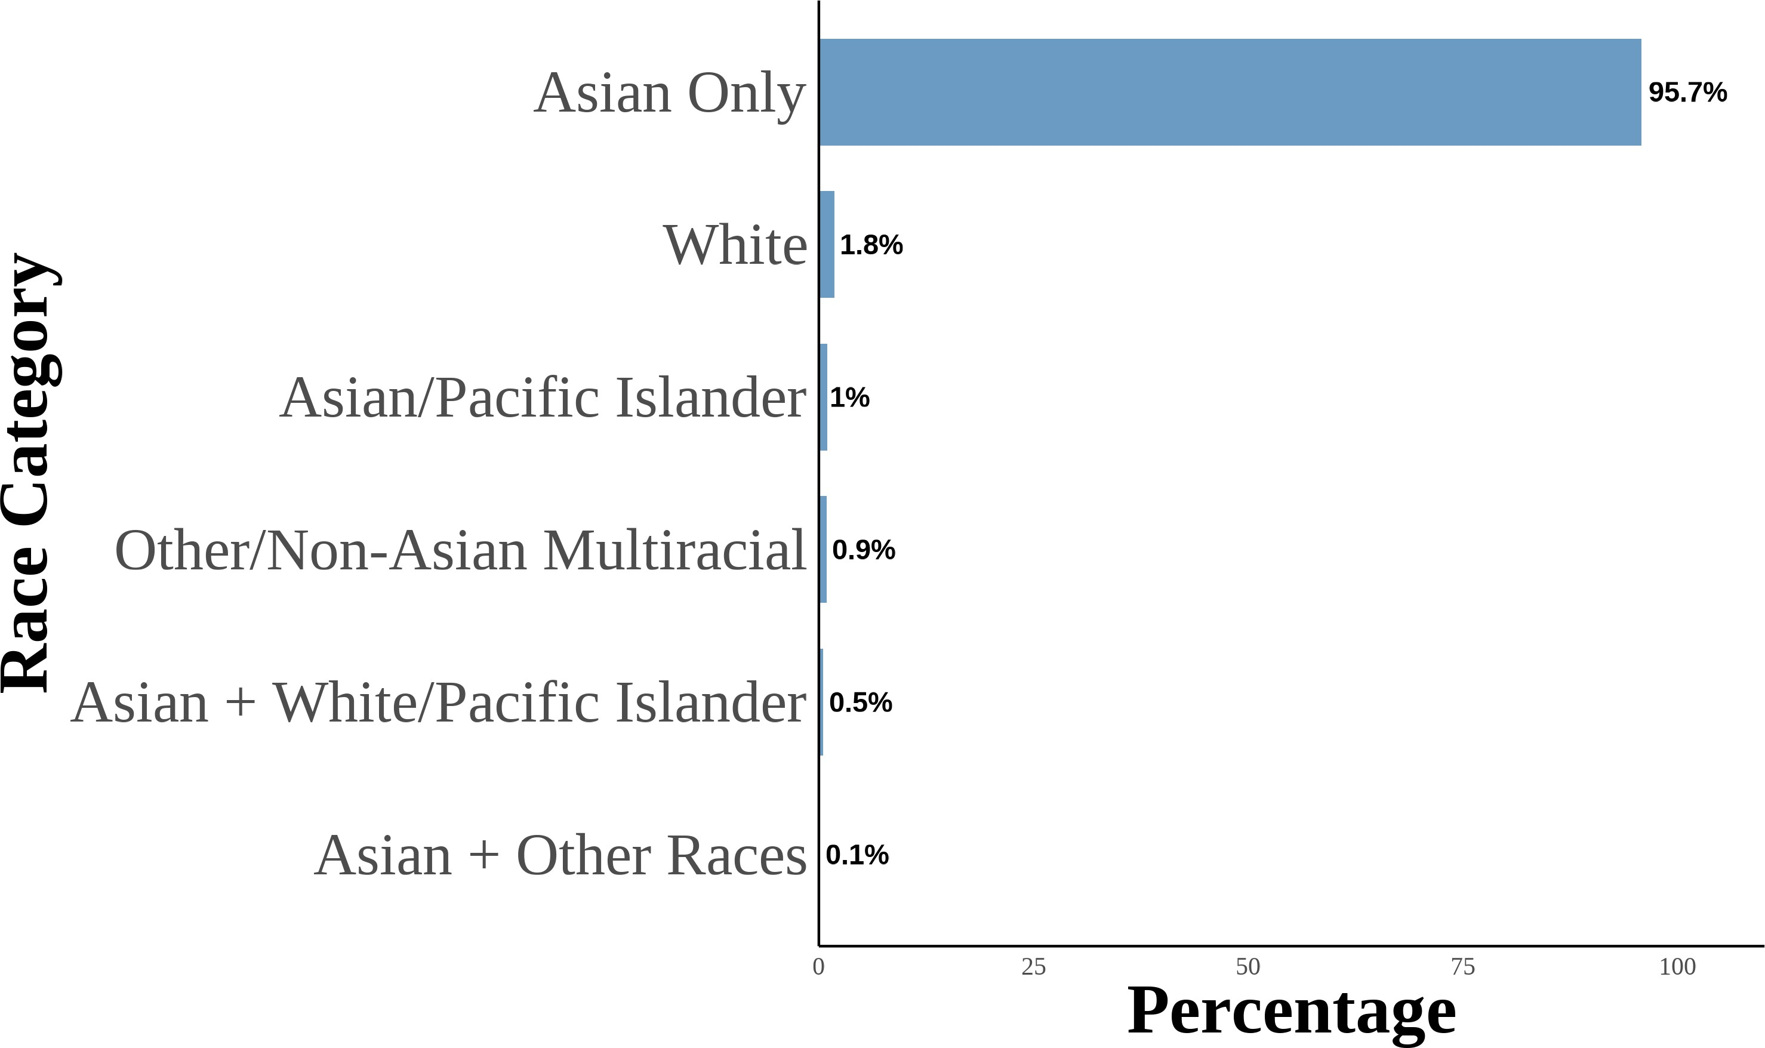

1. Second Generation: Asian Fathers-White Mothers

55

1. Second Generation: White Fathers-Asian Mothers

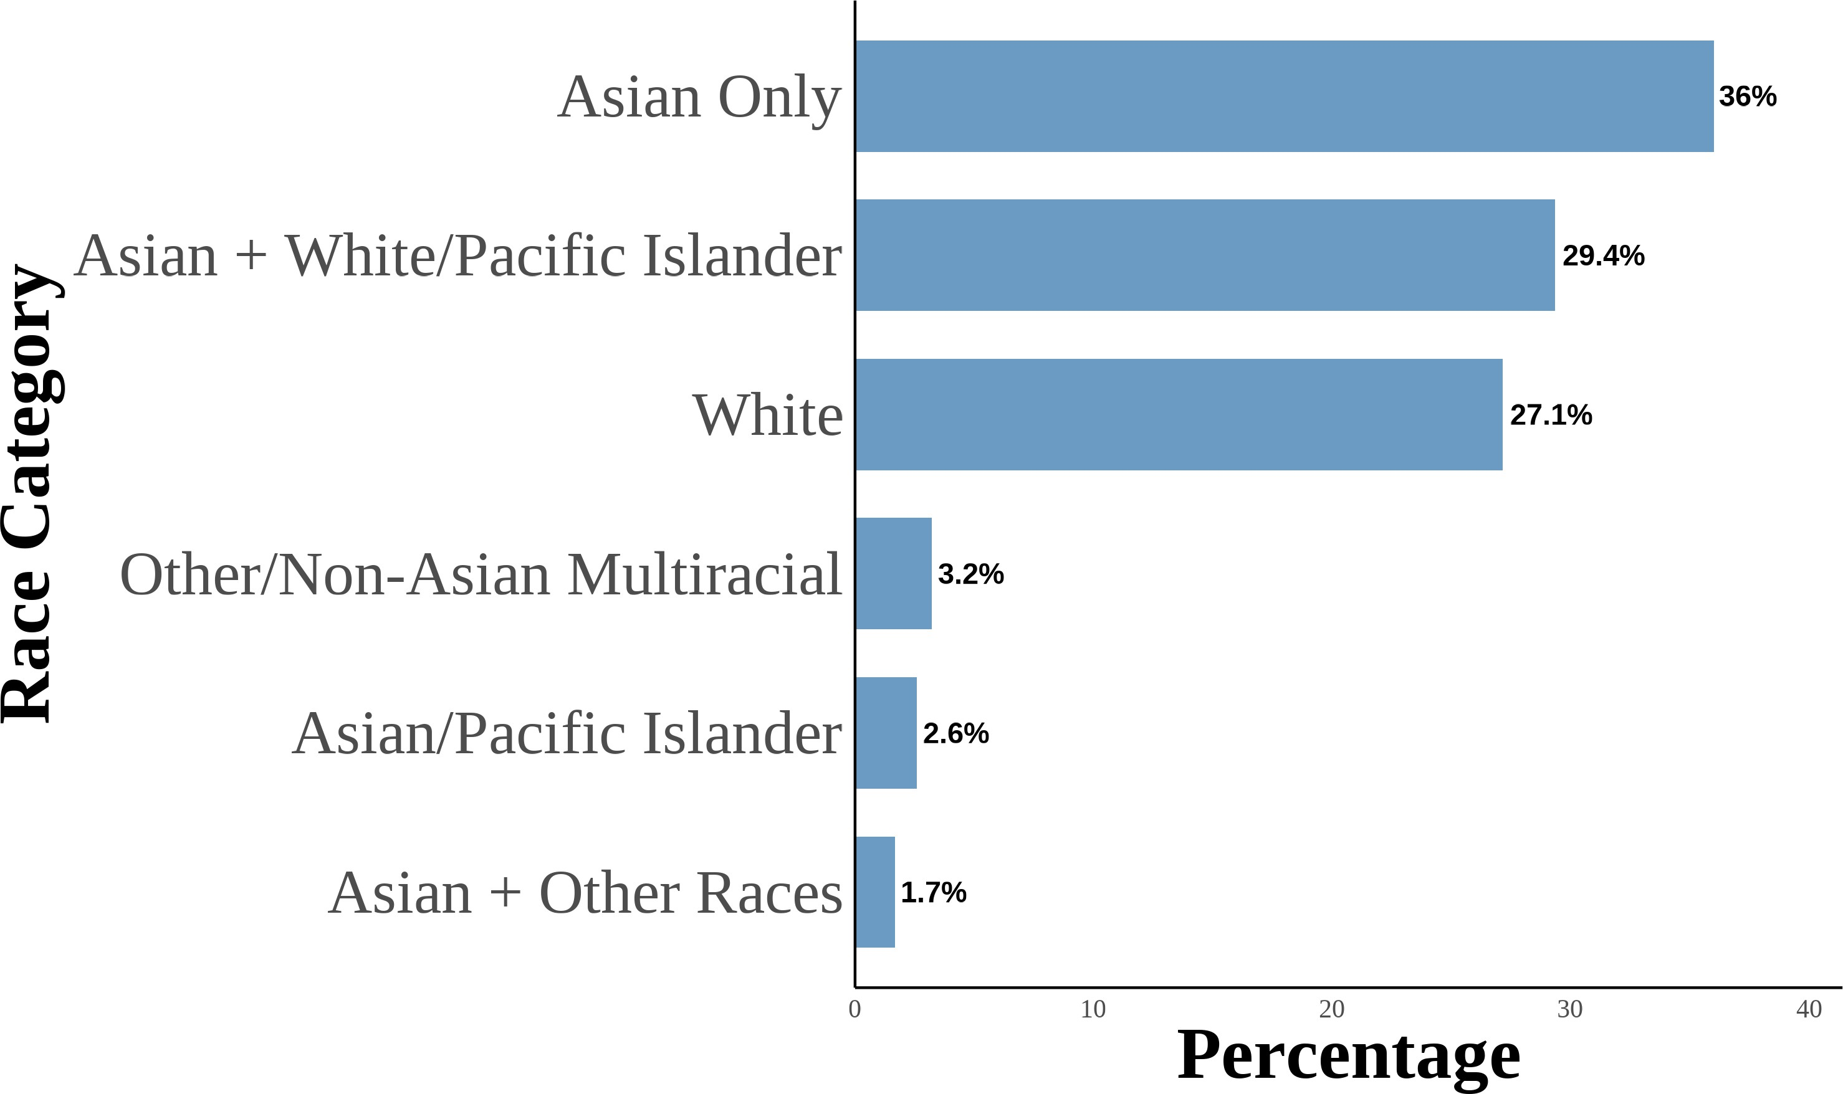 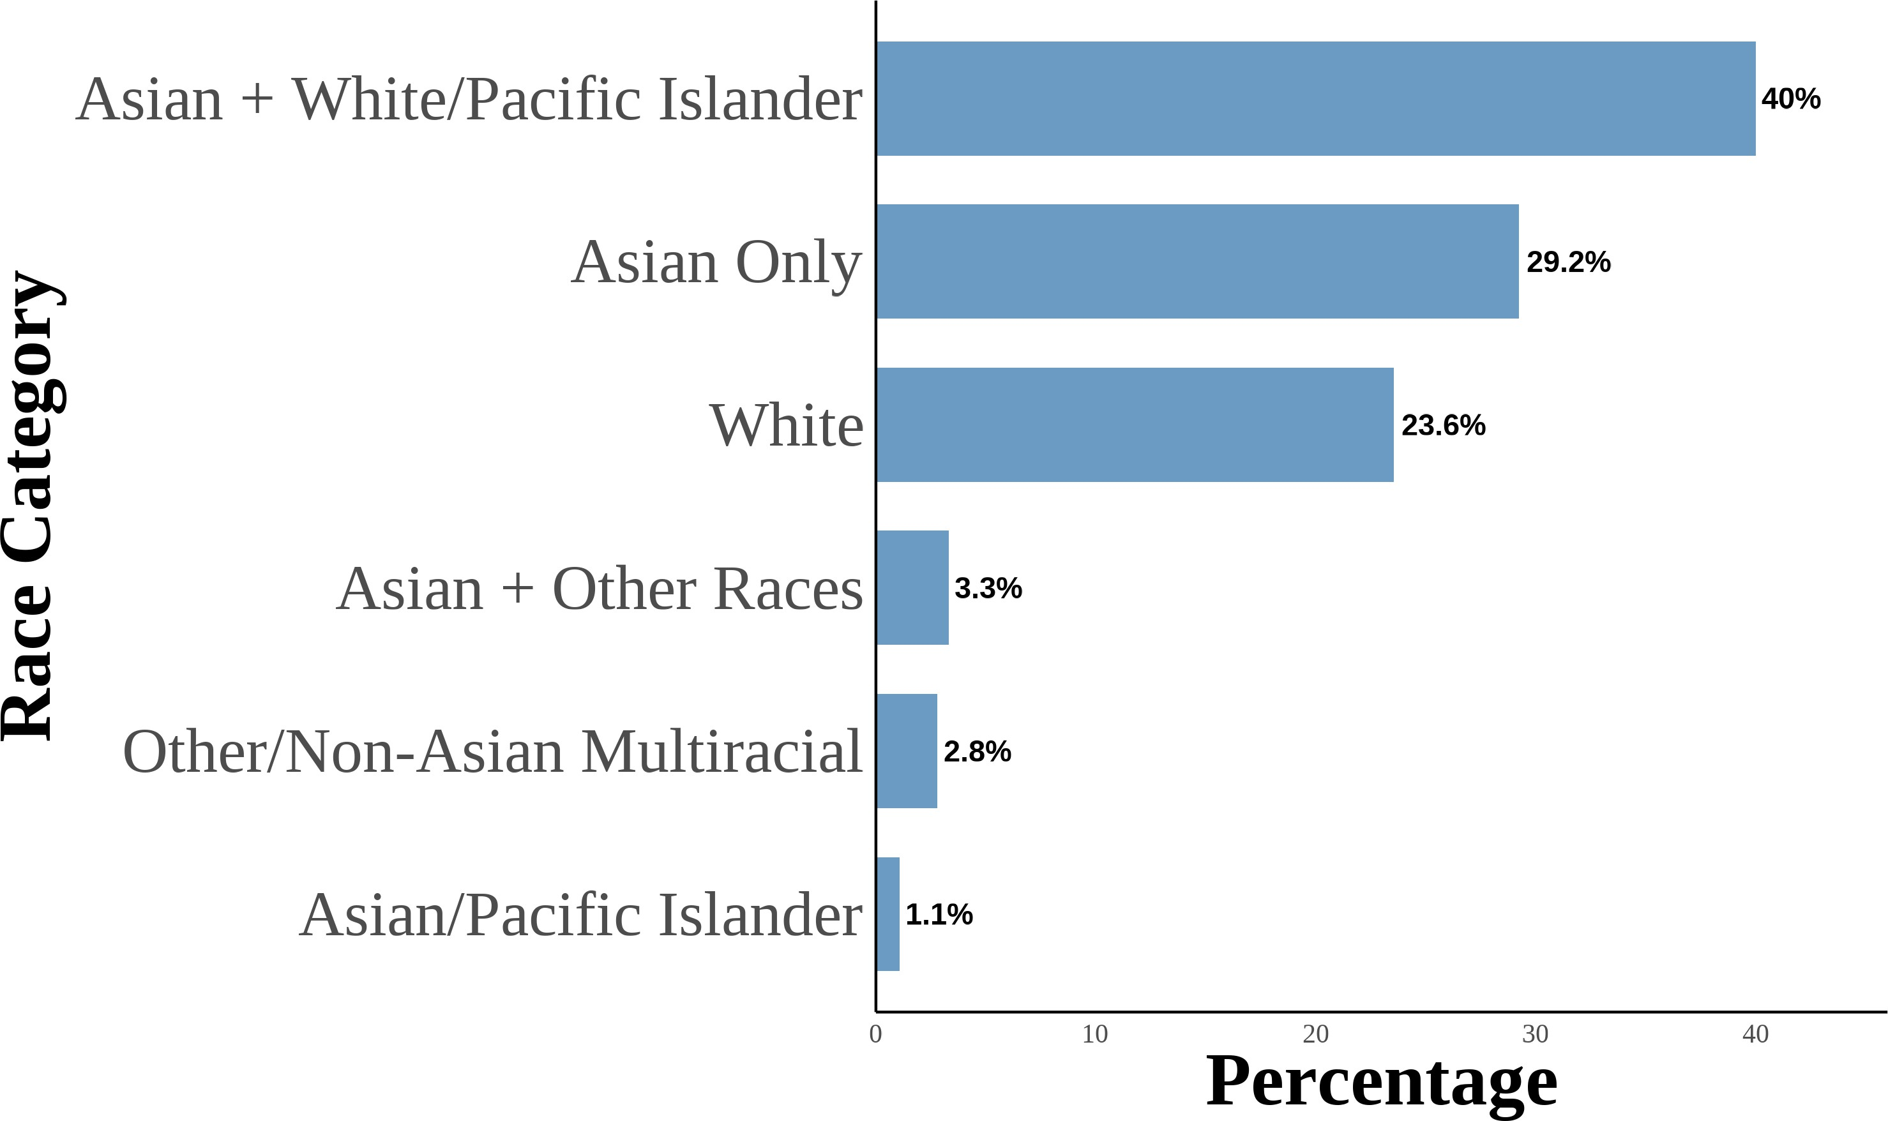

This figure shows the distribution of Asian racial identity among respondents. The data is aggregated from the 2004–2021 Current Population Survey (CPS). The sample includes second-generation objectively Asian Americans. Following Antman, Duncan, and Trejo (2016) and Antman, Duncan, and Trejo (2020), I utilize birthplace information for individuals, parents, and grandparents to create objective Asian ancestry indicators. A second-generation Asian American is defined as a native-born individual with at least one parent born in an Asian country. The first panel is for second-generation Asian Americans. The second panel is for second-generation Asian Americans with both parents born in an Asian country. The third panel is for second-generation Asian Americans with an Asian father and a White mother. The fourth panel is for second-generation Asian Americans with a White father and an Asian mother.

Figure 8: Asian Racial Identity: Third Generation

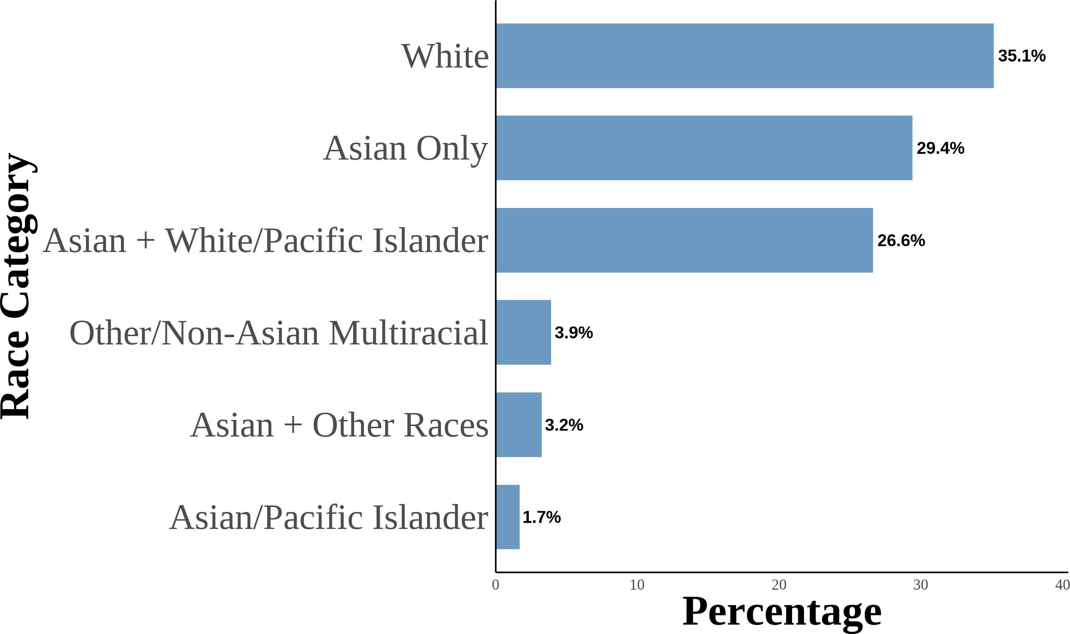(a) All Third Generation (b) Third Generation: One Asian Grandparent

1. Third Generation: Two Asian Grandparents

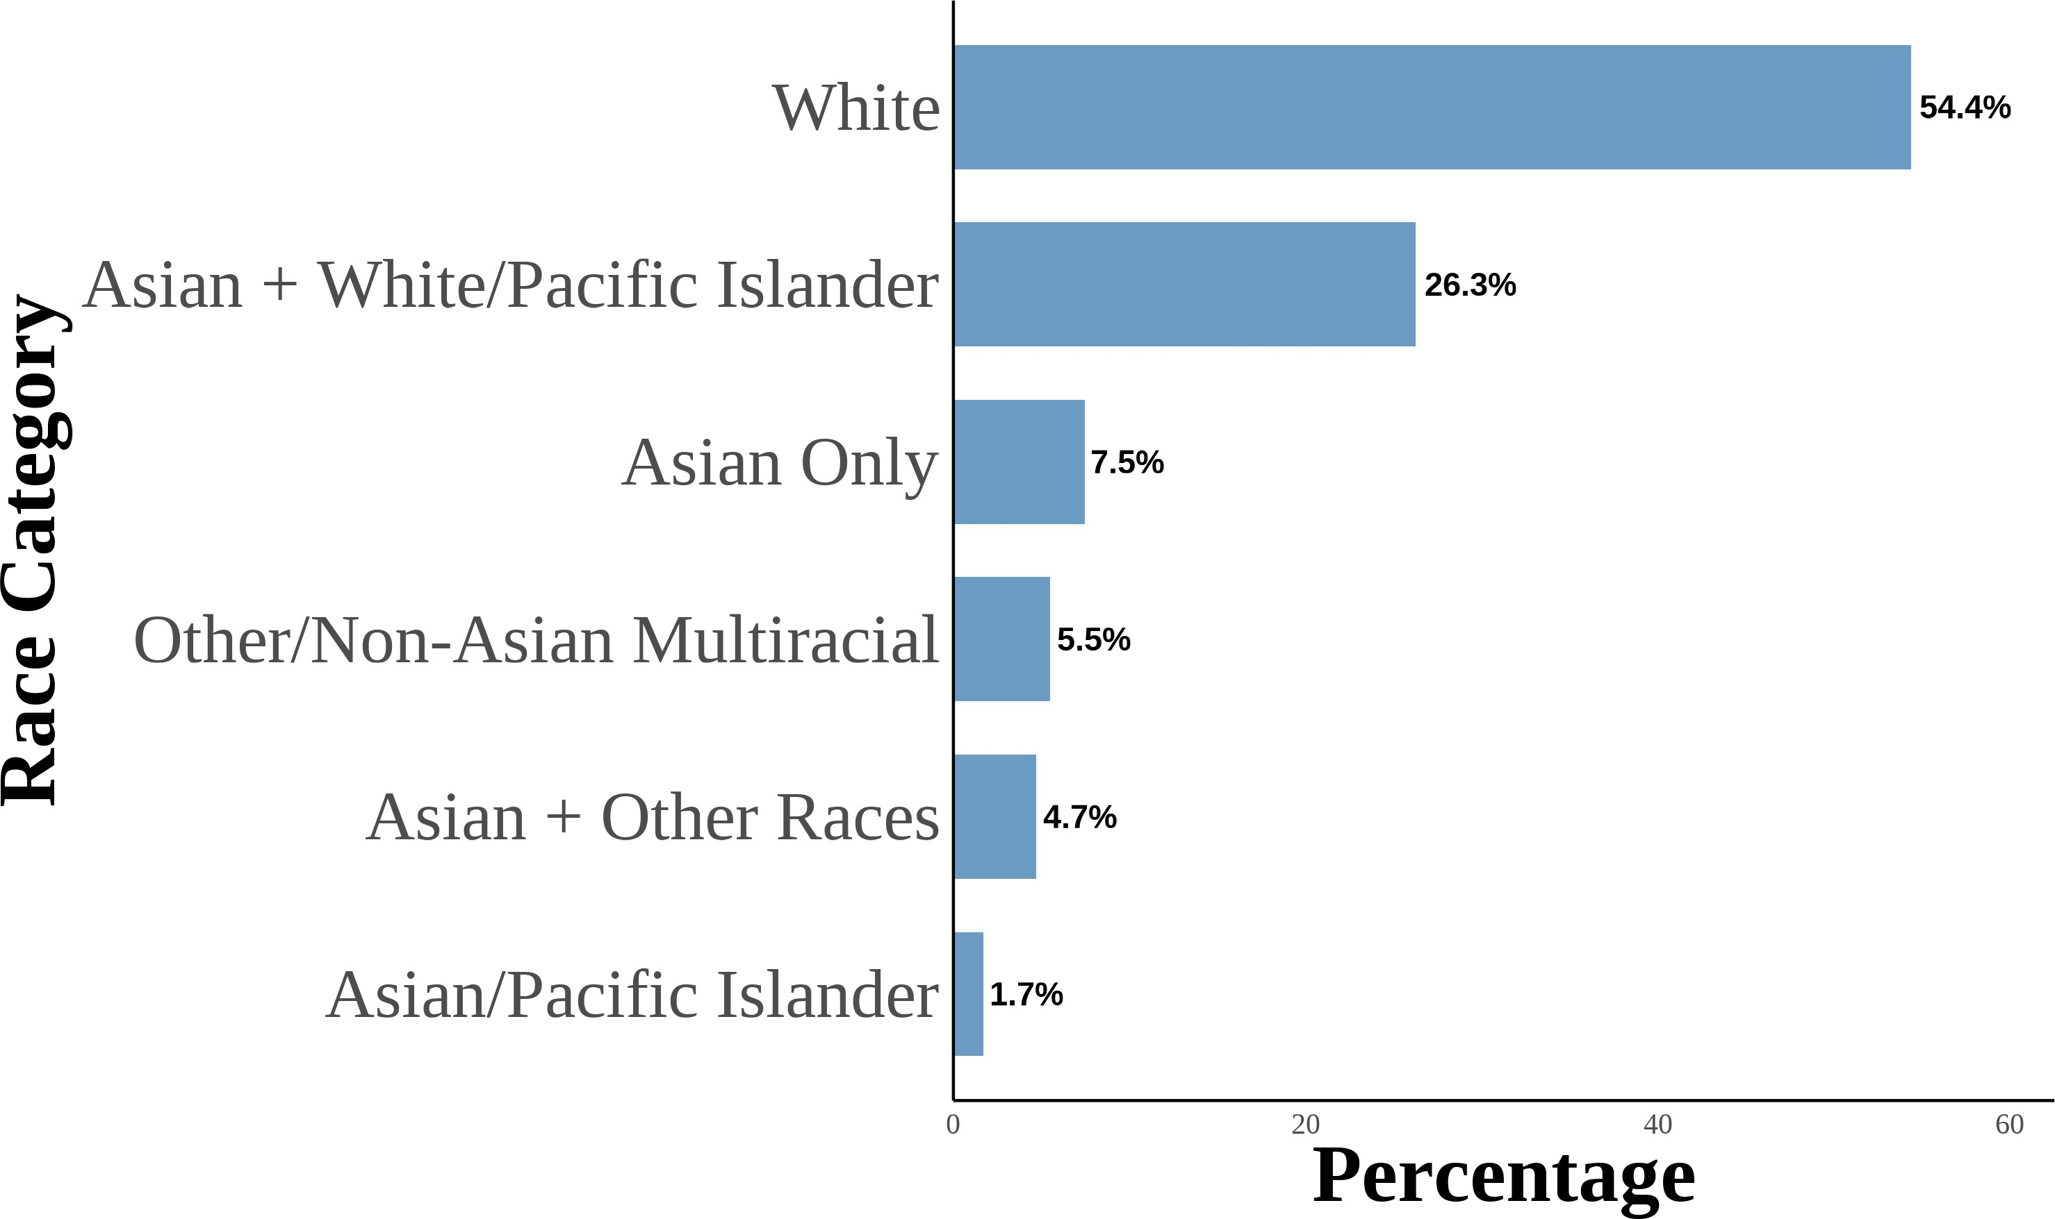 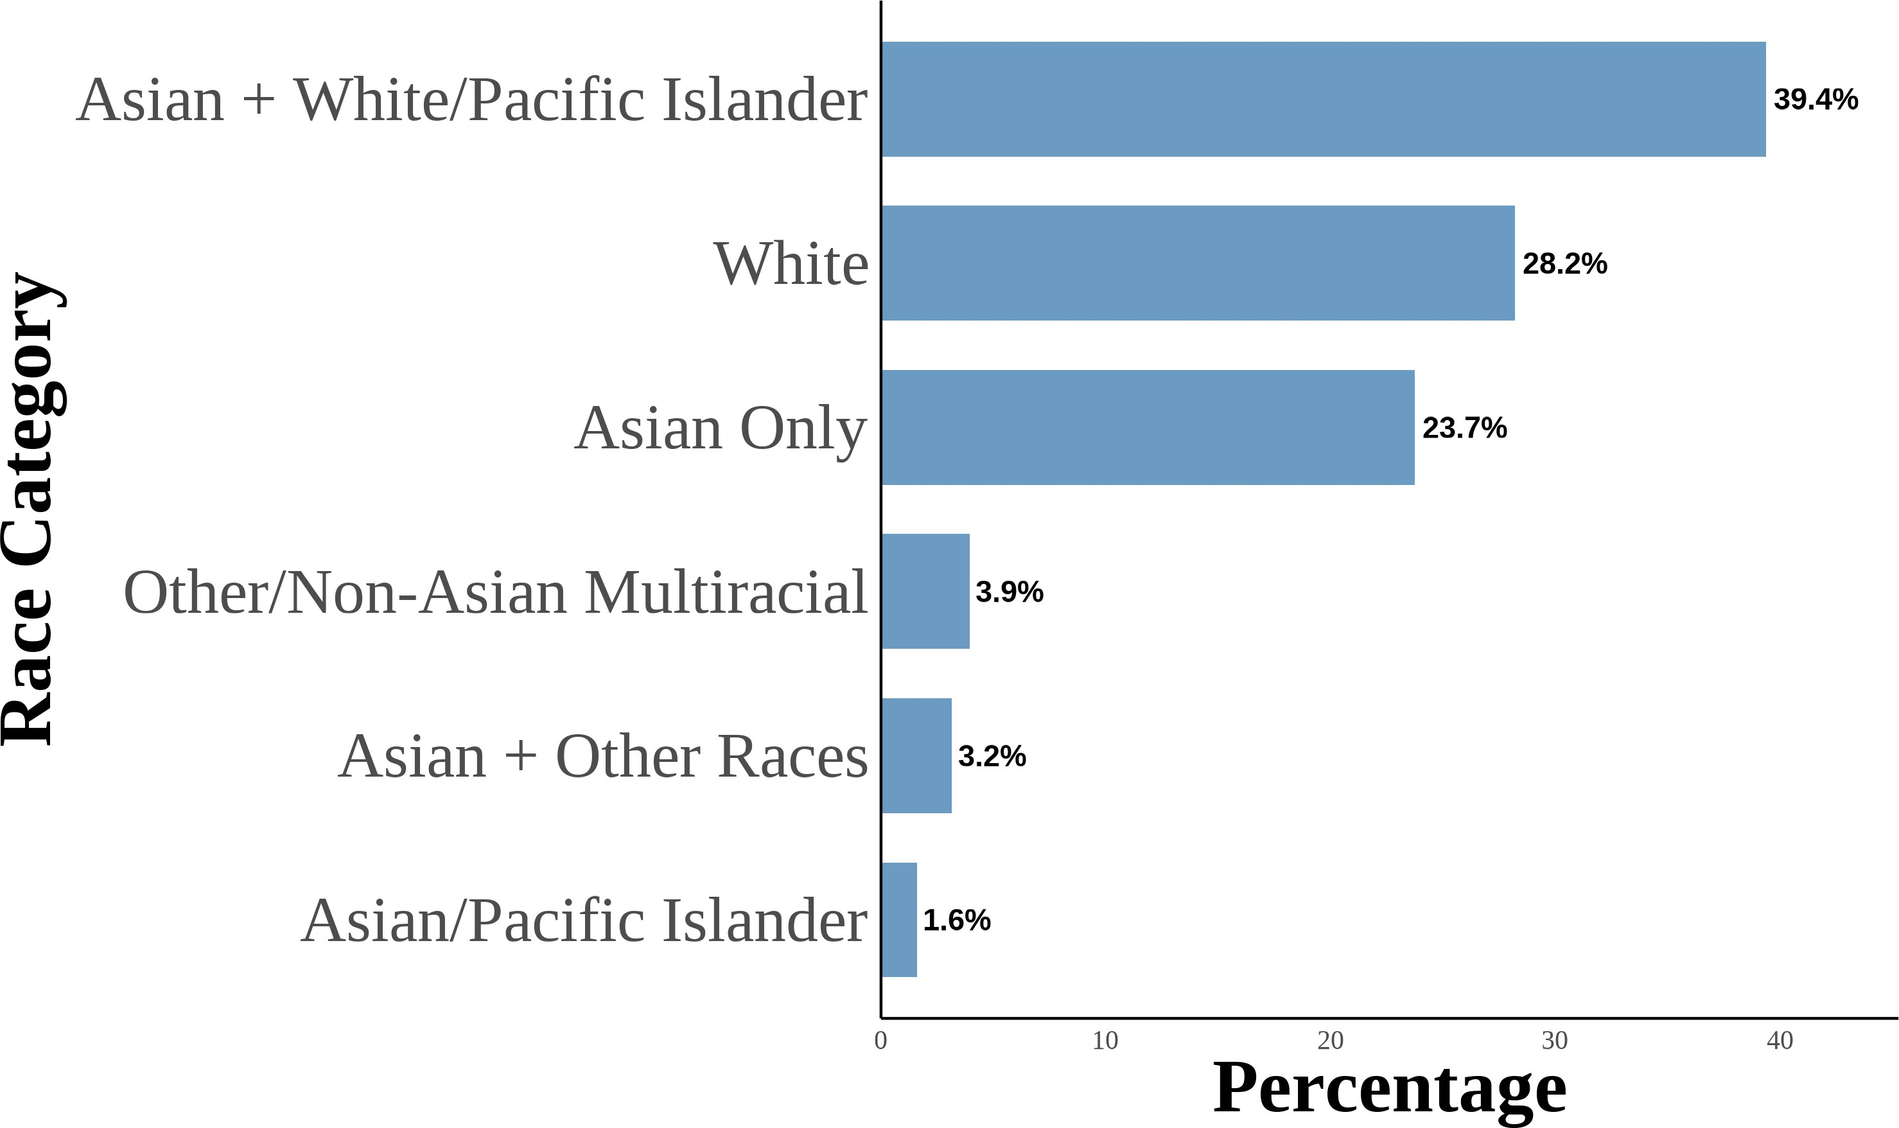

1. Third Generation: Three Asian Grandparents

56

1. Third Generation: Four Asian Grandparents

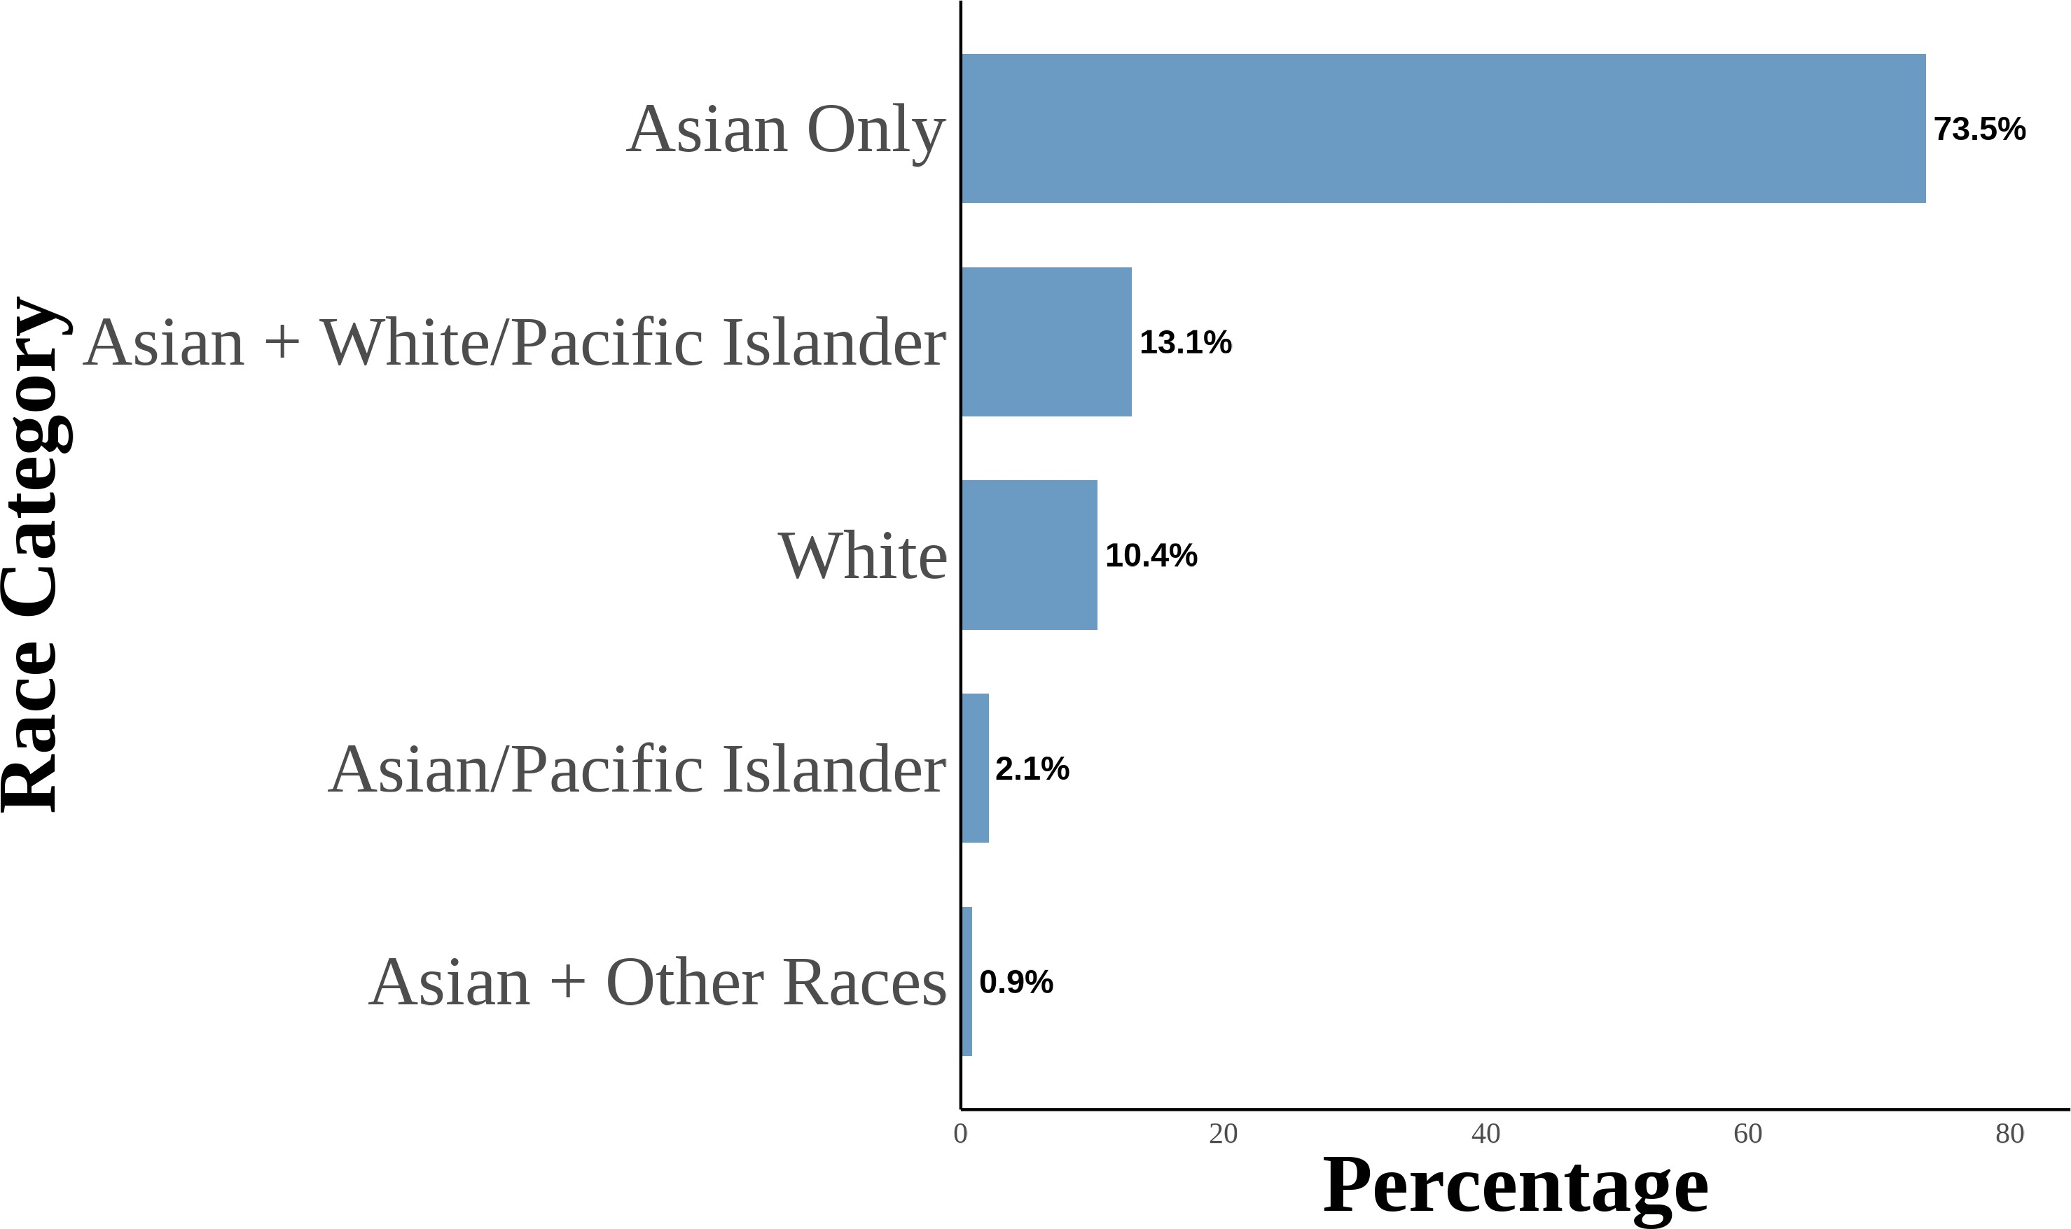 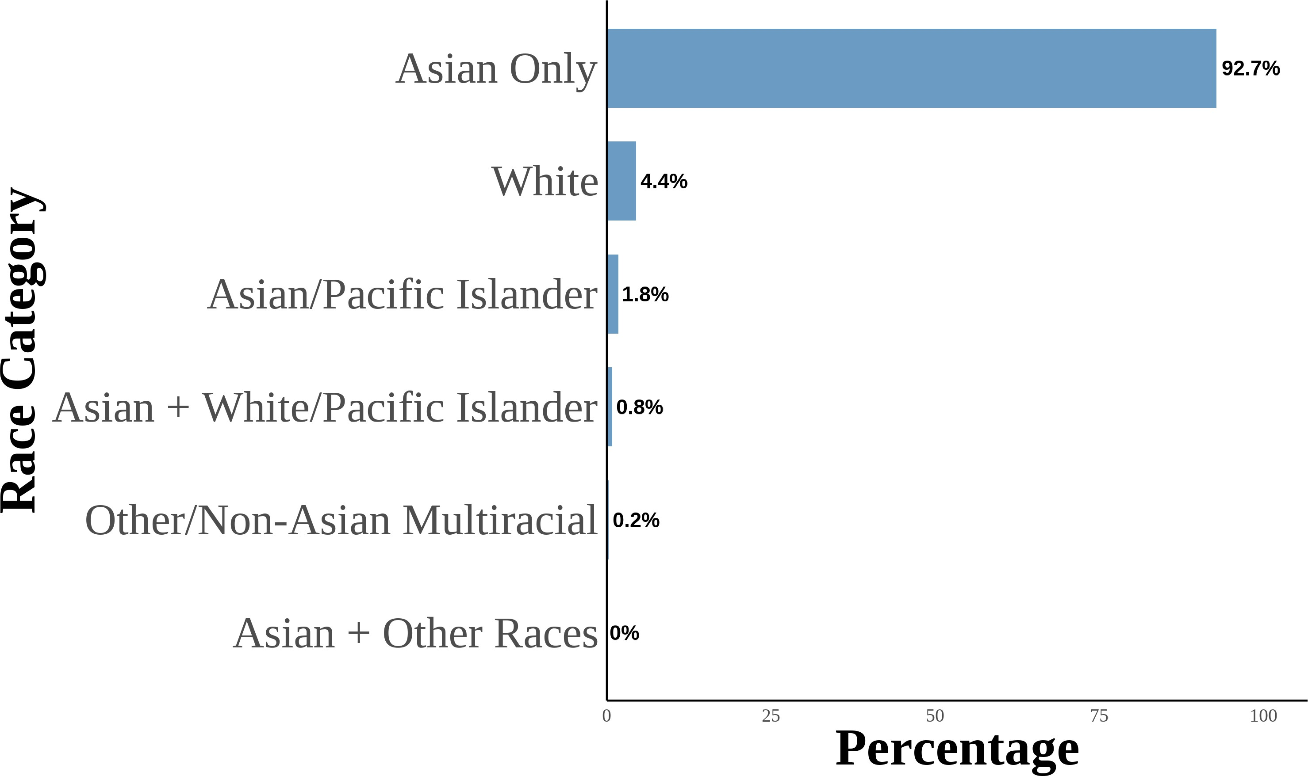

This figure shows the distribution of Asian racial identity among respondents. The data is aggregated from the 2004–2021 Current Population Survey (CPS). The sample includes second-generation objectively Asian Americans. Following Antman, Duncan, and Trejo (2016) and Antman, Duncan, and Trejo (2020), I utilize birthplace information for individuals, parents, and grandparents to create objective Asian ancestry indicators. A third-generation Asian American is defined as a native-born individual with native-born parents and at least one grandparent born in an Asian country. The first panel is for third-generation Asian Americans. The second panel is for third-generation Asian Americans with one grandparent born in an Asian country. The third panel is for third-generation Asian Americans with two grandparents born in an Asian country. The fourth panel is for third-generation Asian Americans with three grandparents born in an Asian country. The fifth panel is for third-generation Asian Americans with four grandparents born in an Asian country.

Figure 9: Relationship Between Self-Reported Asian Identity and Bias: By Gener-ation

(a) All Generations (b) First-Generation

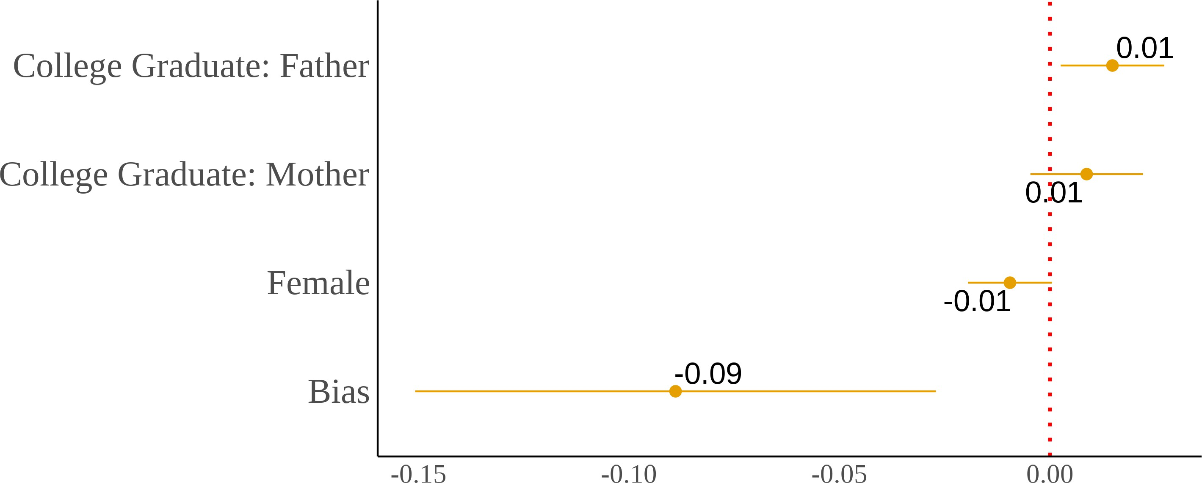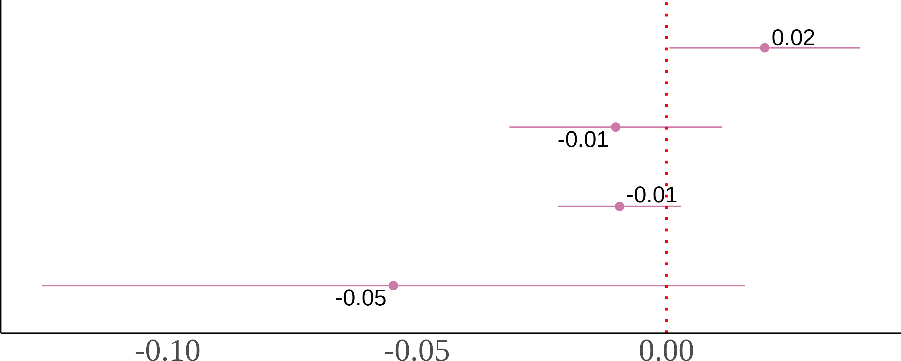

(c) Second-Generation (d) Third-Generation

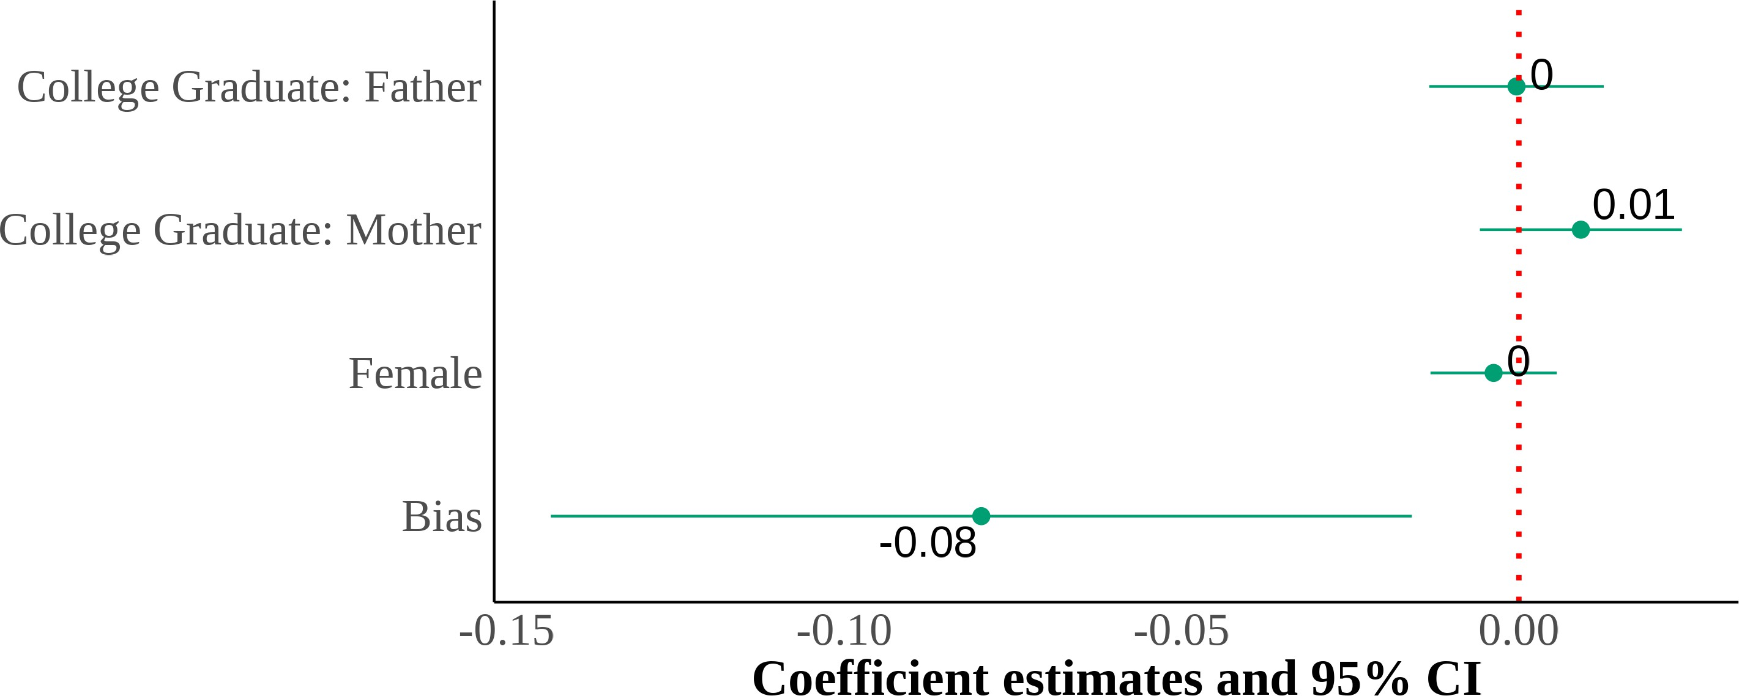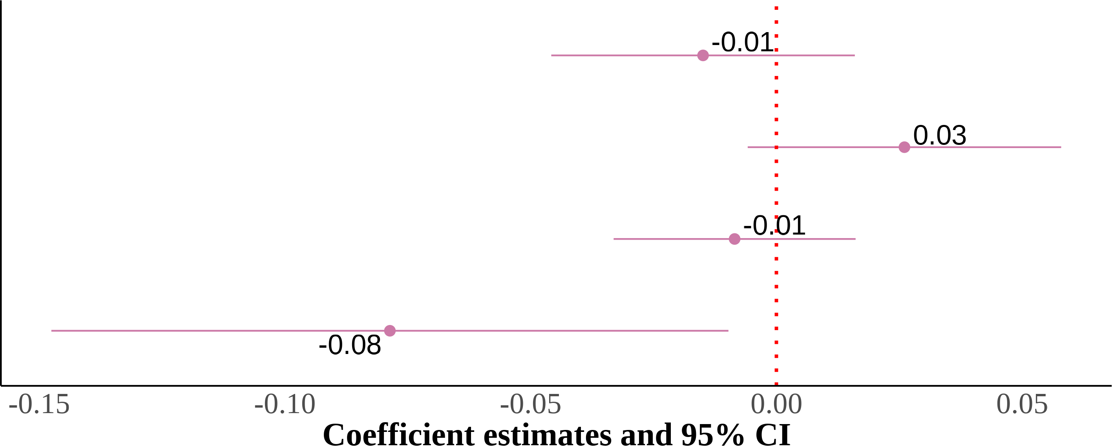

I show four panels of estimating equation (4). I include region *×* year fixed effects with controls for sex, quartic age, and parental education. The dependent variable is self-reported Asian identity and the independent variable is state-level bias. Each panel is the results from the same regression but on different samples that are divided by generation. Standard errors are clustered on the state level. The samples include first-, second-, and third-generation Asian children ages 17 and below who live in intact families. First-generation Asian immigrants are children that were born in a Asian country. Native-born second-generation Asian immigrants are children with at least one parent born in a Asian country. Finally, native-born third-generation Asian immigrants are children with native-born parents and at least one grandparent born in a Asian country.

Figure 10: Relationship Between Self-Reported Asian Identity and Bias: By Gen-eration Among Adults

(a) All Generations (b) First-Generation

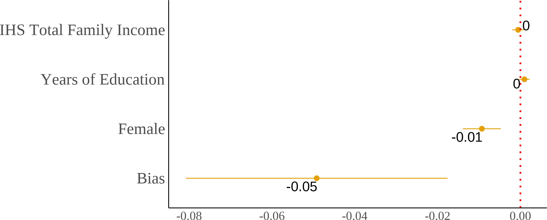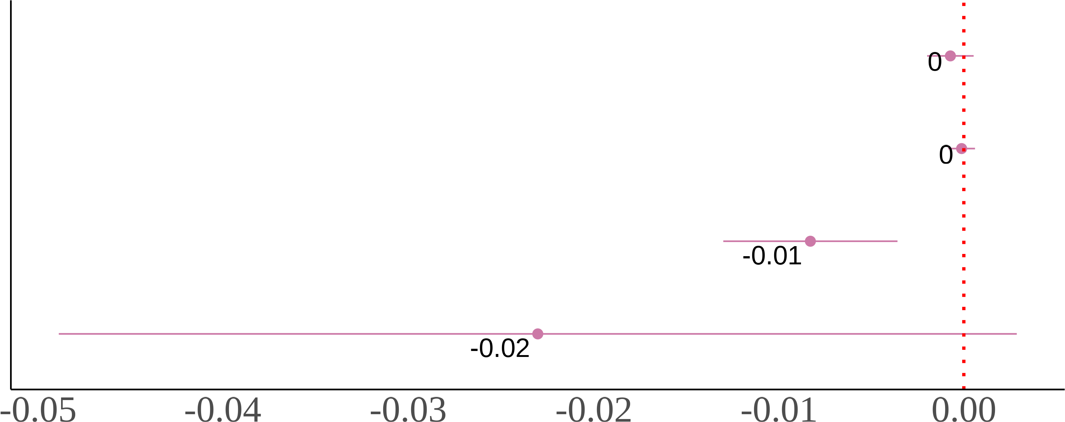

(c) Second-Generation

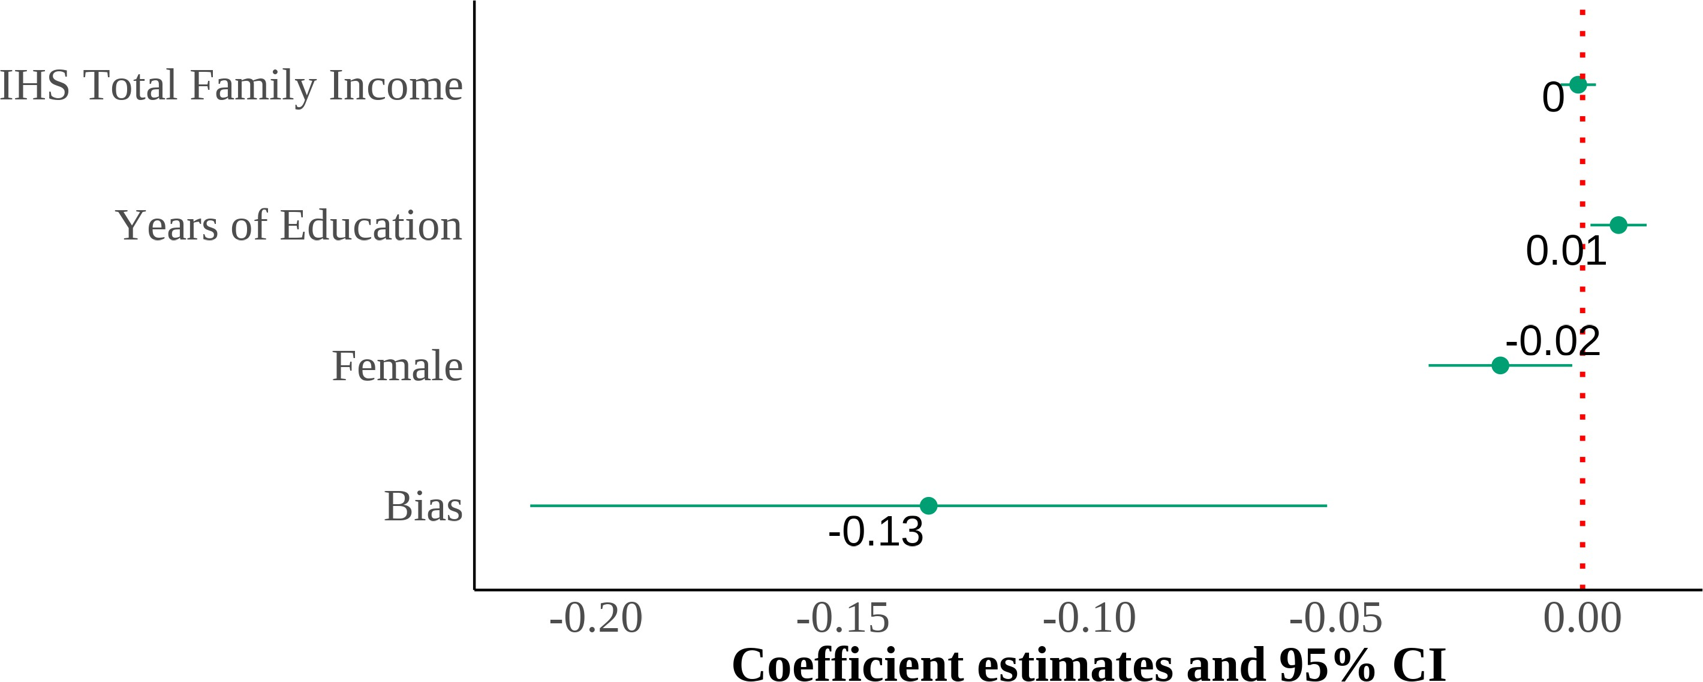

I show three panels of estimating equation (4) on a sample of adults. I include region *×* year fixed effects with controls for sex, quartic age, years of education, and inverse hyperbolic sine of income. The dependent variable is self-reported Asian identity and the independent variable is state-level bias. Each panel is the results from the same regression but on different samples that are divided by generation. Standard errors are clustered on the state level. The samples include first-and second-generation Asian adults ages 18 and above. First-generation Asian immigrants are individuals that were born in a Asian country. Native-born second-generation Asian immigrants are individuals with at least one parent born in a Asian country.

Figure 11: Relationship Between Self-Reported Asian Identity and Bias: By Parental Types

(a) Second-Generation (All Parental Types) (b) Asian Fathers-Asian Mothers

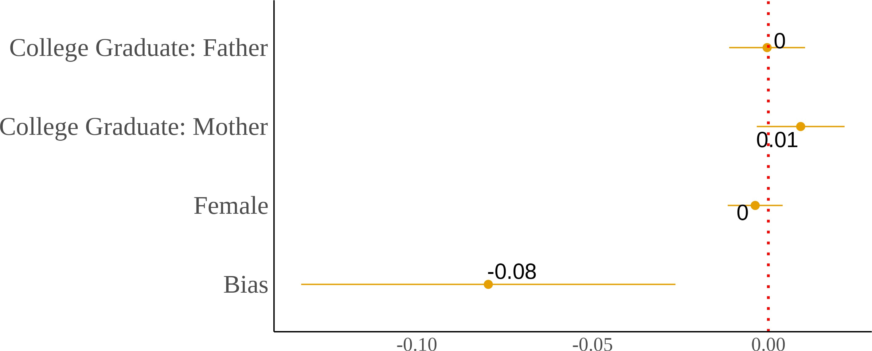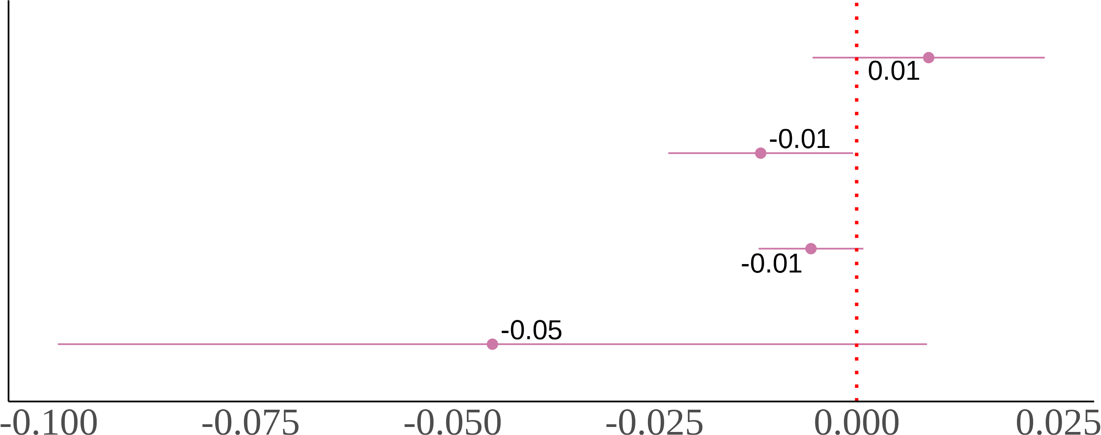

(c) Asian Fathers-White Mothers (d) White Fathers-Asian Mothers

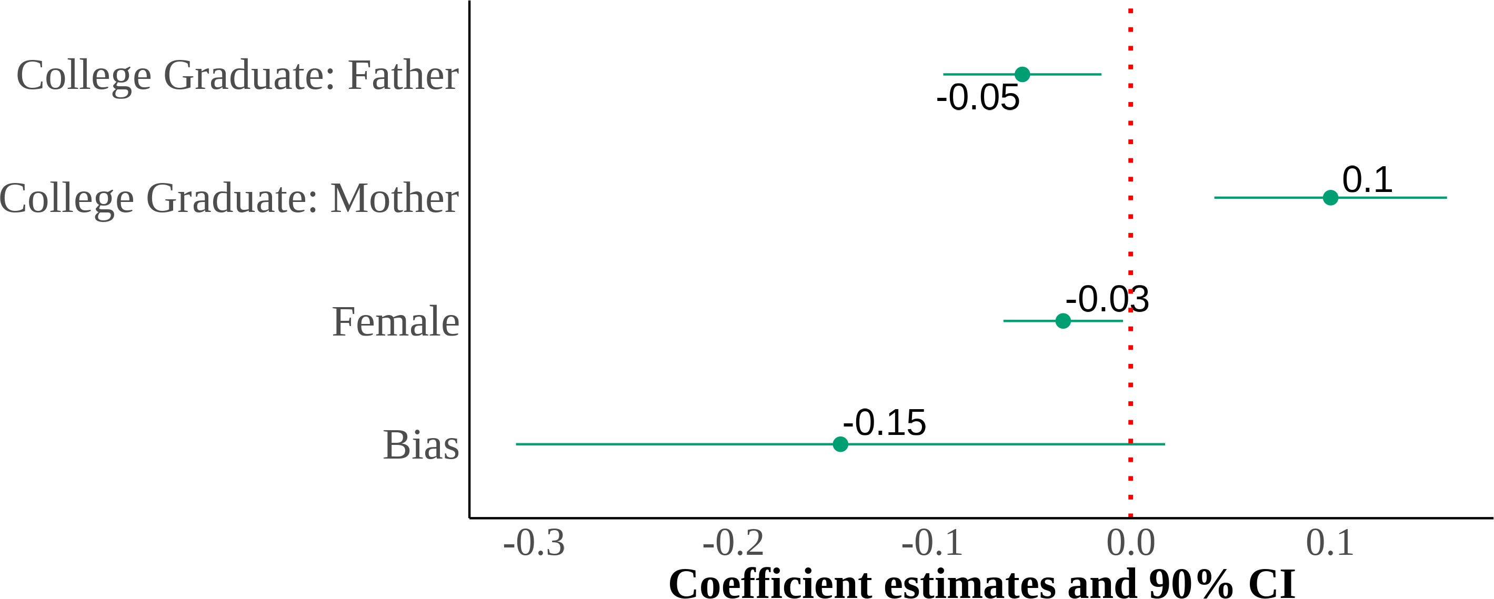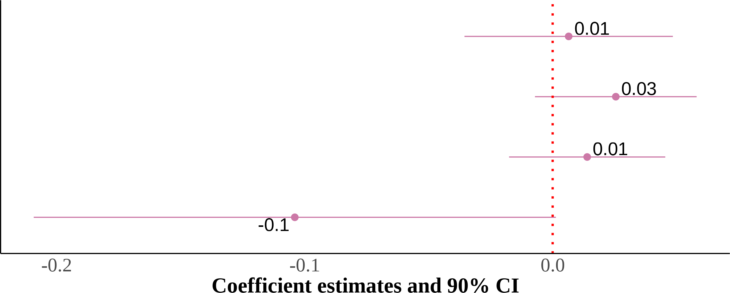

I show four panels of estimating equation (4). I include region *×* year fixed effects with controls for sex, quartic age, and parental education. The dependent variable is self-reported Asian identity and the independent variable is state-level bias. Each panel results from the same regression but on different samples divided by parental types. Standard errors are clustered on the state level. The samples include second-generation Asian children ages 17 and below who live in intact families. Native-born second-generation Asian immigrant children with at least one parent born in an Asian country.

Figure 12: Relationship Between Self-Reported Asian Identity and Bias: By Parental Types Among Adults

(a) Second-Generation (All Parental Types) (b) Asian Fathers-Asian Mothers

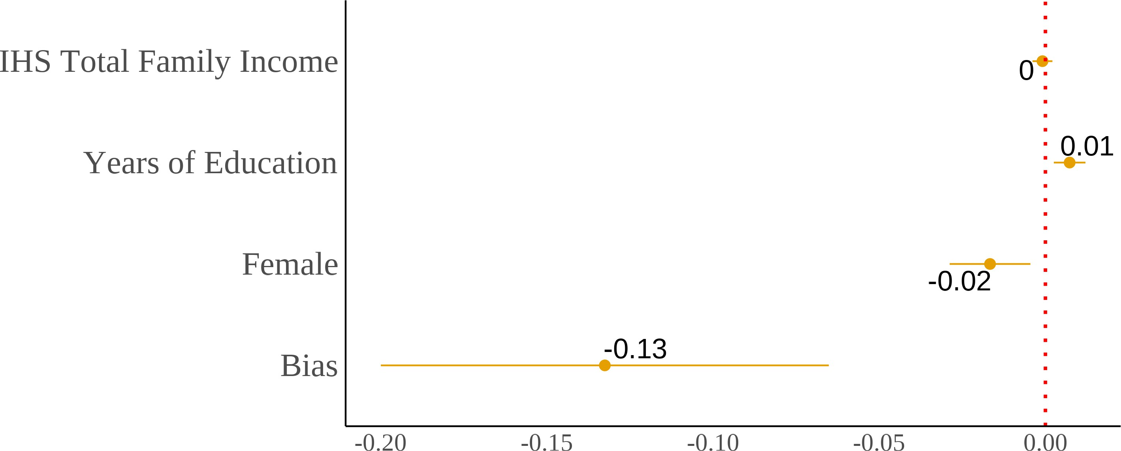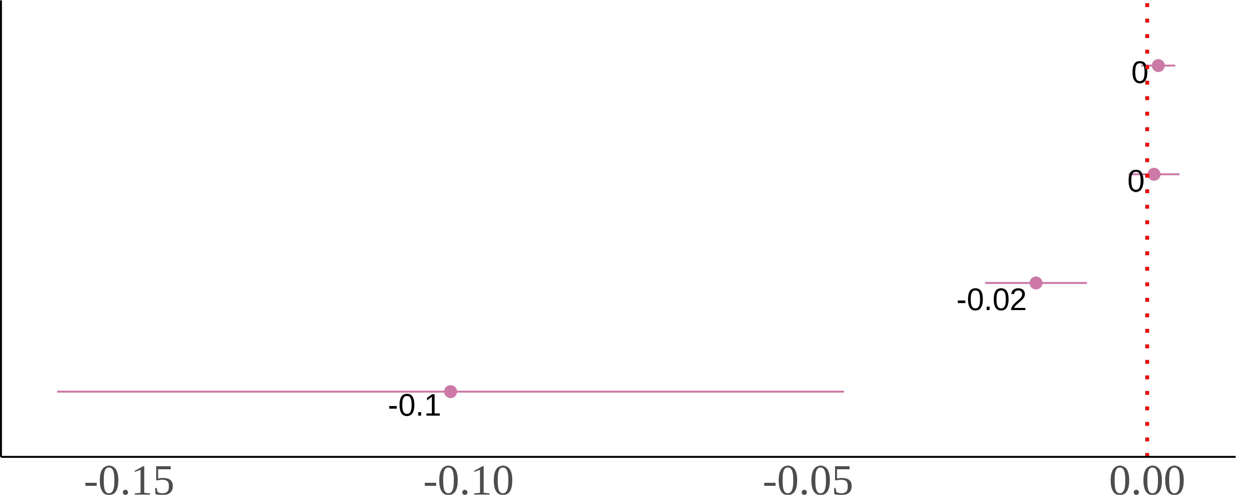

(c) Asian Fathers-White Mothers (d) White Fathers-Asian Mothers

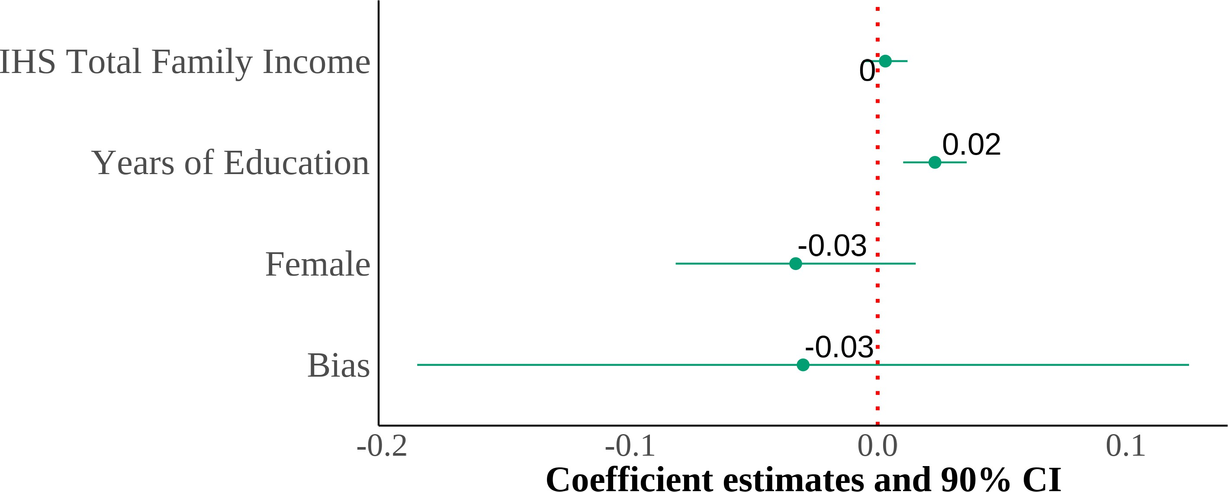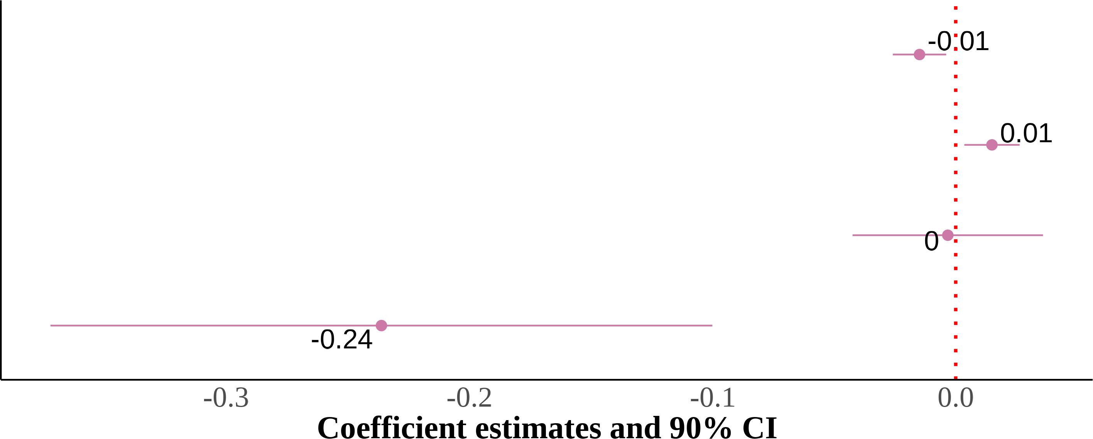

I show four panels of estimating equation (4) on a sample of adults. I include region *×* year fixed effects with controls for sex, quartic age, years of education, and the inverse hyperbolic sine of income. The dependent variable is self-reported Asian identity and the independent variable is state-level bias. Each panel results from the same regression but on different samples divided by parental types. Standard errors are clustered on the state level. The samples include second-generation Asian individuals ages 18 and above. Native-born second-generation Asian immigrant individuals with at least one parent born in an Asian country.

Figure 13: Marginal Effects of Key Covariates on Racial Identity Choice by Parental Ancestry (Second-Generation Asian Americans)

(a) Asian Father-White Mother (AW) (b) White Father-Asian Mother (WA)

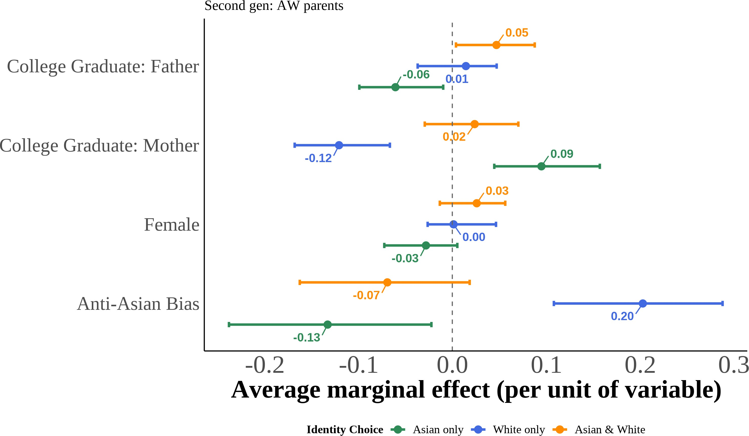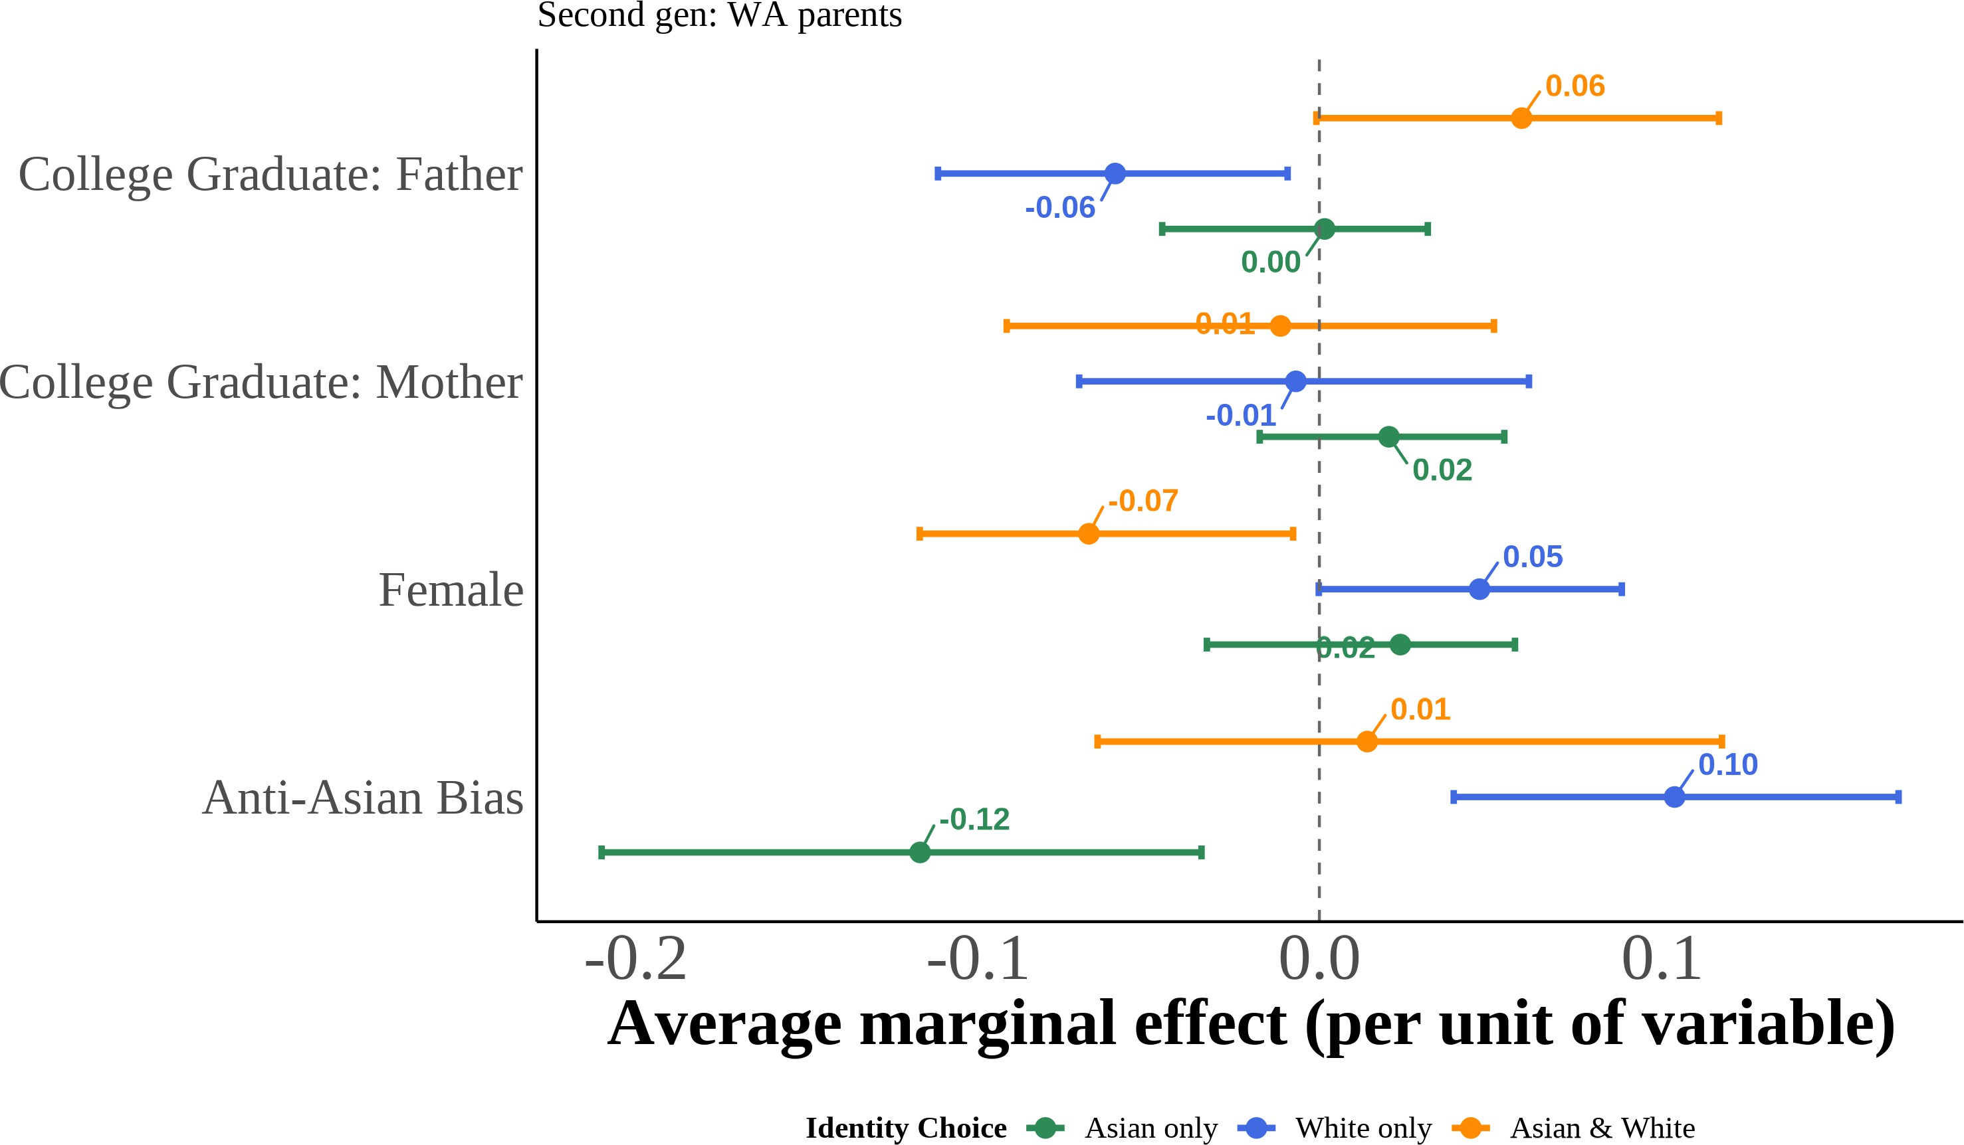

This figure displays the marginal effects of key covariates on the probability of each racial identifi-cation outcome, estimated from equation (5) using multinomial logit models for second-generation Asian Americans by parental ancestry configuration. Marginal effects represent the change in pre-dicted probability for a one-unit increase in the covariate (or discrete change from 0 to 1 for binary variables), holding other variables at their sample means. I include region *×* year fixed effects with controls for quartic age and local Asian population share. Each point corresponds to the me-dian marginal effect across 1,000 bootstrap resamples, with 95% percentile confidence intervals. Second-generation Asian Americans are native-born individuals with at least one Asian-born par-ent.

Figure 14: Marginal Effects of Key Covariates on Racial Identity Choice by Parental Ancestry (Adult Second-Generation Asian Americans)

(a) Asian Father-White Mother (AW) (b) White Father-Asian Mother (WA)

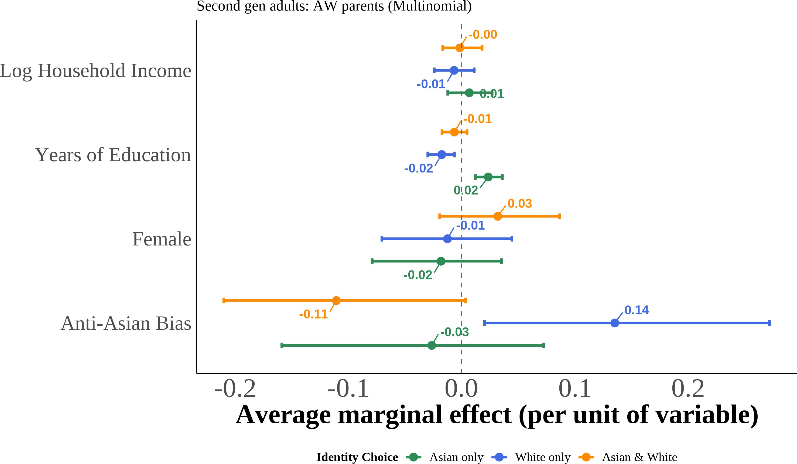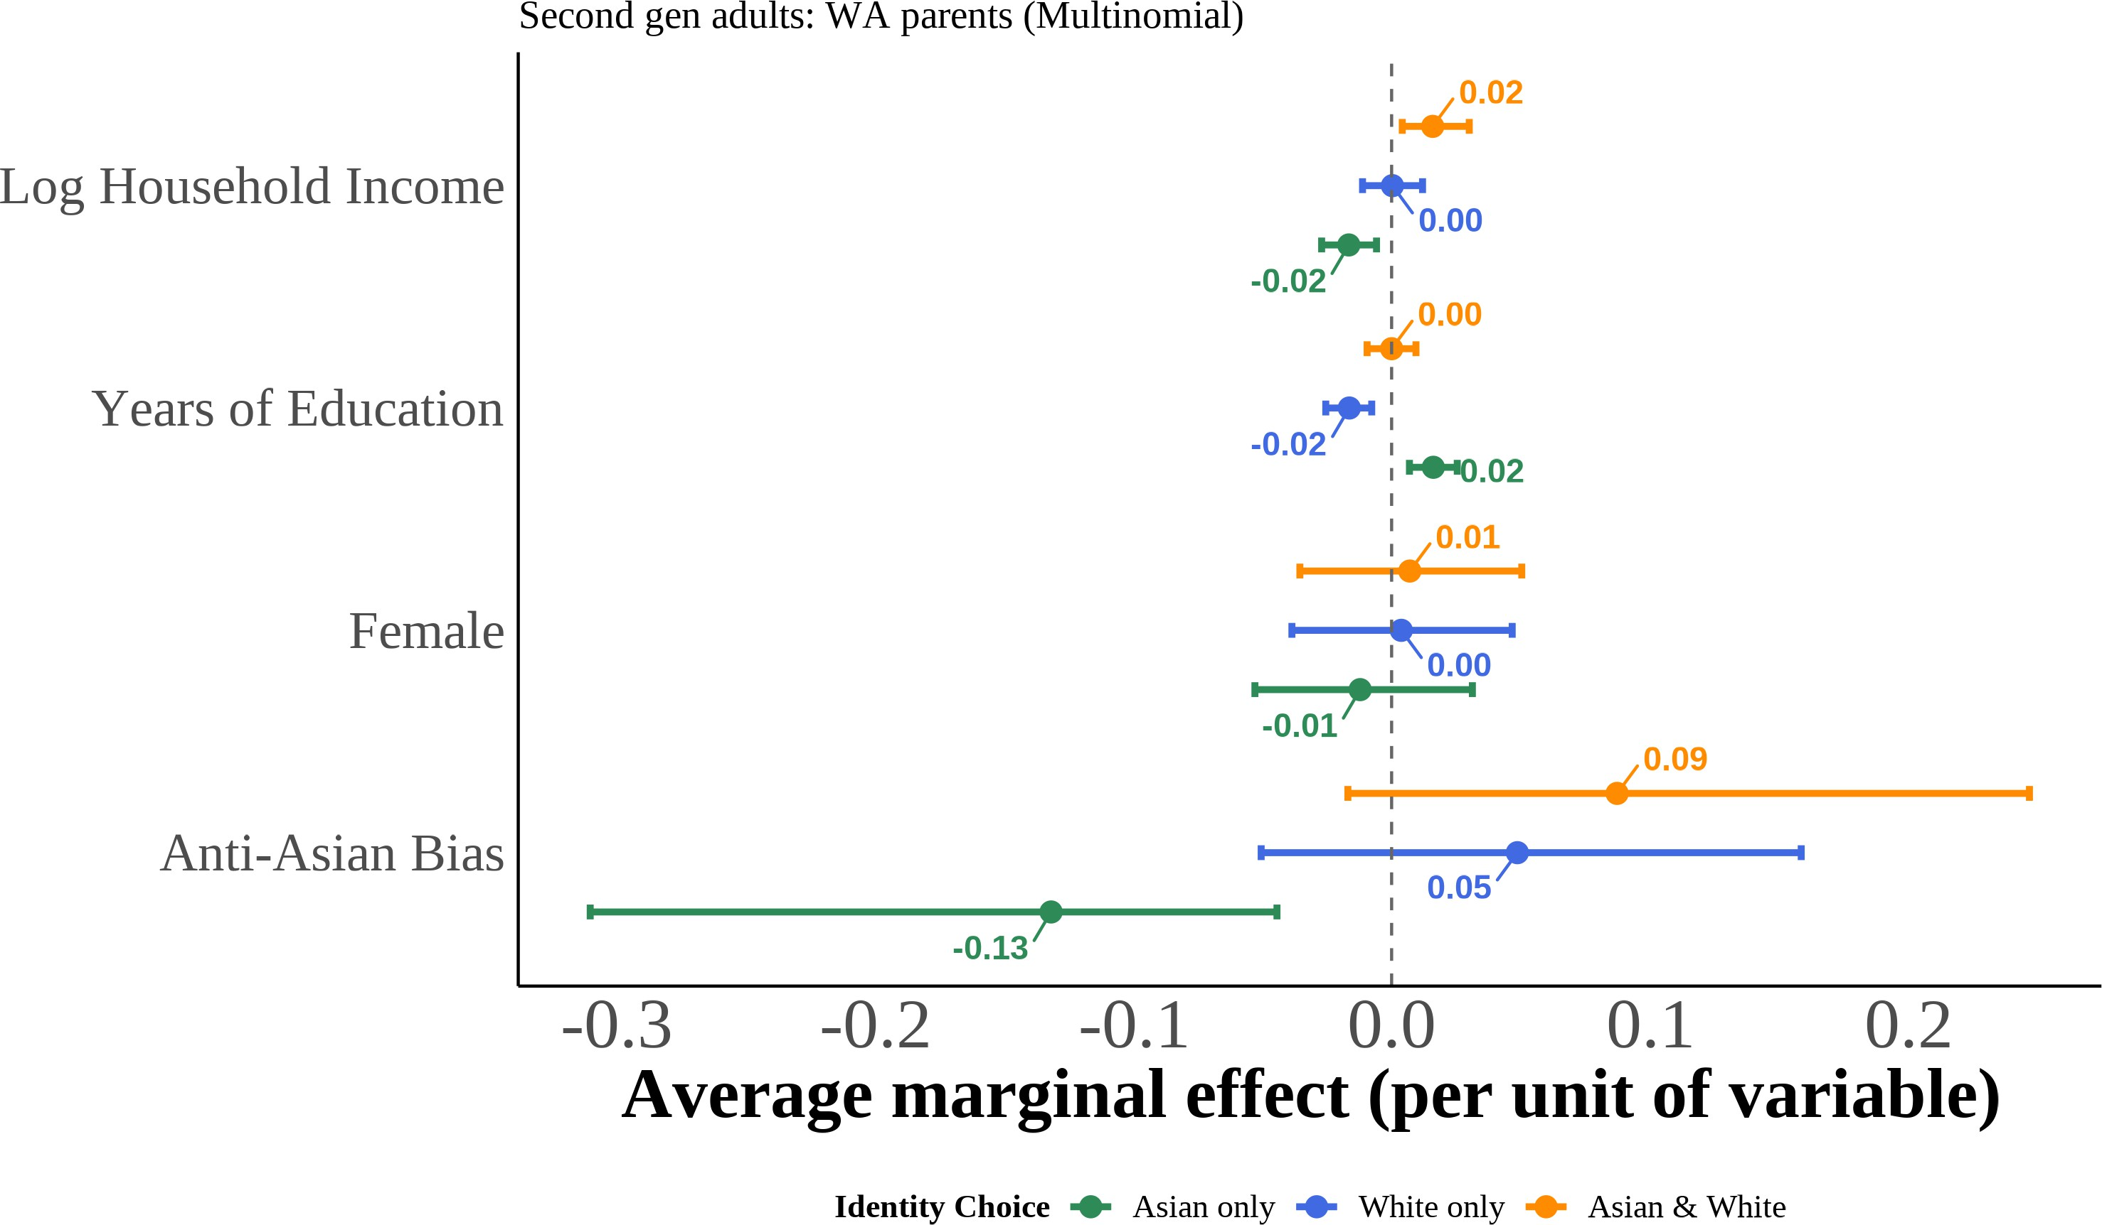

This figure displays the marginal effects of key covariates on the probability of each racial identifi-cation outcome, estimated from equation (5) using multinomial logit models for second-generation adults with Asian father/White mother (AW) and White father/Asian mother (WA). Marginal ef-fects represent the change in predicted probability for a one-unit increase in the covariate (or dis-crete change from 0 to 1 for binary variables), holding other variables at their sample means. I include region *×* year fixed effects with controls for quartic age and local Asian population share. Each point corresponds to the median marginal effect across 1,000 bootstrap resamples, with 95% percentile confidence intervals. Second-generation Asian Americans are native-born individuals with at least one Asian-born parent.

Figure 15: Marginal Effects of Key Covariates on Racial Identity Choice by Num-ber of Asian Grandparents (Third-Generation Asian Americans)

(a) One Asian Grandparent (b) Two Asian Grandparents

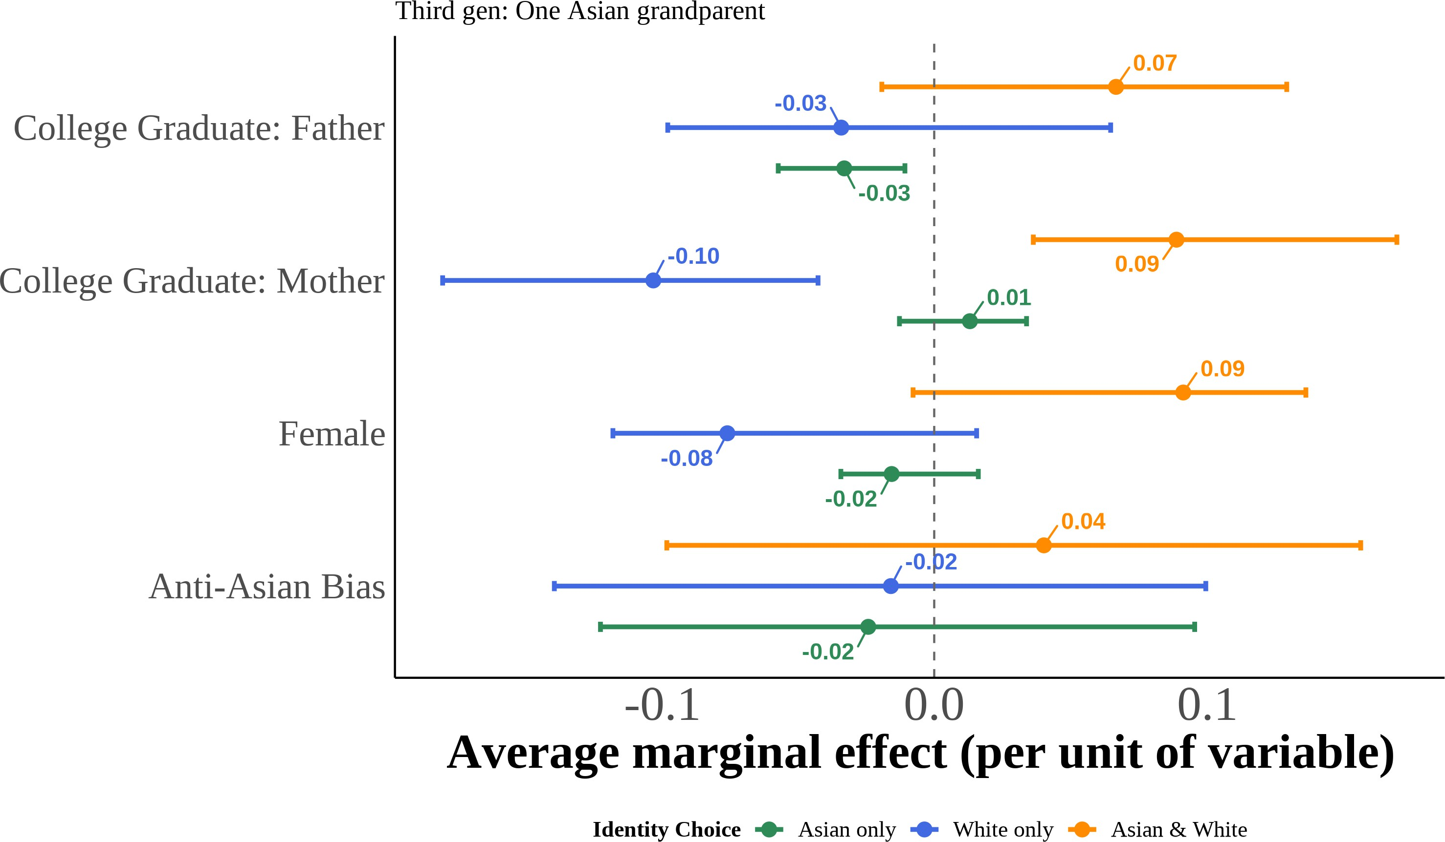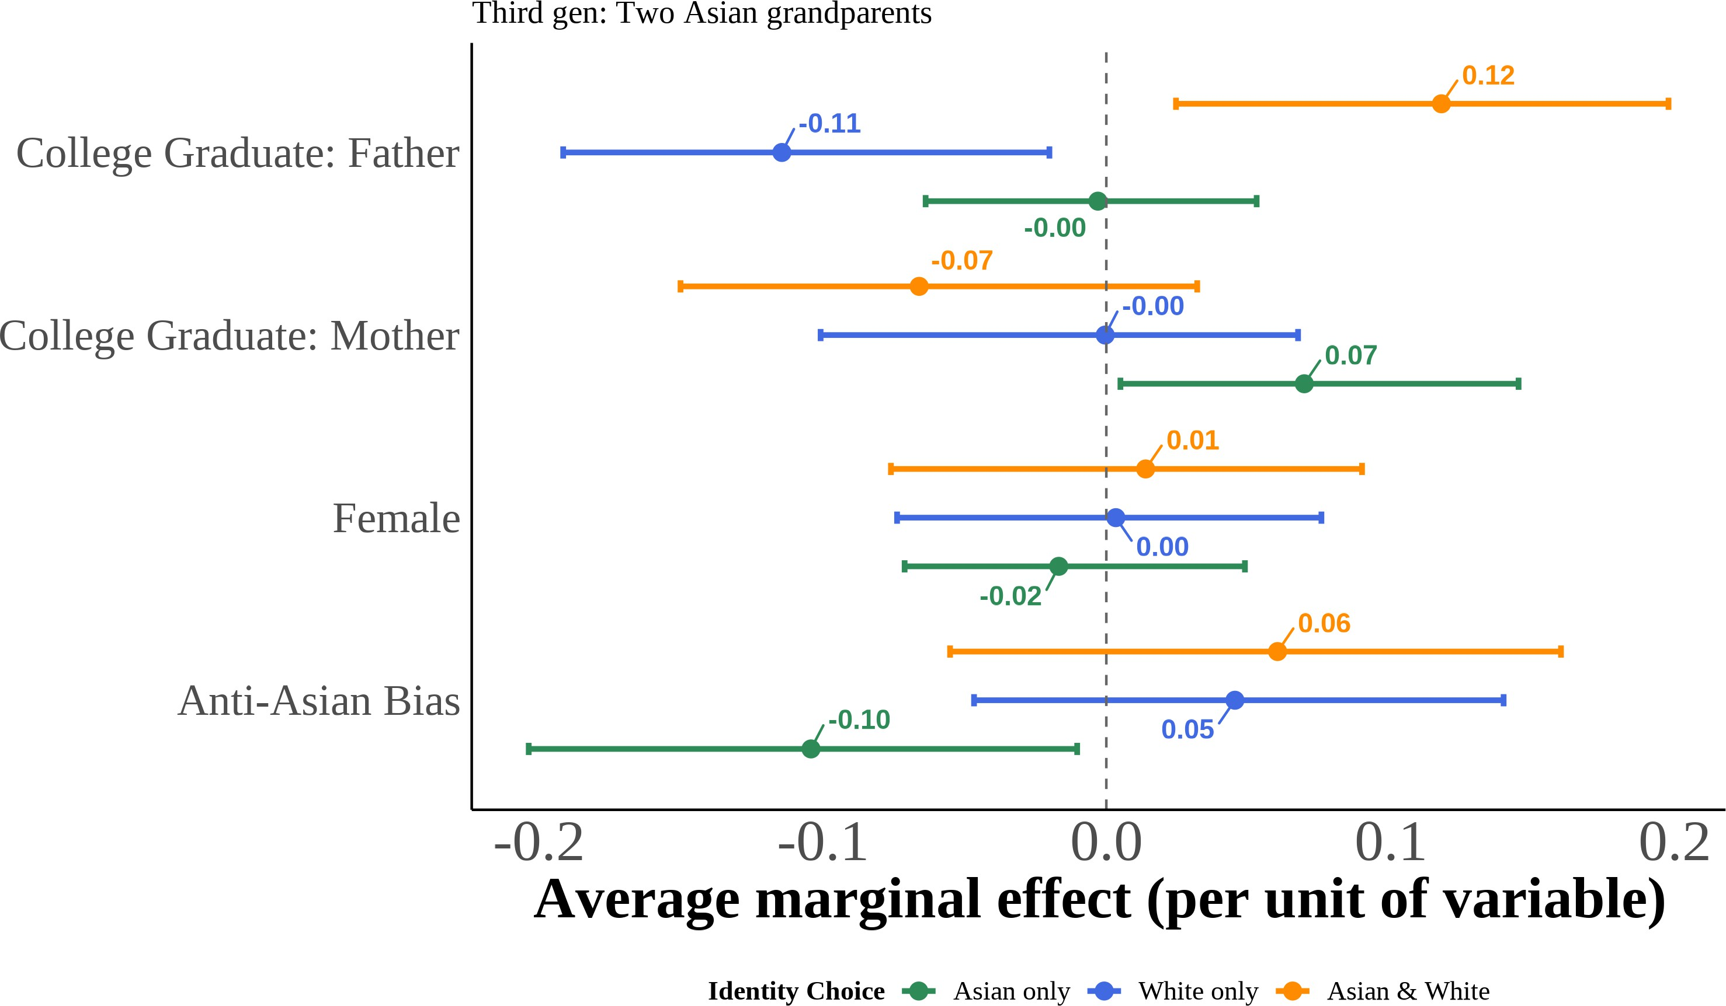

This figure displays the marginal effects of key covariates on the probability of each racial identifi-cation outcome, estimated from equation (5) using multinomial logit models for third-generation Asian Americans by number of Asian grandparents. Marginal effects represent the change in pre-dicted probability for a one-unit increase in the covariate (or discrete change from 0 to 1 for binary variables), holding other variables at their sample means. I include region *×* year fixed effects with controls for quartic age and local Asian population share. Each estimate is the median across 1,000 bootstrap resamples, and 95% percentile confidence intervals accompany every point.

## Responses to Editors and Referee

I would like to thank the editors and the anonymous referees for their insight-ful comments, suggestions, and effort and time in reviewing this paper. I have addressed all the comments and suggestions in the revised manuscript. Below, I provide a summary of the changes made to the manuscript in response to the comments and suggestions. Please note that the comments from the referees are quoted verbatim, and my responses follow each comment.

## Responses to Referee One

I would like to thank referee one for the insightful comments and suggestions.

Below is a detailed response to the comments and suggestions.

**R1:** 1. Beginning with the paper’s theoretical account of racial bias and its potential impact on racial identity, I appreciate the author’s use of formal theory to present a logical and rational model explaining why bias may affect racial identity. However, I feel the author misses an important literature on racial identity and assimilation that focuses on the behavioral aspects of race and racial identity. While they do briefly touch on some of this literature, I suggest that revisions have a greater focus on the behavioral literature on racial identity and as-similation in addition to the formal model. A good work that I could suggest on this topic is Telles and Ortiz’s Generations of Exclusion.

**Response:** I thank the referee for this suggestion. I have added a paragraph in the introduction discussing Telles and Ortiz’s Generations of Exclusion and other related works on racial identity and assimilation. Specifically, I add the following paragraph in the introduction:

“While Akerlof and Kranton (2000) theoretical model that I use provides a log-ical framework for understanding how bias affects racial identity, the behavioral literature on racial identity and assimilation offers crucial empirical insights that complement this theoretical approach. Research in this tradition emphasizes how racial identity is not merely a cognitive construct but is actively performed, nego-tiated, and reconstructed through daily interactions and life experiences (Waters 1990). Telles and Ortiz (2008)’s study of Mexican Americans demonstrates how in-dividuals strategically adapt their racial presentations across different social con-texts while maintaining core identity elements across generations.

Similarly, behavioral studies have documented how discrimination experiences

shape identity salience and group attachment, with individuals developing adap-tive strategies that range from ethnic distancing to reactive ethnicity depending on situational factors (Zhou 1997). This behavioral perspective reveals that racial identity operates as both a response to external categorization and an active pro-cess of boundary maintenance (Cornell and Hartmann 2006). While this litera-ture has primarily relied on qualitative observations and ethnographic methods to document identity flexibility, the present analysis advances this understanding by quantifying these strategic choices through systematic comparison of objective an-cestry measures with subjective racial identification across varying environmental contexts.”

**R1:** 2. As for the methods, I have a few concerns that I hope the author can address in future drafts. One concern that looms over the paper for me is that the ’objective’ measure of Asian background may not be as objective as it seems. For instance, it is unclear that, say, the children or grandchildren of people who were born to non-asian parents in Asia, for example, on an American military base, would be classified as Asian. I don’t think this is a huge concern for the analysis, but it needs to at least be addressed.

**Response:** I appreciate the referee’s attention to this issue. It is a point I ad-dress in the paper’s data section in the following footnote “I restrict first-generation cases to those whose parents were born in Asian countries to exclude US citizens born abroad to American parents”. Following the comment, I added a few sen-tences to clarify this point. Specifically, I added the following sentences in the data section: “Note that while the ancestry measure provides an objective assessment

of Asian heritage, it may not capture all nuances of racial identity. For instance, White individuals with Asian ancestry born to non-Asian parents in Asia, such as on American military bases, may be classified as Asian in the data. To avoid potential misclassification, I remove individuals who report that they were born abroad of American parents. ”

**R1:** 3. Second, I am concerned that using the state as the unit of analysis for regional bias may be problematic. Perhaps the bias of the community that one grows up in would be better measured at the city or zip-code level. For instance, those who live in Austin, Texas may have a very different experience with bias than those who live in rural west Texas. If the authors could provide even a supplemental analysis in which they analyze this at local level, this would help significantly to alleviate these concerns.

**Response:** I thank the referee for this suggestion. I agree that using more gran-ular geographic units would provide a more precise measure of local bias. How-ever, there are major data limitations that prevent me from doing so. First, the CPS does not provide geographic identifiers below the county level and only for 45% of the sample and only for counties with larger populations. Therefore, if used at the county level, I would lose more than half of the sample and potentially intro-duce bias. Second, even if I had access to more granular geographic identifiers in the CPS, to my knowledge, there are no measures of racial bias at more granular geographic levels. The General Social Survey (GSS), which I use as one of my measures of racial bias, is only representative at the the state level. The American National Election Studies (ANES) is only available at the state level. The Uniform

Crime Reports (UCR), which I use to calculate anti-Asian hate crimes, is recom-mended to not be used at the county level and is not available at lower levels. The Implicit Association Test (IAT) data is the only dataset that available at the county level, however, many social scientists have raised concerns about using the IAT on it’s own. Therefore, while I agree with the referee that using more granular geographic units would be ideal, I am limited by data availability. I will add a paragraph to the conclusion discussing this limitation and suggesting that future research could explore this question using more granular geographic units if data becomes available. Specifically, I will add the following paragraph to the conclu-sion: “More granular geographic units, such as counties, city, or zip-code level, could provide a more precise measure of local bias. However, data limitations prevent the use of these finer geographic levels in the current analysis. Future research could explore this question using more detailed geographic identifiers if such data becomes available, allowing for a deeper understanding of how local contexts shape racial identity.”

To strengthen how I address this concern, I have conducted supplemental analyses using county-level and MSA-level Implicit Association Test (IAT) data, which are available at more granular geographic levels than the state-level mea-sures used in the main analysis. These results are presented in Appendix Figures A.2, A.3, A.4, and A.5. The patterns observed at the county and MSA levels are consistent with the main state-level findings, showing similar negative relation-ships between anti-Asian bias and Asian identity reporting across generations and parental types. While these analyses are limited to IAT measures alone (due to data availability constraints for other bias measures at sub-state levels), they provide additional evidence that the documented relationships hold at more lo-calized geographic scales. I have also added a footnote in the main results section

directing readers to these supplemental analyses. The footnote reads: “I show the results using county-level and MSA-level anti-Asian bias measures from the Implicit Association Test (IAT) show similar patterns. I present the county-level results in Figures A.2 and A.3, while I show the MSA-level in Figures A.4 and A.5.”

**R1:** 4. Additionally, while I understand why children are of partic-ular interest, I would also like to see what the results look like for Asian adults. Is this phenomenon of calculating one’s identity concentrated among children? Do they come to identify more with their Asian roots as they reach adolescence and adulthood? Are the same calculations being made by adults? These are important questions that including the sample of adults could be useful to help answer.

**Response:** Thank you so much for this important suggestion. I agree that examining the relationship between bias and racial identity among adults would provide valuable insights into how these dynamics evolve over the life course. To address this comment, I have conducted supplemental analyses using the same empirical strategy on an adult sample (ages 18 and above) from the CPS. I show the summary statistics for the adult sample in Table (2) and the ethnic attrition for first- and second-generation Asian adults in Table (5). Moreover, I present the relationship between anti-Asian bias and self-reported Asian identity among adults in Figures 10 and 12. The results indicate that the negative relationship between anti-Asian bias and Asian identity reporting among adults mirrors the patterns observed in children, suggesting that similar identity calculations are at play across age groups.

I also added the following two discussion of the results in the main text. First: “Adult samples show similar patterns (Figure 10).20 A one standard deviation increase in anti-Asian bias correlates with a 5 percentage point decrease in Asian racial identity reporting across all adults, with a 2 percentage point decrease among first-generation adults (statistically insignificant) and a 13 percentage point de-

crease among second-generation adults. Higher household income and years of education both positively correlate with Asian identity reporting, with each addi-tional year of education associated with approximately 1–2 percentage point in-creases.” Second: “Adult second-generation results show even larger heterogene-ity by family structure (Figure 12). A one standard deviation increase in anti-Asian bias correlates with a 13 percentage point decrease across all second-generation adults, with the largest effect among White father-Asian mother adults (24 per-centage points, panel D). Notably, higher education positively correlates with Asian identity reporting among mixed-race adults but shows no effect in endoga-mous families, suggesting that more educated individuals with Asian ancestry are more likely to maintain their Asian racial identity. This selective retention implies that studies using self-reported racial identity may overestimate Asian American success and underestimate assimilation speed, as successful Asians remain visible in the data while less successful Asians attrit to other racial categories.”

**R1:** 5. Lastly and importantly, it is also unclear to me why the author uses measures of animus towards African Americans from the ANES in their bias index, especially when measures of animus towards Asian Americans are available on the very same study. Here I think the

1. For adults with Asian ancestry, I can only observe birthplaces of the person and their parents, not grandparents, limiting analysis to first- and second-generation individuals.

author either needs to make a case for the bias they are interested in being more broad than just bias toward Asian-Americans or they need to reestimate their measures of bias.

**Response:** Thank you for this important methodological observation. You raise a valid point about the conceptual alignment between my bias measures and outcomes. Let me clarify my approach: The ANES racial animus questions do primarily focus on attitudes toward Black Americans, I also use measures of animus toward Asian Americans. Research consistently shows that racial preju-dices are highly correlated across different minority groups—individuals who ex-press bias toward one racial minority typically hold similar attitudes toward oth-ers (Almasalkhi 2023; Mora and Paschel 2020). These measures therefore capture general patterns of racial animus rather than group-specific bias alone. Crucially, my composite bias index combines three distinct components: (1) Asian-focused IAT measures, (2) ANES racial animus questions, and (3) hate crimes specifically targeting Asian Americans. This multi-proxy approach effectively weights the overall bias measure toward Asian-specific prejudice (two of three components directly measure anti-Asian sentiment) while incorporating information about the broader racial climate through the ANES measures. This methodological choice serves two purposes: it reduces measurement error through the composite ap-proach while capturing both specific anti-Asian bias and the general environ-ment of racial prejudice that affects all minority groups. I added the following to the text of the manuscript to address the important point the referee raised: “While the ANES racial animus questions primarily focus on attitudes toward Black Americans, research demonstrates that racial prejudices are highly corre-lated across different minority groups, with individuals who express bias toward

one racial minority typically holding similar attitudes toward others (Almasalkhi 2023; Mora and Paschel 2020). These measures therefore capture broader pat-terns of racial animus that extend beyond anti-Black sentiment specifically. When combined with the Asian-focused IAT measures and hate crimes against Asian Americans in my composite index, this multi-proxy approach weights the bias measure more heavily toward Asian-specific prejudice while still capturing the general racial climate.”

## Responses to Referee Two

I would like to thank referee two for the insightful and constructive comments and suggestions. Below is a detailed response to the comments and suggestions.

**R2:** 1. The paper reports that roughly 96% of individuals who were born in Asia or who have two Asian parents report being Asian. Before analyzing this group, it would be essential to understand the 4% who do not. Do they report being of a single racial group not else-where classified (e.g., Indian or Chinese), in which case we might rea-sonably either exclude them since we do not know what they reported or assume that they chose a subcategory of Asian? Is there any way to determine what proportion might be expats born in Asia (primarily in Hong Kong or Singapore)?

**Response:** Thank you for this important question. Allow me to break down your comment into different parts that I would address separately.

First, regarding the 4% of individuals born in Asia or with two Asian parents who do not report being Asian, I have examined their self-reported racial identi-ties. I believe that this comment is related to your other comment below regard-ing showing the distribution of racial identities among those with Asian ancestry. I will respond to that comment below in more detail. However, to briefly ad-dress this point, I added a new section to the manuscript (From the Data: Asian Racial Identity and Attrition) where I show the racial attrition and racial choices among those with Asian ancestry. Specifically, I show which of the following cat-egories they report: (1) Asian only, (2) White only, (3) Asian and White/Pacific Islander, (4) other non-Asian multiracial combinations, (5) Asian combined with other races, and (6) Asian/Pacific Islander.

Moreover, my analysis defines Asian countries as East Asian and Southeast Asian nations (China, Hong Kong, Taiwan, Japan, Korea, Mongolia, Cambodia,

Indonesia, Laos, Malaysia, Philippines, Singapore, Thailand, and Vietnam), ex-cluding South Asian and Middle Eastern countries. This classification aligns with standard demographic research on East and Southeast Asian populations and re-flects shared experiences within these regions. To make this clearer, I have added a footnote in the data section specifying which countries are included in the defi-nition of Asian countries. The footnote reads: “For this analysis, Asian countries comprise East Asian and Southeast Asian nations, including China, Hong Kong, Taiwan, Japan, Korea, Mongolia, Cambodia, Indonesia, Laos, Malaysia, Philip-pines, Singapore, Thailand, and Vietnam, but exclude South Asian and Middle Eastern countries, consistent with standard demographic classifications.”

Finally, regarding your point on the ability using the data to identify expats born in Asian countries (i.e. US citizens born abroad to US parents). It is a point I address in the paper’s data section in the following footnote “I restrict first-generation cases to those whose parents were born in Asian countries to exclude US citizens born abroad to American parents”. To make sure that this would be clear in the paper, I added a few sentences to clarify this point. Specifically, I added the following sentences in the data section: “It is important to note that while the ancestry measure provides an objective assessment of Asian heritage, it may not capture all nuances of racial identity. For instance, White individuals with Asian ancestry born to non-Asian parents in Asia, such as on American military bases, may not be classified as Asian in the data. To avoid potential misclassification, I remove individuals who report that they were born abroad of American parents.”

**R2:** 2. Leaving aside these issues, it is problematic to use a linear probability model when the probability is near 0 or 1. Given the range of bias shown in some of the figures, a coefficient of -.05 suggests that

the predicted probability of reporting to be Asian is likely to exceed 1 for a nontrivial number of observations. At the very least, the author should show that the results are robust to using probit and logit. I am more inclined to the view that trying to explain the small proportion of individuals with two Asian parents who do not self-identify as Asian is not likely to be productive.

**Response:** I thank the reviewer for this important methodological point. To address concerns about the linear probability model’s limitations when probabil-ities approach boundary values, I have estimated both logit and probit models alongside the LPM specifications for all analyses. As shown in Tables A.1-A.4, the marginal effects from logit and probit models are remarkably consistent with the LPM coefficients across all generational groups, providing strong evidence for the robustness of the findings.

Regarding the specific concern about predicted probabilities exceeding 1: the logit and probit specifications, which are bounded between 0 and 1 by construc-tion, yield nearly identical marginal effects, confirming that boundary issues are not driving the results.

The reviewer raises an interesting point about the substantive focus on the minority who do not self-identify as Asian despite having Asian ancestry. How-ever, this phenomenon represents a theoretically important pattern that motivates my research design choices. This is precisely why I break down my analysis by generation and family structure—to demonstrate how identity switching costs vary systematically across different groups. As outlined in Akerlof and Kran-ton (2000), individuals face differential costs when changing identities based on their circumstances and social constraints. Those with more proscribed identity choices, such as individuals with two Asian parents who appear phenotypically Asian, face higher switching costs and react differently to their environment than

those with less constrained options, such as mixed-race individuals who possess greater phenotypic ambiguity. My findings support this theoretical prediction: while bias effects are statistically insignificant among second-generation children with two Asian parents, they are substantial and significant among children from interracial families (15 percentage points for Asian father-White mother families and 10 percentage points for White father-Asian mother families). I present results for all subgroups both for transparency and to illustrate this crucial heterogene-ity in identity switching costs. The systematic relationship between experienced bias and identity reporting across these different constraint structures provides insights into how discrimination shapes ethnic and racial identification processes, with direct implications for measuring racial gaps and understanding the eco-nomic mechanisms underlying assimilation patterns.

**R2:** 3. The interesting part of the paper concerns individuals of mixed ancestry, most of whom do not identify as Asian. But, the only Asian/not only Asian dichotomy is problematic. What proportion of the “not only Asian” reports being Asian and something else? In gen-eral, we want to know whether explanatory variables shift mixed-race individuals from reporting themselves as Asian only to something else only, or to biracial.

**Response:** I appreciate the reviewer’s insightful comments on the complexi-ties of racial identity. I believe that addressing this point will significantly enhance my paper. First, to address your comment regarding the distribution of racial identities among those with Asian ancestry, I have added a new section to the manuscript (From the Data: Asian Racial Identity and Attrition) where I show the racial attrition and racial choices among those with Asian ancestry. Specifically, I show which of the following categories they report: (1) Asian only, (2) White

only, (3) Asian and White/Pacific Islander, (4) other non-Asian multiracial com-binations, (5) Asian combined with other races, and (6) Asian/Pacific Islander. I provide this breakdown for all generations and separately for first-, second-, and third-generation individuals in Figures 5-8. Please see Section 4 for the full dis-cussion of these results.

The data reveal that among those not identifying as “Asian only,” there is sub-stantial variation in identity choices. Among second-generation children from interracial families, 29% of those with Asian fathers and White mothers report “Asian and White/Pacific Islander” (biracial), while 27% report “White only.” Similarly, 40% of those with White fathers and Asian mothers report “Asian and White/Pacific Islander,” while 24% report “White only.” This pattern shows that mixed-ancestry individuals do not simply shift from Asian identification to White identification, but frequently adopt multiracial identities.

The breakdown becomes even more complex among third-generation individ-uals. Those with fewer Asian grandparents are more likely to report “White only” (54% for those with one Asian grandparent), while those with more Asian an-cestry maintain higher rates of multiracial identification. Critically, even among third-generation children with four Asian grandparents, 92% still report “Asian only,” demonstrating that family composition rather than generational status drives identity flexibility.

These findings directly address the reviewer’s question “What proportion of the “not only Asian” reports being Asian and something else?”

To further explore how explanatory variables influence these identity choices, I added results from estimating the effects of bias, parental education, and sex us-ing a multinomial logistic regression. This approach allows me to model the prob-abilities of reporting “Asian only,” “White only,” and “Asian and White/Pacific

Islander” as separate outcomes.

I present the results in Figures 13–15, reveal that anti-Asian bias significantly decreases the likelihood of reporting “Asian only” while increasing the probabili-ties of both “White only” and “Asian and White/Pacific Islander” identifications among mixed-ancestry individuals. For example, among second-generation chil-dren from Asian father-White mother families, a one standard deviation increase in anti-Asian bias is associated with a 12 percentage point decrease in the probabil-ity of reporting “Asian only,” a 20 percentage point increase in “White only,” and a 5 percentage points decrease in “Asian and White/Pacific Islander.” To discuss these results, I broke down the results into two subsection. The first subsection—sub-section 5.1.1 titles “Dichotomous Asian Racial Identity Reporting and Anti-Asian Bias”—discusses the dichotomous outcomes. The second subsection—sub-section 5.1.2 titled “Multinomial Logit Results: Racial Identity Choices and Anti-Asian Bias”—focuses on the multinomial outcomes.

**R2:** 4. The paper either doesn’t report basic summary statistics about the distribution of bias, or I missed it. The effect of a one-standard-deviation increase in anti-Asian bias on the probability of reporting only Asian appears to be modest.

**Response:** I appreciate the reviewer’s comments regarding the need for clearer presentation of the bias measures. In the original manuscript, I provided several maps and figures illustrating the geographic distribution of anti-Asian bias across states. In Figure 2, I show the aggregate bias index for the two most biased (North Dakota and Tennessee) and two least biased states (Hawaii and Vermont) in Panel 2a. In Panel 2b, I show the self-reported Asian identity rates for the two most biased and two least biased states to illustrate the differences. This would provide

visual evidence of the variation in bias levels across states. For example, a one standard deviation bias increases equivalent to moving from Washington, DC, or Vermont to North Dakota in 2020. Additionally, in Figure 3, I present maps showing the variation in anti-Asian bias across states and over time for my bias index. The maps are of state-level bias in 2004 (Panel 3a), 2008 (Panel 3c), 2012 (Panel 3c), and 2016 (Panel 3d). Finally, I show the average state-level bias over the entire sample period in Figure 4. A discussion of these figures is provided in subsection 7 titled “Measuring Anti-Asian Sentiment” in the data section 3.

**R2:** 5. It is surprising that the paper does not look more carefully at other potential explanatory factors, such as income. This is partic-ularly important because the paper is motivated by the potential bias in measures of Asian/non-Asian disparities. However, unless report-ing Asian identity is directly or indirectly related to the outcomes for which we want to measure disparities, to a first approximation, there is no bias in the disparities estimates. For example, if reporting a non-Asian identity is uncorrelated with income, the estimated income of Asians is unbiased. The problem only arises if highincome Asians are more (or less) likely to report themselves as non-Asian.

**Response:** I would like to thank the reviewer for this important comment. I agree that examining how racial identity reporting correlates with socioeconomic outcomes like income is crucial for understanding potential biases in measuring disparities. The issue of including income is problematic since family income is only available in the Annual Social and Economic Supplements (ASEC) of the CPS, i.e. the March supplement. Therefore, if I were to include income in my analysis, my sample size would be reduced significantly. Moreover, since I agree that income is an important variable to consider, I included parental education as it is a proxy for socioeconomic status.

Furthermore, in my analysis of the adult sample, I included individual inde-pendent variables that include income. As shown in the paragraph describing Fig-ure (12), the adult specifications reveal that higher household income positively correlates with Asian identity reporting. This finding directly addresses the re-viewer’s concern about potential bias in disparity estimates: higher-income Asian Americans are indeed more likely to report Asian identity, which would lead to overestimation of Asian outcomes and underestimation of the true Asian-White gaps in surveys that rely on self-reported race.

These results support the reviewer’s intuition that the relationship between identity reporting and socioeconomic outcomes is crucial for understanding mea-surement bias. The positive correlation between income and Asian identity re-porting, combined with the differential effects by parental education, suggests that studies measuring Asian-White disparities may indeed be systematically bi-ased, particularly overestimating the assimilation and socioeconomic success of Asian Americans.

**R2:** 6. Similarly, any effect of anti-Asian bias on reporting is only important if it affects Asians differentially based on their incomes (or other variables we examine for disparities). Thus, it is somewhat sur-prising that anti-Asian bias is not interacted with other variables, al-though I expect that the data are not up to the task.

**Response:** I appreciate the reviewer’s insightful comment about the impor-tance of examining how anti-Asian bias effects vary by socioeconomic character-istics. I have directly addressed this concern through several approaches. First, I estimated interaction models that examine how demeaned state-level bias ef-fects differ by parental education and gender, as presented in Figures (A.6) and (A.7). These results reveal that anti-Asian bias effects indeed vary significantly

by parental education, particularly among mixed-race families, where individu-als with college-educated parents respond differently to above-average state bias levels in their identity reporting decisions.

Second, in my adult sample analysis that includes individual income as a co-variate, I am able to examine how bias effects interact with socioeconomic status more directly. The adult specifications show not only that higher household in-come positively correlates with Asian identity reporting, but also reveal differen-tial patterns of bias responsiveness across income levels. This analysis demon-strates that the relationship between anti-Asian bias and identity reporting is in-deed moderated by socioeconomic factors, directly addressing the reviewer’s con-cern about differential effects by income and other variables relevant for measur-ing disparities.

These interaction analyses confirm that anti-Asian bias does not affect all Asian Americans uniformly—rather, its effects are concentrated among specific socioe-conomic groups, which has important implications for understanding potential biases in disparity estimates.

**R2:** 7. The argument that parents and children provide similar reports about the child’s race is not compelling. Presumably, most children mimic their parents’ views and only develop an independent self-concept late in childhood or in adulthood. That doesn’t make the parent’s report or the child’s report uninteresting; it just affects the in-terpretation.

**Response:** I would like to thank the reviewer for their thoughtful critique re-garding the interpretation of parental versus child reports of racial identity. The reviewer correctly notes that children often internalize parental views and may not develop independent racial self-concepts until later in development. How-

ever, I address these concerns multiple ways that reinforce the robustness of my findings.

First, as part of my robustness checks, I directly examine this issue by analyz-ing reporting patterns by household respondent type in Table (3). The empirical evidence shows remarkably consistent patterns across different reporting arrange-ments, with main Asian racial identity effects of 72 percentage points whether mothers or fathers serve as proxies, and 87 percentage points when children them-selves serve as household respondents. This consistency suggests that the under-lying phenomenon I am measuring—the relationship between anti-Asian bias and identity reporting—is robust across different respondent types. Furthermore, I ex-plore ethnic attrition patterns among adults. I find that the attrition among adults are similar to those of children, as shown in Table (5), suggesting that proxy re-porting aligns with individuals’ self-identification.

Second, and more importantly, I address this concern directly in my robust-ness analysis by examining adult samples where individuals unambiguously self-report their racial identity. As demonstrated in Table (5) and Figures (10-12), I find similar patterns of ethnic attrition and bias effects among adults. This replication with self-reporting adults confirms that the relationship between environmental bias and identity choices is not an artifact of proxy reporting or parental influence on children’s responses.

The Antman, Duncan, and Trejo (2020) finding that Hispanic identification pat-terns don’t vary by household respondent provides additional external validation for the robustness of racial identity reporting across different respondent arrange-ments.

The reviewer’s point about the interpretation is particularly valuable because it clarifies that whether parents or children are making these identity choices, the

mechanism I identify—strategic responses to environmental bias—remains sub-stantively important. If parents are making strategic identity choices in response to anti-Asian bias (whether for themselves or on behalf of their children), this rep-resents exactly the type of adaptive behavior my theory predicts and has the same implications for measurement bias in demographic data. The reviewer’s insight helps clarify the phenomenon of interest (bias-responsive identity reporting) op-erates at the family level, which I think would strengthen rather than weaken the theoretical importance of these findings.

**R2:** 8. My memory, perhaps incorrect, is that Akerlof and Kran-ton primarily discuss identity in terms of prescribed, not proscribed, behaviors. Of course, the requirement to act in a certain way may also be interpreted as a requirement not to act in some other way, but the former is more in line with the presentation in the original paper.

**Response:** Thank you for pointing out this important distinction regarding Akerlof and Kranton’s (2000) framework on identity. In thier paper, they discuss both prescribed and proscribed behaviors as integral components of identity for-mation and maintenance. I did correct the terminology in the manuscript to align more closely with your point. Specifically, I revised the language to emphasize “prescribed behaviors”.

**R2:** 9. On page 23, I find the statement “While my aim is not to es-tablish a causal effect of bias on self-reported Asian identity, I intend to illustrate a correlation between anti-Asian bias and self-reported iden-tity” extremely odd. Presumably, the goal is to show that the level of bias causes some Asians to switch between an Asian and non-Asian identity. If not, why is the paper interesting? The following sentence maintains that the existence of a correlation suggests possible bias in

other measures, but as discussed above, this is only important if anti-Asian bias interacts with characteristics we are comparing between Asians and others.

**Response:** I would like to thank the reviewer for pointing out this important issue regarding the framing of my research objectives. I removed the sentence you highlighted.

**R2:** 10. The world would be a better place if economists stopped including the final paragraph of the introduction, which we all skip anyway. The body of the introduction should be a sufficient guide without a paragraph telling us that the conceptual framework is in a section called conceptual framework.

**Response:** I appreciate this feedback and have removed the final paragraph from the introduction to streamline the presentation.

**R2:** 11. There is a potentially interesting paper here, but the cur-rent version is quite far from that paper. I expect that the paper should focus almost entirely on “Asians” of mixed ancestry. It should begin by showing how those individuals report their race and not simply use an Asian only/everything else dichotomy. It should then explore more fully what determines the choice among the possible responses, rather than just examining the effect of anti- Asian bias. If possible, it should examine whether anti-Asian bias affects “Asians” with different char-acteristics (education, income, gender) differently It should then return to motivating discussion of bias in the measure of disparities to give us a sense of how important endogenous identity is for our estimates.

**Response:** I am deeply grateful to the reviewer for these comprehensive and incisive comments, which have fundamentally strengthened this paper. The re-viewer’s suggestions have helped me sharpen the empirical focus, and better con-

nect the findings to their broader implications for measuring disparities. I partic-ularly appreciate the opportunity to address these substantive critiques, as they have guided me toward a more compelling and policy-relevant analysis.

I would like to specifically point out that your suggestions have been incor-porated throughout the revision in several key ways. First, following your rec-ommendation to focus more intensively on mixed-ancestry individuals, I have expanded the analysis to examine AW and WA families separately, as shown in the new interaction analysis in Figures (A.6) and (A.7). These results reveal the heterogeneous effects you anticipated and demonstrate that bias responses vary significantly by family composition and socioeconomic characteristics.

Second, I have addressed your call for examining differential effects by in-corporating interaction models that show how anti-Asian bias affects individuals differently based on parental education, gender, and income. The adult sample analysis now includes direct income controls and demonstrates the selection ef-fects you highlighted—that higher-income Asian Americans are more likely to maintain Asian identity, leading to potential overestimation of Asian outcomes in standard surveys.

Third, I have strengthened the connection between identity reporting patterns and measurement bias in disparity estimates, directly addressing your concern about the policy relevance of endogenous identity choices. The findings now clearly demonstrate how selective identity reporting could systematically bias our understanding of Asian American socioeconomic outcomes.

Finally, your suggestion to move beyond the Asian only/everything else di-chotomy has informed my discussion of the multinomial results, where I examine the full range of identity choices available to mixed-race individuals. These revi-sions have transformed the paper from a descriptive analysis of identity patterns

into a more theoretically grounded examination of how environmental factors shape strategic identity choices with clear implications for demographic measure-ment and policy research.

ONLINE APPENDIX

# The Effect of Racial and Ethnic Attitudes on Asian Identity in the U.S

## Data

Figure A.1: Examples of an Implicit Association Test

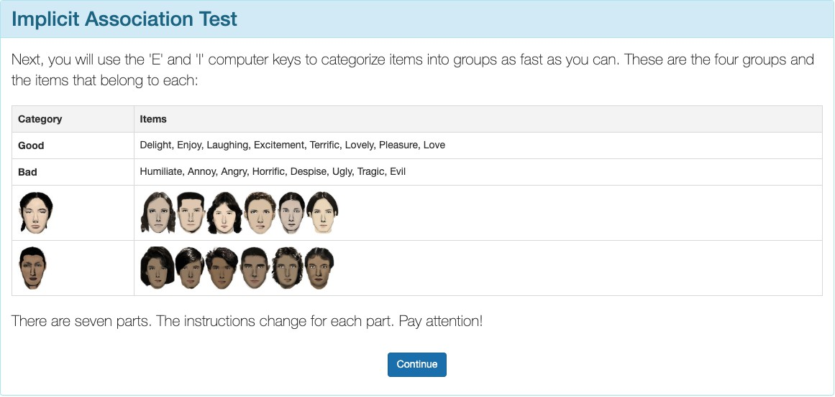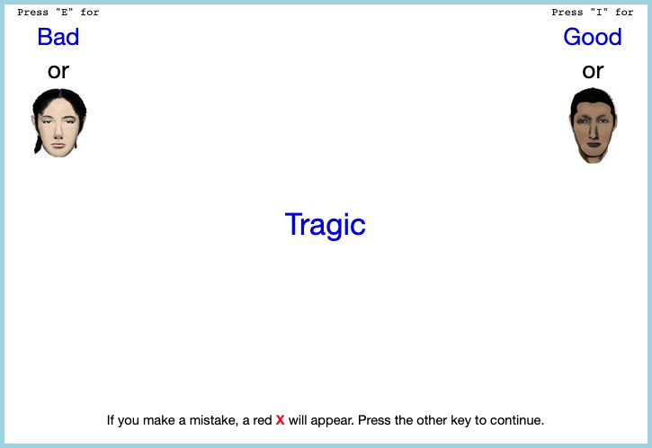

Here are a few examples of what a respondent would see on an implicit association test.

## Tables

Table A.1: Asian Identity Models - All Generations (with Marginal Effects)

|  |  |  |  |
| --- | --- | --- | --- |
|  | LPM | Logit (ME) | Probit (ME) |
| Bias | -0.0890*** | -0.0896*** | -0.1046*** |
|  | (0.0308) | (0.2704) | (0.2704) |
| Female | -0.0095* | -0.0103** | -0.0121** |
|  | (0.0050) | (0.0422) | (0.0422) |
| College Graduate: Mother | 0.0087 | 0.0097 | 0.0114 |
|  | (0.0067) | (0.0571) | (0.0571) |
| College Graduate: Father | 0.0148** | 0.0153*** | 0.0178*** |
|  | (0.0061) | (0.0486) | (0.0486) |
| Mean | 0.65 | 0.65 | 0.65 |
| Observations | 129,078 | 129,078 | 129,078 |

* p < 0.1, ** p < 0.05, *** p < 0.01

1 Linear Probability Model (LPM) shows coefficients. Logit and Probit show marginal effects.

2 All models include region × year fixed effects.

3 Standard errors clustered at state level.

4 ME = Marginal Effects calculated at sample means.

Table A.2: Asian Identity Models - First Generation (with Marginal Effects)

Model Type LPM Logit (ME) Probit (ME)

|  |  |  |  |  |  |  |  |  |
| --- | --- | --- | --- | --- | --- | --- | --- | --- |
|  | | | LPM |  | Logit (ME) |  | Probit (ME) |  |
|  | Bias |  | -0.0548 |  | -0.0394 |  | -0.0157 |  |
|  |  |  | (0.0351) |  | (0.7894) |  | (0.7894) |  |
|  | Female |  | -0.0094 |  | -0.0112 |  | -0.0045 |  |
|  |  |  | (0.0062) |  | (0.1666) |  | (0.1666) |  |
|  | College Graduate: Mother |  | -0.0102 |  | -0.0125 |  | -0.0050 |  |
|  |  |  | (0.0106) |  | (0.2610) |  | (0.2610) |  |
|  | College Graduate: Father |  | 0.0197** |  | 0.0217** |  | 0.0087** |  |
|  |  |  | (0.0095) |  | (0.2446) |  | (0.2446) |  |
|  | Mean |  | 0.96 |  | 0.96 |  | 0.96 |  |
|  | Observations |  | 15,499 |  | 13,855 |  | 13,855 |  |

* p < 0.1, ** p < 0.05, *** p < 0.01

1 First generation Asian immigrants only.

2 Linear Probability Model (LPM) shows coefficients. Logit and Probit show marginal effects.

3 Standard errors clustered at state level.

4 ME = Marginal Effects calculated at sample means.

Table A.3: Asian Identity Models - Second Generation (with Marginal Effects)

Model Type LPM Logit (ME) Probit (ME)

|  |  |  |  |  |  |  |  |  |
| --- | --- | --- | --- | --- | --- | --- | --- | --- |
|  |  |  | LPM |  | Logit (ME) |  | Probit (ME) |  |
|  | Bias |  | -0.0797** |  | -0.0766** |  | -0.0851** |  |
|  |  |  | (0.0318) |  | (0.3400) |  | (0.3400) |  |
|  | Female |  | -0.0037 |  | -0.0044 |  | -0.0049 |  |
|  |  |  | (0.0047) |  | (0.0492) |  | (0.0492) |  |
|  | College Graduate: Mother |  | 0.0092 |  | 0.0090 |  | 0.0100 |  |
|  |  |  | (0.0075) |  | (0.0693) |  | (0.0693) |  |
|  | College Graduate: Father |  | -0.0004 |  | 0.0002 |  | 0.0002 |  |
|  |  |  | (0.0064) |  | (0.0647) |  | (0.0647) |  |
|  | Mean |  | 0.73 |  | 0.73 |  | 0.73 |  |
|  | Observations |  | 80,137 |  | 80,137 |  | 80,137 |  |

* p < 0.1, ** p < 0.05, *** p < 0.01

1 Second generation Asian immigrants only.

2 Linear Probability Model (LPM) shows coefficients. Logit and Probit show marginal effects.

3 Standard errors clustered at state level.

4 ME = Marginal Effects calculated at sample means.

Table A.4: Asian Identity Models - Third Generation (with Marginal Effects)

Model Type LPM Logit (ME) Probit (ME)

|  |  |  |  |  |  |  |  |  |
| --- | --- | --- | --- | --- | --- | --- | --- | --- |
|  |  |  | LPM |  | Logit (ME) |  | Probit (ME) |  |
|  | Bias |  | -0.0786** |  | -0.0859** |  | -0.0807** |  |
|  |  |  | (0.0343) |  | (0.3497) |  | (0.3497) |  |
|  | Female |  | -0.0085 |  | -0.0078 |  | -0.0073 |  |
|  |  |  | (0.0123) |  | (0.1189) |  | (0.1189) |  |
|  | College Graduate: Mother |  | 0.0260 |  | 0.0278* |  | 0.0261* |  |
|  |  |  | (0.0159) |  | (0.1293) |  | (0.1293) |  |
|  | College Graduate: Father |  | -0.0149 |  | -0.0128 |  | -0.0120 |  |
|  |  |  | (0.0154) |  | (0.1231) |  | (0.1231) |  |
|  | Mean |  | 0.31 |  | 0.31 |  | 0.31 |  |
|  | Observations |  | 33,442 |  | 33,405 |  | 33,405 |  |

* p < 0.1, ** p < 0.05, *** p < 0.01

1 Third generation Asian immigrants only.

2 Linear Probability Model (LPM) shows coefficients. Logit and Probit show marginal effects.

3 Standard errors clustered at state level.

4 ME = Marginal Effects calculated at sample means.

Table A.5: Subjective Asian Identity and Asian Bias

|  |  |  |  |  |  |  |  |  |
| --- | --- | --- | --- | --- | --- | --- | --- | --- |
|  | (1) | (2) | (3) | (4) | (5) | (6) | (7) | (8) |
| Ai | Ai | Ai | Ai | Ai | Ai | Ai | Ai |
| Bias | −0.04*** | −0.14*** | −0.02*** | −0.02 | −0.03*** | −0.07** | −0.10*** | −0.04 |
|  | (0.01) | (0.04) | (0.01) | (0.03) | (0.01) | (0.03) | (0.03) | (0.03) |
| Female | −0.01** | −0.01** | −0.01** | −0.01* | −0.01** | −0.01* | −0.01* | −0.01* |
|  | (0.00) | (0.00) | (0.00) | (0.00) | (0.00) | (0.00) | (0.00) | (0.00) |
| College Graduate: Mother | 0.01 | 0.01 | 0.01 | 0.01 | 0.01 | 0.01 | 0.01 | 0.01 |
|  | (0.01) | (0.01) | (0.01) | (0.01) | (0.01) | (0.01) | (0.01) | (0.01) |
| College Graduate: Father | 0.01** | 0.01* | 0.01** | 0.01** | 0.01** | 0.01** | 0.01** | 0.01** |
|  | (0.01) | (0.01) | (0.01) | (0.01) | (0.01) | (0.01) | (0.01) | (0.01) |
| Both parents Asian | 0.63*** | 0.63*** | 0.62*** | 0.62*** | 0.63*** | 0.63*** | 0.63*** | 0.62*** |
|  | (0.03) | (0.03) | (0.03) | (0.03) | (0.03) | (0.03) | (0.03) | (0.03) |
| First Gen | 0.01 | 0.02 | 0.02* | 0.02** | 0.02* | 0.02** | 0.02* | 0.02** |
|  | (0.01) | (0.01) | (0.01) | (0.01) | (0.01) | (0.01) | (0.01) | (0.01) |
| Second Gen | 0.02 | 0.02 | 0.01 | 0.02 | 0.02 | 0.02 | 0.02 | 0.02 |
|  | (0.01) | (0.01) | (0.01) | (0.02) | (0.02) | (0.02) | (0.02) | (0.02) |
| N | 129078 | 129078 | 129078 | 129078 | 129078 | 129078 | 129078 | 129078 |
| Region FE |  |  |  |  | X | X |  |  |
| Year FE |  | X |  | X |  | X |  |  |
| State FE |  |  | X | X |  |  |  | X |
| Year-Region FE |  |  |  |  |  |  | X | X |

* p < 0.1, ** p < 0.05, *** p < 0.01

1 I include controls for sex, quartic age, and parental education.

2 Standard errors are clustered on the state level.

Table A.6: Relationship Between Bias and Self-Reported Asian Identity: By Gen-eration

i i

|  |  |  |  |  |
| --- | --- | --- | --- | --- |
| (1) | | (2) | (3) | (4) |
| Ai | | A1 | A2 | A3  i |
| Bias | -0.09*** | -0.05 | -0.08** | -0.08** |
|  | (0.03) | (0.04) | (0.03) | (0.03) |
| Female | -0.01* | -0.01 | 0.00 | -0.01 |
|  | (0.00) | (0.01) | (0.00) | (0.01) |
| College Graduate: Mother | 0.01 | -0.01 | 0.01 | 0.03 |
|  | (0.01) | (0.01) | (0.01) | (0.02) |
| College Graduate: Father | 0.01** | 0.02** | 0.00 | -0.01 |
|  | (0.01) | (0.01) | (0.01) | (0.02) |
| Observations | 129,078 | 15,499 | 80,137 | 33,442 |
| Mean | 0.65 | 0.44 | 0.22 | 0.66 |
| Year *×* Region FE | X | X | X | X |

* p < 0.1, ** p < 0.05, *** p < 0.01

1 Each column is an estimation of a heterogeneous effect of regression (4) by generation with region × year fixed effects. I include controls for sex, quartic age, fraction of Asians in a state, and parental education. I also added parents’ (AA, AW, and WA) and grandparents’ (AAAA, AAAW, AAWA, etc.) type dummy variables to the regression on second and third generation immigrants, where A is objectively Asian (born in a Asian country) and W is objectively White (native-born). Standard errors are clustered on the state level.

2 The samples include children ages 17 and below who live in intact fami-

lies. First-generation Asian immigrant children that were born in a Asian country. Native-born second-generation Asian immigrant children with at least one parent born in a Asian country. Finally, native-born third-generation Asian immigrant children with native-born parents and at least one grandparent born in a Asian country.

3 Data source is the 2004-2021 Current Population Survey.

Table A.7: Relationship Between Bias and Self-Reported Asian identity Among Second-Generation Asian Immigrants: By Parental Type

|  |  |  |  |  |  |  |  |  |
| --- | --- | --- | --- | --- | --- | --- | --- | --- |
| Parents Type |  | All |  | Both Parents from Asian Country |  | Father  from Asian Country |  | Mother  from Asian Country |
|  |  |  |  | (AA) |  | (AW) |  | (WA) |
|  |  | (1)  A2 |  | (2)  A2 |  | (3)  A2 |  | (4)  A2 |
| Bias |  | -0.08** |  | -0.05 |  | -0.15 |  | -0.10 |
|  |  | (0.03) |  | (0.03) |  | (0.10) |  | (0.06) |
| Female |  | 0.00 |  | -0.01 |  | -0.03* |  | 0.01 |
|  |  | (0.00) |  | (0.00) |  | (0.02) |  | (0.02) |
| College Graduate: Mother |  | 0.01 |  | -0.01* |  | 0.10*** |  | 0.03 |
|  |  | (0.01) |  | (0.01) |  | (0.03) |  | (0.02) |
| College Graduate: Father |  | 0.00 |  | 0.01 |  | -0.05** |  | 0.01 |
|  |  | (0.01) |  | (0.01) |  | (0.02) |  | (0.03) |
| Observations |  | 80,137 |  | 50,835 |  | 9,055 |  | 20,247 |
| Year *×* Region FE |  | X |  | X |  | X |  | X |
| Mean |  | 0.73 |  | 0.97 |  | 0.39 |  | 0.3 |

* p < 0.1, ** p < 0.05, *** p < 0.01

1 Each column is an estimation of a heterogeneous effect of regression (4) by type of parents with region × year fixed effects. I include controls for sex, quartic age, fraction of Asians in a state, and parental education. Standard errors are clustered on the state level.

2 The samples include second-generation Asian children ages 17 and below who live in intact families. Native-born second-

generation Asian immigrant children with at least one parent born in a Asian country.

3 Column (1) includes the results to regression (4) on all second-generation immigrants, column (2) includes the results to regression (4) on second-generation immigrants that who has a father and mother that were born in a Asian country (AA), column (3) includes the results to regression (4) on second-generation immigrants that who has a father that was born in a Asian country and a native-born mother (AW), and column (4) includes the results to regression (4) on second-generation immigrants that who has a native-born father and a mother that was born in a Asian country (WA).

4 Data source is the 2004-2021 Current Population Survey.

Table A.8: Logistic Regression Analysis of Bias and Interracial Marriages

|  |  |  |  |  |
| --- | --- | --- | --- | --- |
|  | Asian Men |  | Asian Women |  |
| (1) | (2) |  | (3) |
| Interethnic | Interethnic |  | Interethnic |
| Bias 0.38*** | −0.19 |  | 0.33** |  |
| (0.11) | (0.16) |  | (0.14) |  |
| College Graduate: Wife 0.35*** | 0.44*** |  | 0.56*** |  |
| (0.04)  College Graduate: Husband −0.06 | (0.06)  −0.03 |  | (0.05)  −0.15*** |  |
| (0.04) | (0.06) |  | (0.05) |  |
| Observations 69, 800 | 52, 032 |  | 60, 171 |  |
| Year *×* Region FE X | X |  | X |  |
| * p < 0.1, ** p < 0.05, *** p < 0.01 |  |  |  |  |

1 This is the result to estimating (6) as a logistic regression. The coefficients are expo-nentiated, thus should be interpreted as odds ratios.

2 I include controls for partners’ sex, age, education, and years since immigrating to the

United States. Standard errors are clustered on the household level.

3 Data source is the 2004-2020 Current Population Survey Data.

## Figures

Figure A.2: Relationship Between Self-Reported Asian Identity and Bias: By Gen-eration at the County Level

(a) All Generations (b) First-Generation

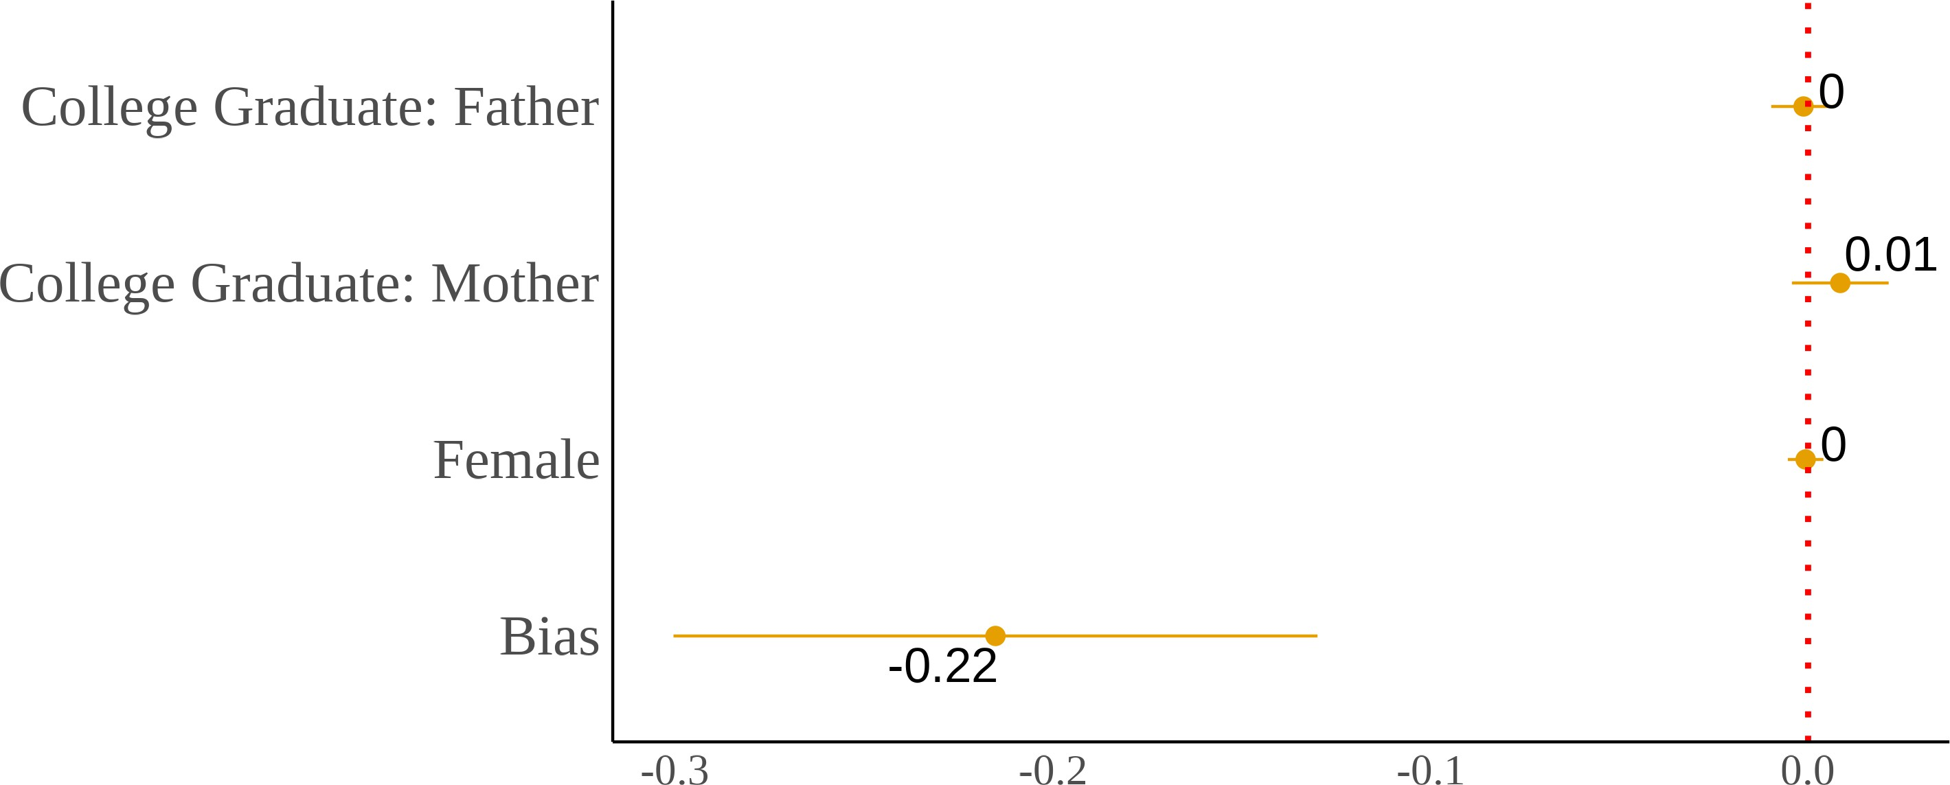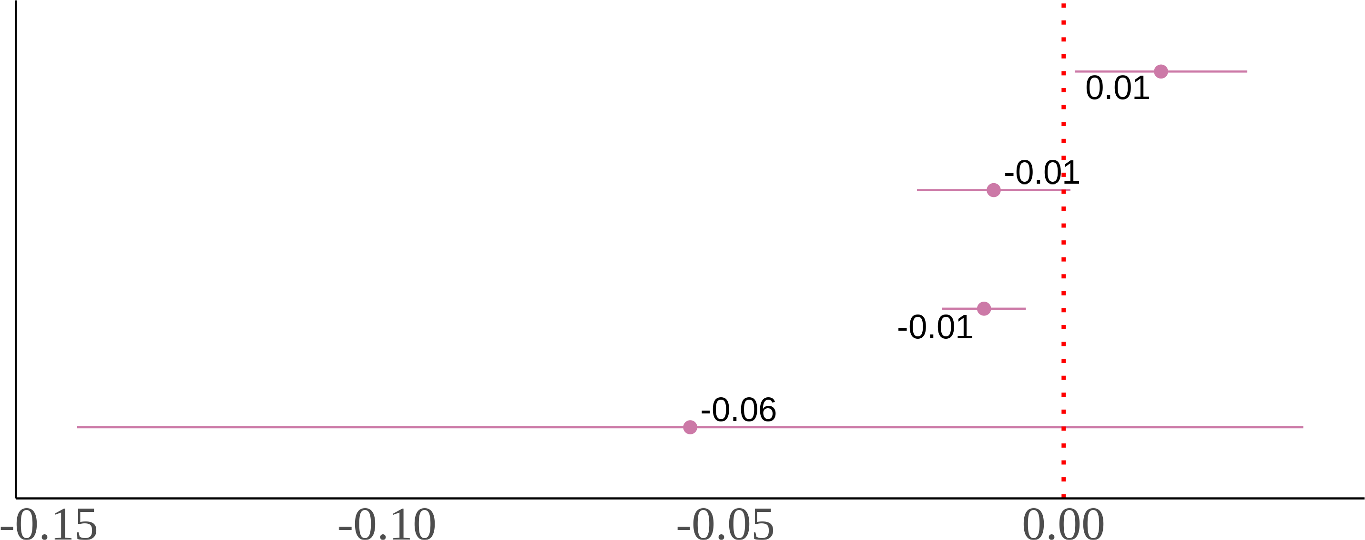

(c) Second-Generation (d) Third-Generation

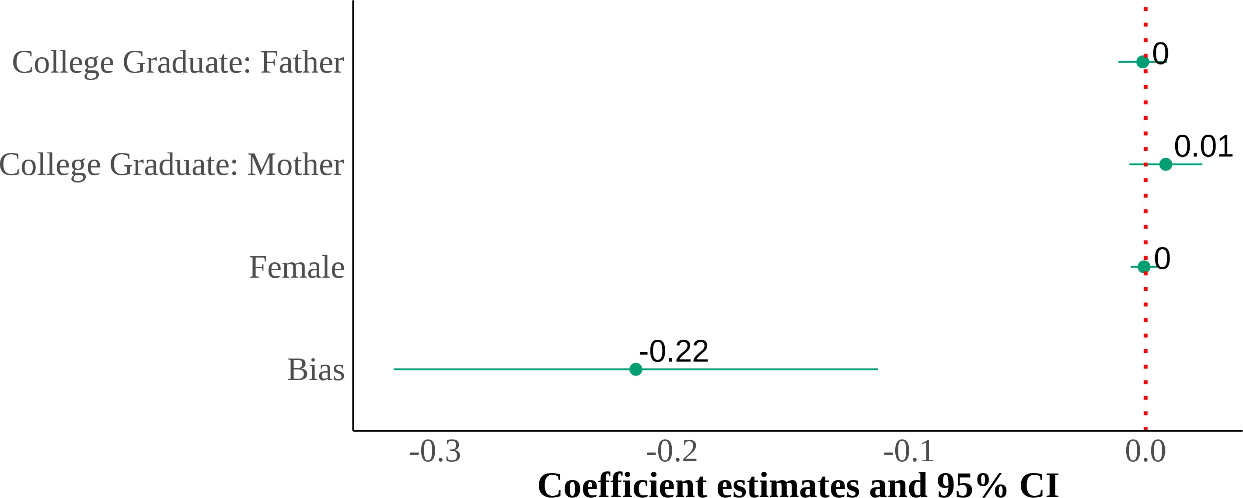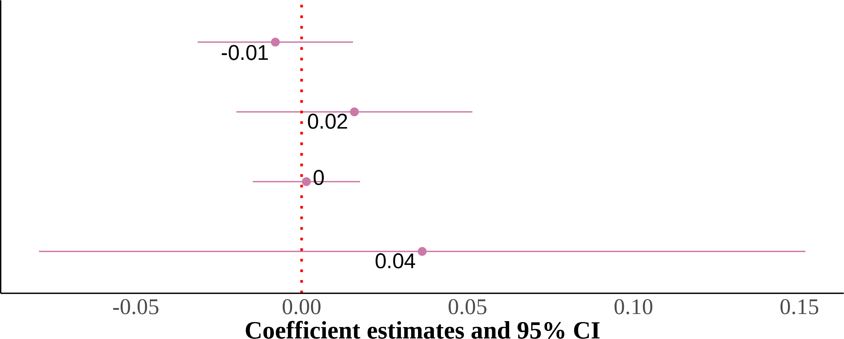

I show four panels of estimating the effect of county-level anti-Asian implicit bias. I include state and year fixed effects with controls for sex, quartic age, and parental education. The dependent variable is self-reported Asian identity and the independent variable is county-level bias. Each panel is the results from the same regression but on different samples that are divided by gener-ation. Standard errors are clustered on the state level. The samples include first-, second-, and third-generation Asian children ages 17 and below who live in intact families. First-generation Asian immigrants are children that were born in a Asian country. Native-born second-generation Asian immigrants are children with at least one parent born in a Asian country. Finally, native-born third-generation Asian immigrants are children with native-born parents and at least one grandparent born in a Asian country.

Figure A.3: Relationship Between Self-Reported Asian Identity and Bias: By Parental Types at the County Level

(a) Second-Generation (All Parental Types) (b) Asian Fathers-Asian Mothers

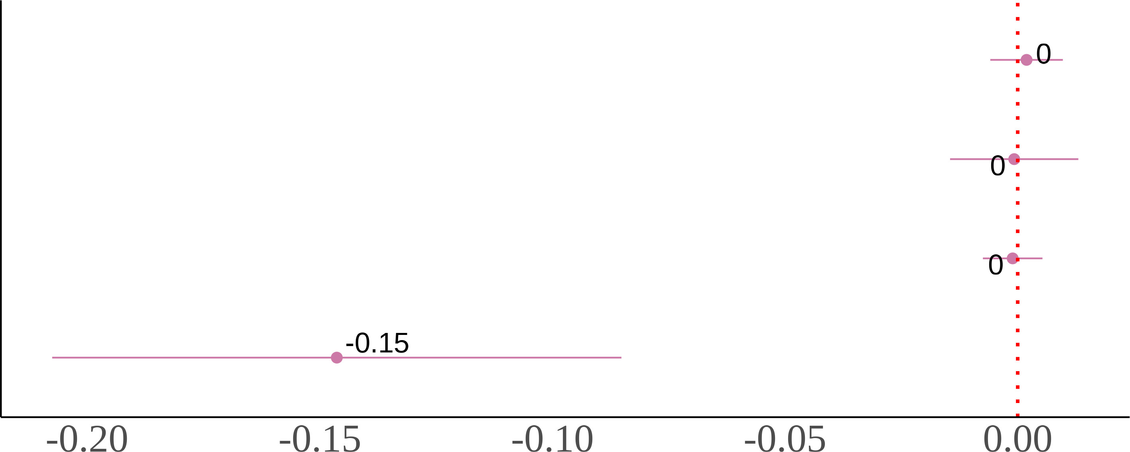

(c) Asian Fathers-White Mothers (d) White Fathers-Asian Mothers

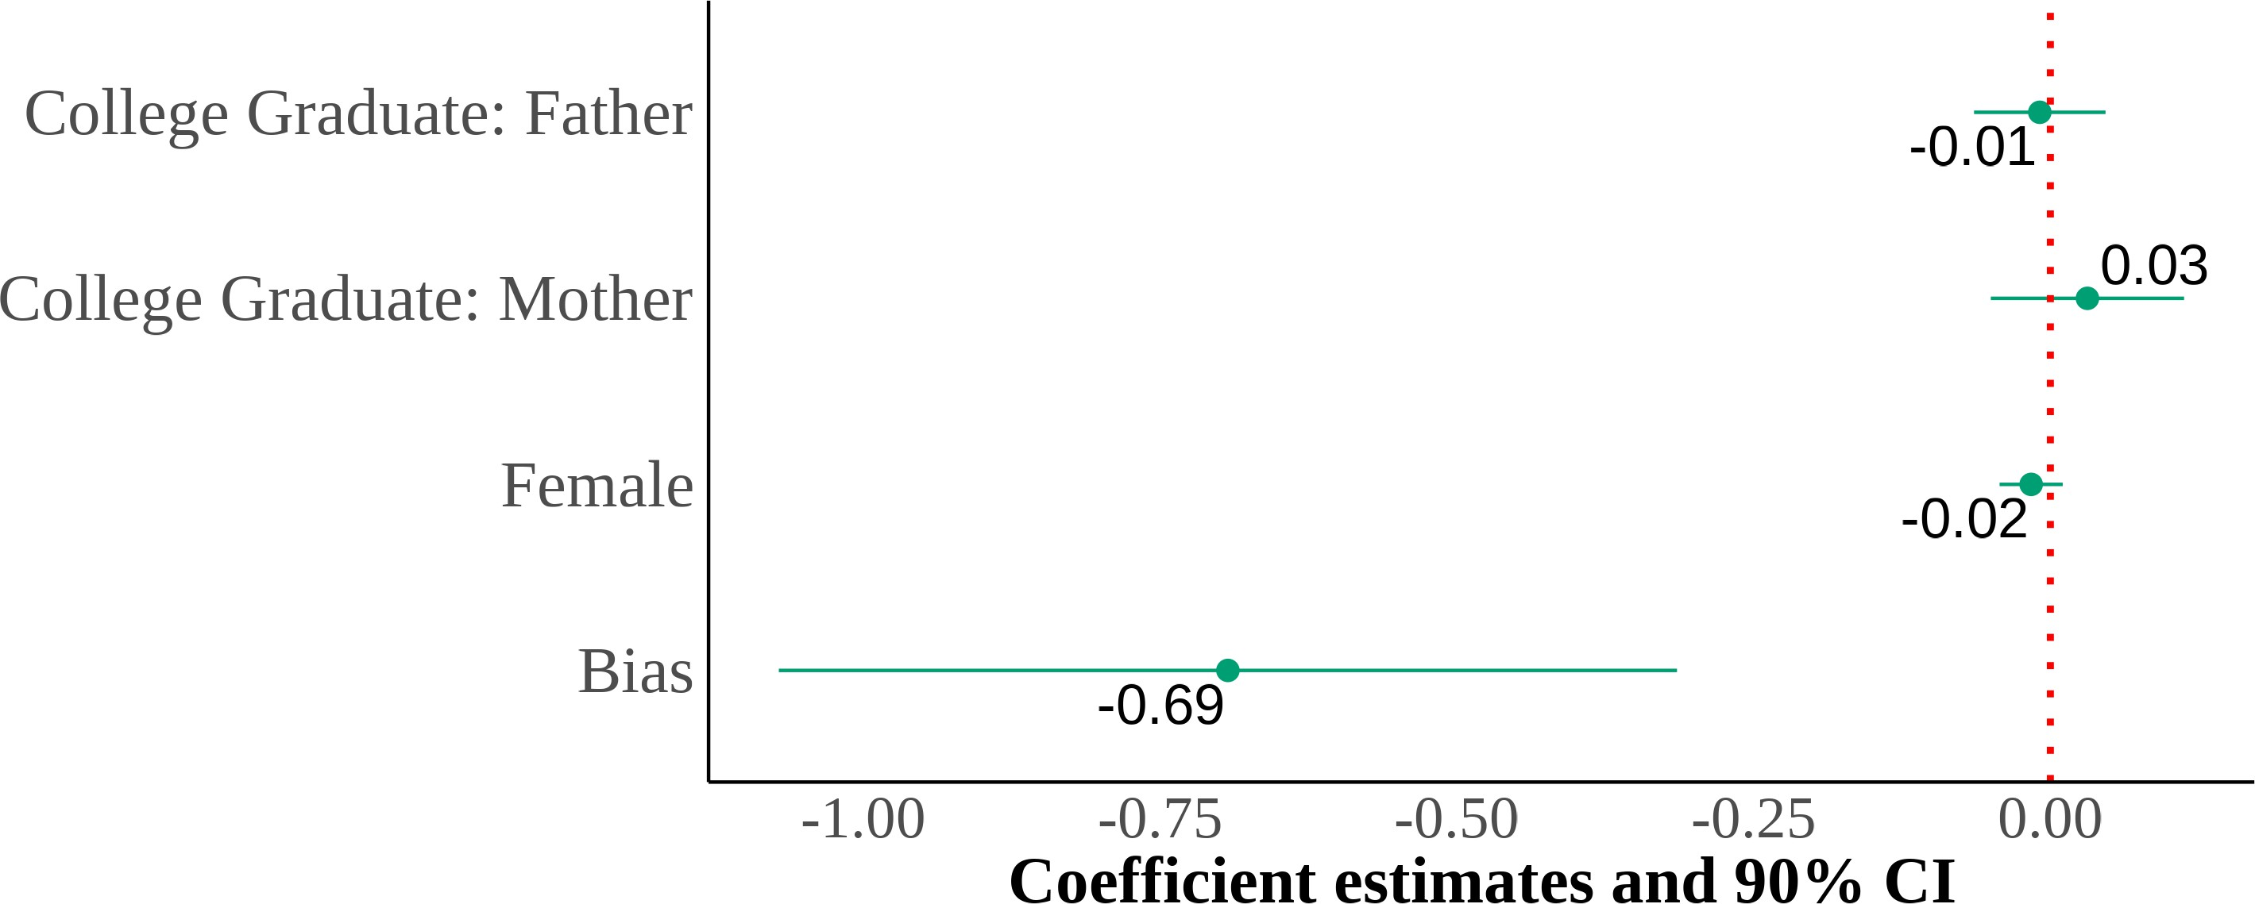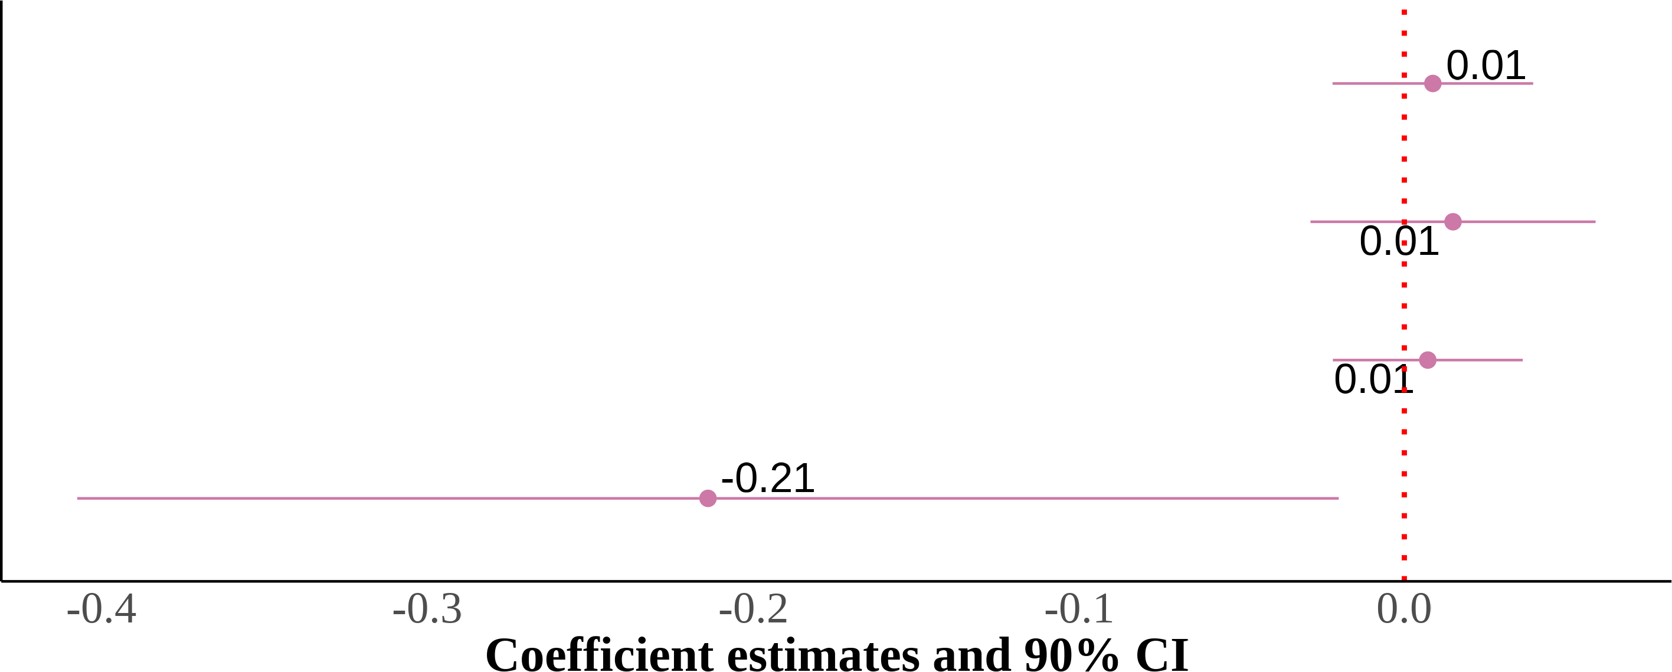

I show four panels of estimating the effect of county-level anti-Asian implicit bias—using the im-plicit association test (IAT) scores. I include state and year fixed effects with controls for sex, quartic age, and parental education. The dependent variable is self-reported Asian identity and the independent variable is county-level bias. Each panel results from the same regression but on different samples divided by parental types. Standard errors are clustered on the state level. The samples include second-generation Asian children ages 17 and below who live in intact fami-lies. Native-born second-generation Asian immigrant children with at least one parent born in an Asian country.

Figure A.4: Relationship Between Self-Reported Asian Identity and Bias: By Gen-eration at the MSA Level

(a) All Generations (b) First-Generation

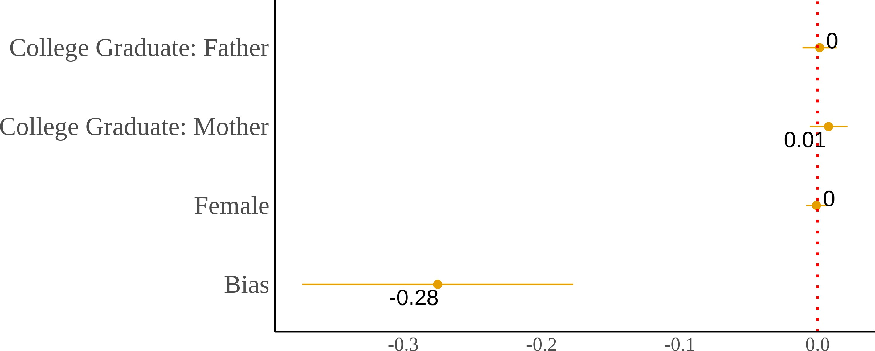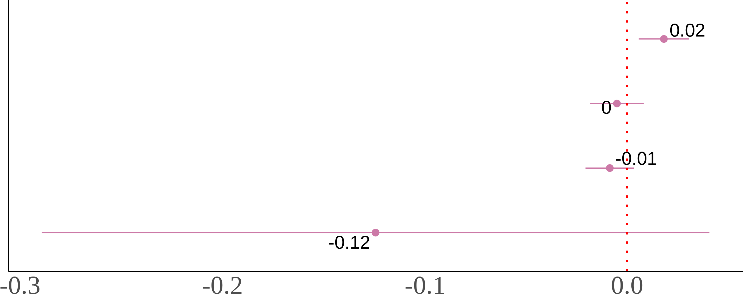

(c) Second-Generation (d) Third-Generation

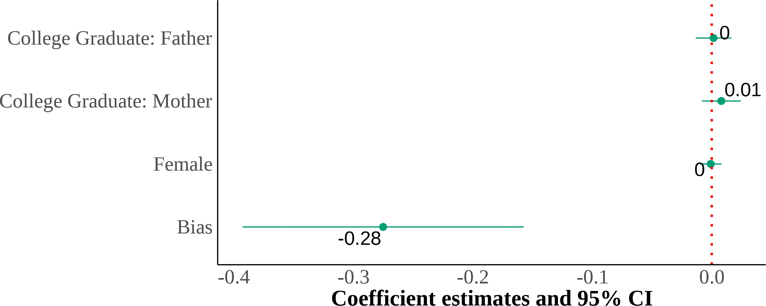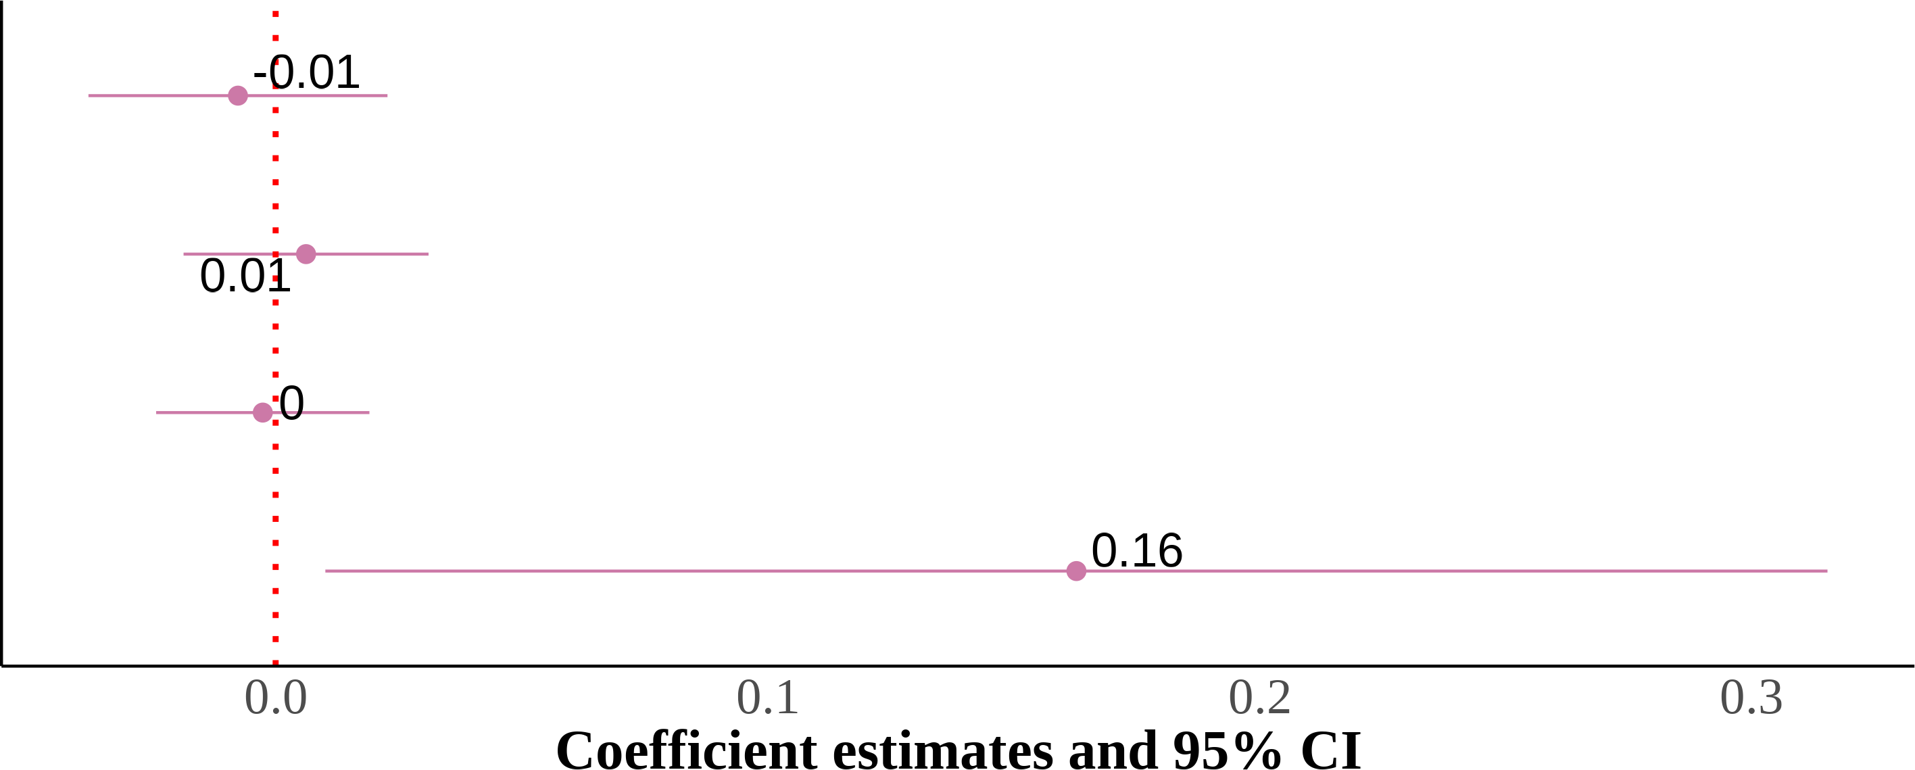

I show four panels of estimating the effect of MSA-level anti-Asian implicit bias. I include state and year fixed effects with controls for sex, quartic age, and parental education. The dependent variable is self-reported Asian identity and the independent variable is MSA-level bias. Each panel is the results from the same regression but on different samples that are divided by generation. Standard errors are clustered on the state level. The samples include first-, second-, and third-generation Asian children ages 17 and below who live in intact families. First-generation Asian immigrants are children that were born in a Asian country. Native-born second-generation Asian immigrants are children with at least one parent born in a Asian country. Finally, native-born third-generation Asian immigrants are children with native-born parents and at least one grandparent born in a Asian country.

Figure A.5: Relationship Between Self-Reported Asian Identity and Bias: By Parental Types at the MSA Level

(a) Second-Generation (All Parental Types) (b) Asian Fathers-Asian Mothers



(c) Asian Fathers-White Mothers (d) White Fathers-Asian Mothers



I show four panels of estimating the effect of county-level anti-Asian implicit bias—using the im-plicit association test (IAT) scores. I include state and year fixed effects with controls for sex, quartic age, and parental education. The dependent variable is self-reported Asian identity and the independent variable is county-level bias. Each panel results from the same regression but on different samples divided by parental types. Standard errors are clustered on the state level. The samples include second-generation Asian children ages 17 and below who live in intact fami-lies. Native-born second-generation Asian immigrant children with at least one parent born in an Asian country.

Figure A.6: Interaction Effects of Anti-Asian Bias with Gender and Parental Edu-cation: By Mixed Parental Types Among Adults

(a) Asian Fathers-White Mothers (b) White Fathers-Asian Mothers

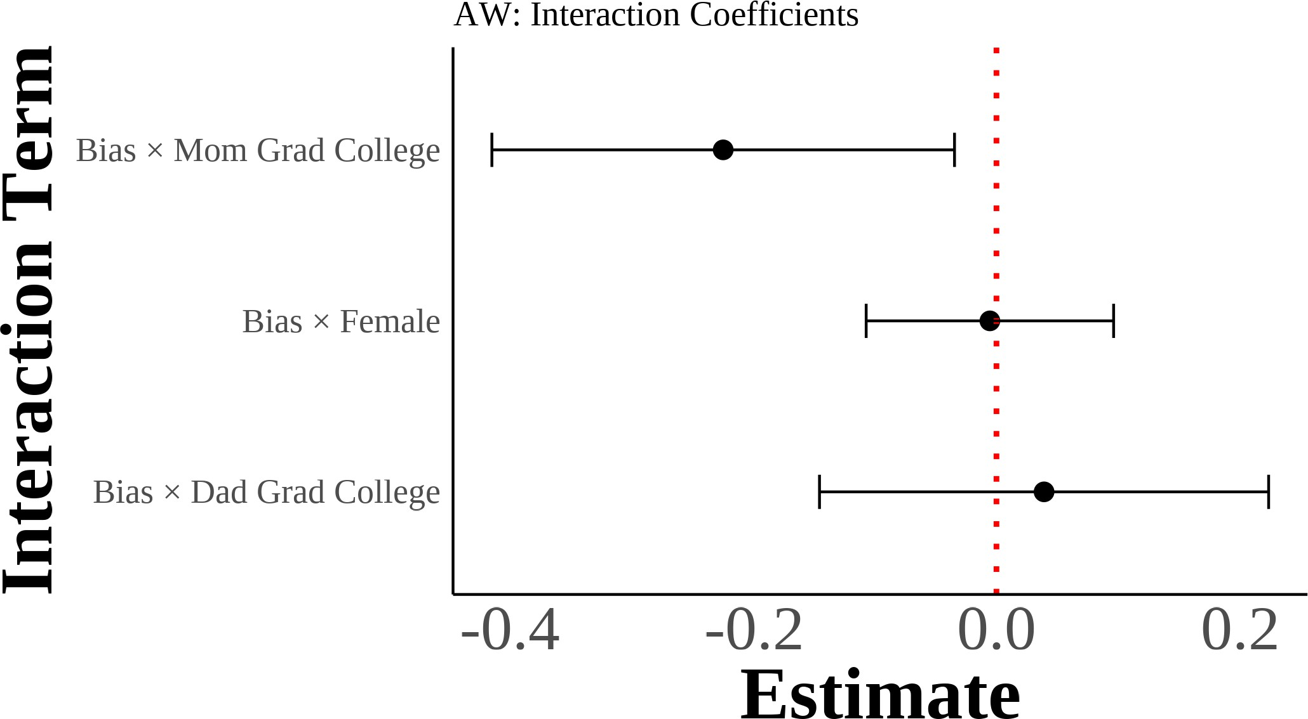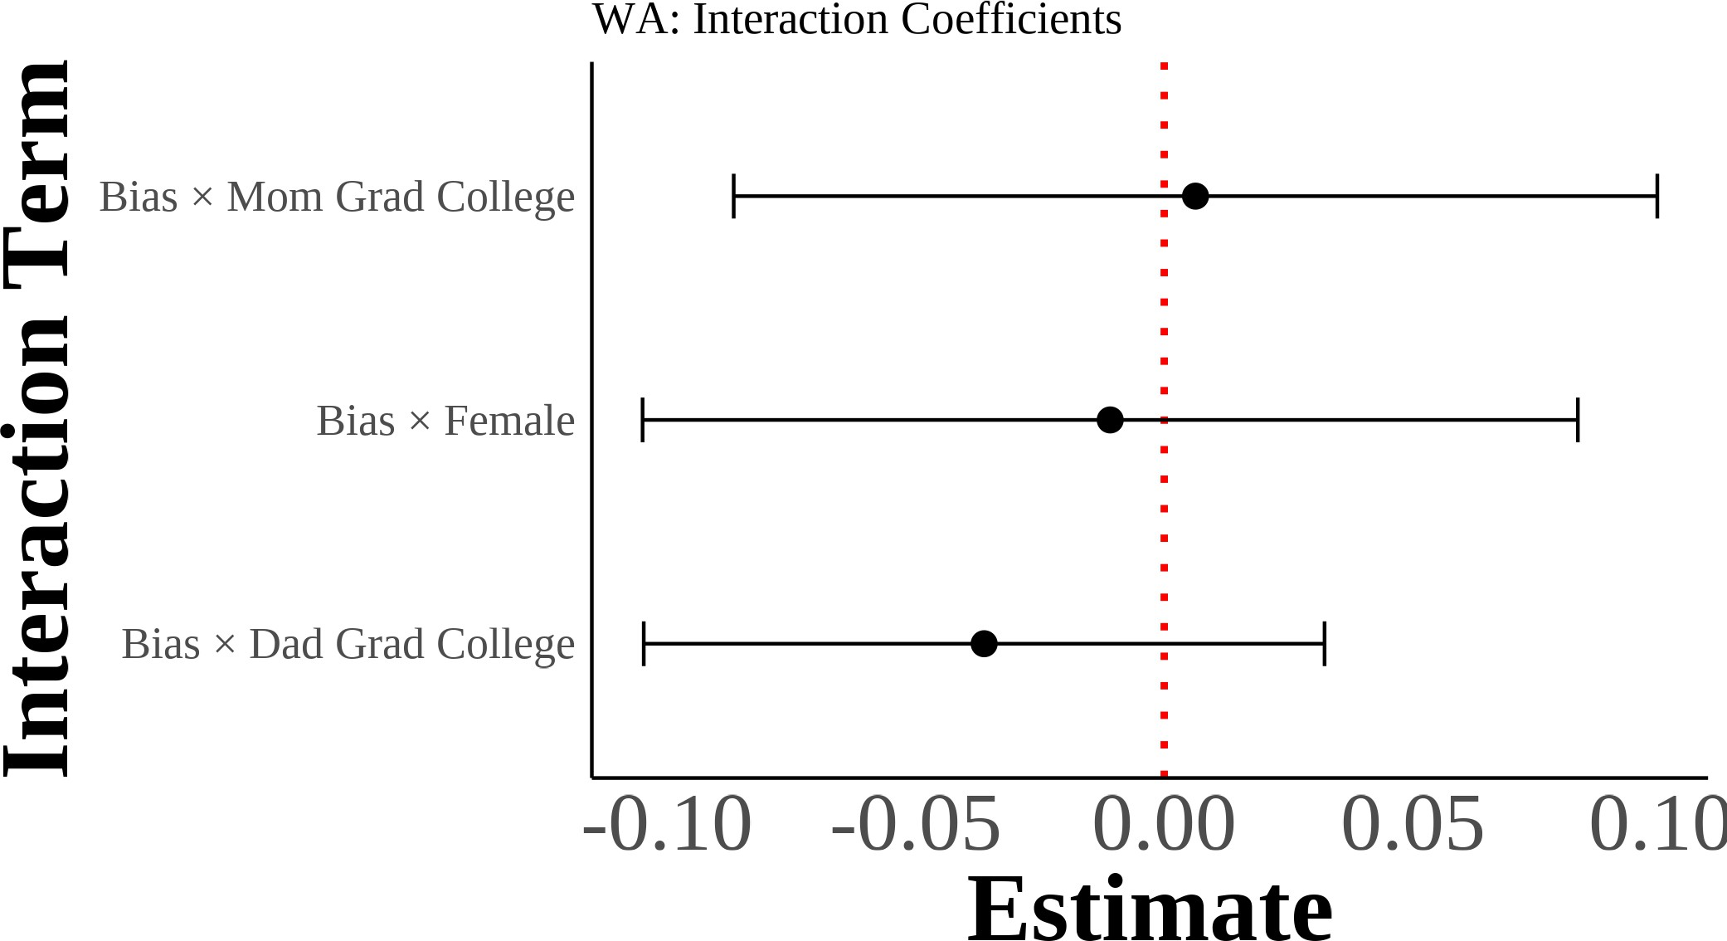

I show interaction coefficients from estimating equation (4) with interaction terms for gender and parental education. I include region *×* year fixed effects with controls for sex, quartic age, years of education, and the inverse hyperbolic sine of income. The dependent variable is self-reported Asian identity and the independent variables include demeaned state-level bias interacted with gender and parental education indicators. Each panel results from separate regressions on dif-ferent samples divided by mixed parental types. Standard errors are clustered on the state level. The samples include second-generation Asian individuals ages 18 and above with mixed-race parentage. Native-born second-generation Asian immigrant individuals with one parent born in an Asian country and one parent born outside of Asia.

Figure A.7: Interaction Effects of Anti-Asian Bias with Gender and Parental Edu-cation: By Asian Grandparent Count Among Third Generation

(a) One Asian Grandparent (b) Two Asian Grandparents

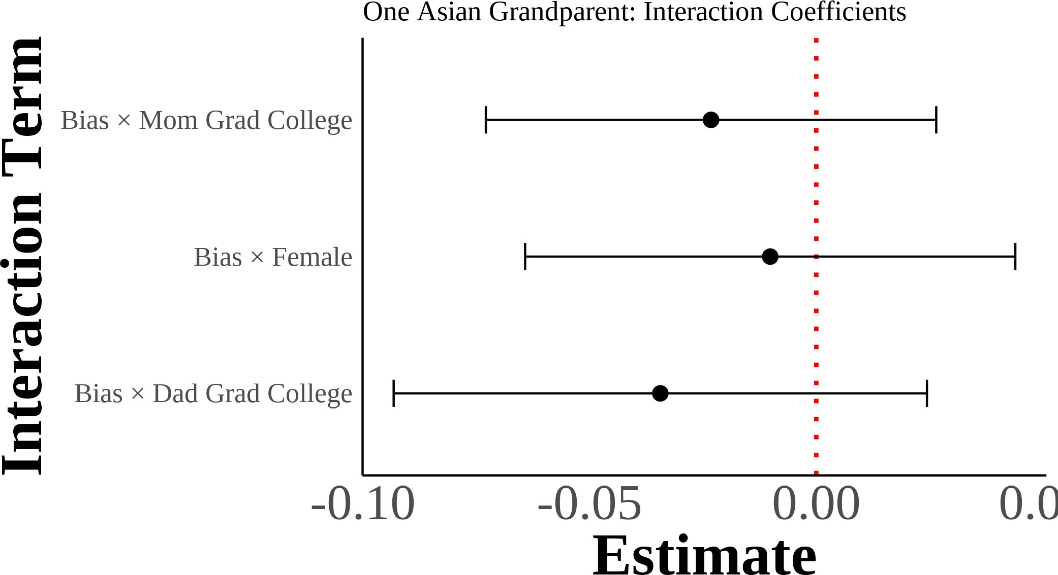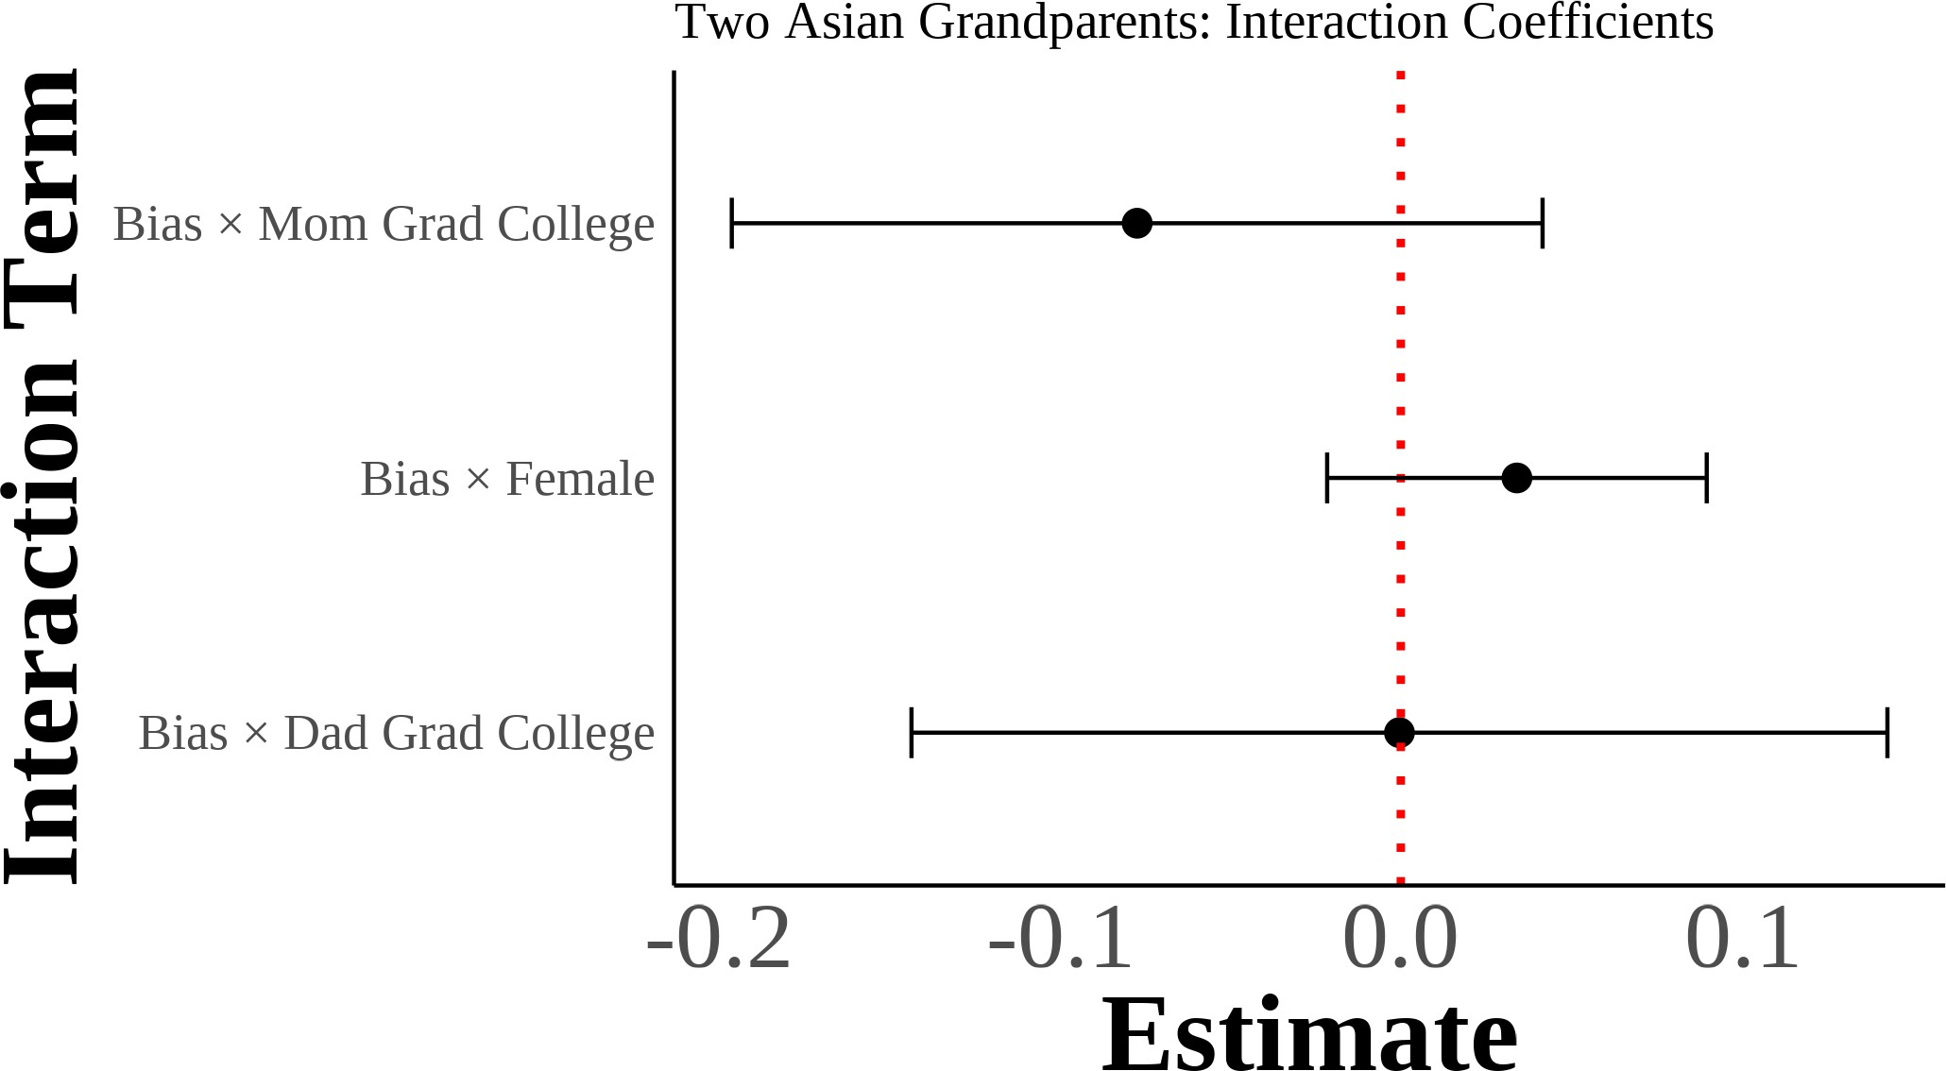

(c) Three Asian Grandparents

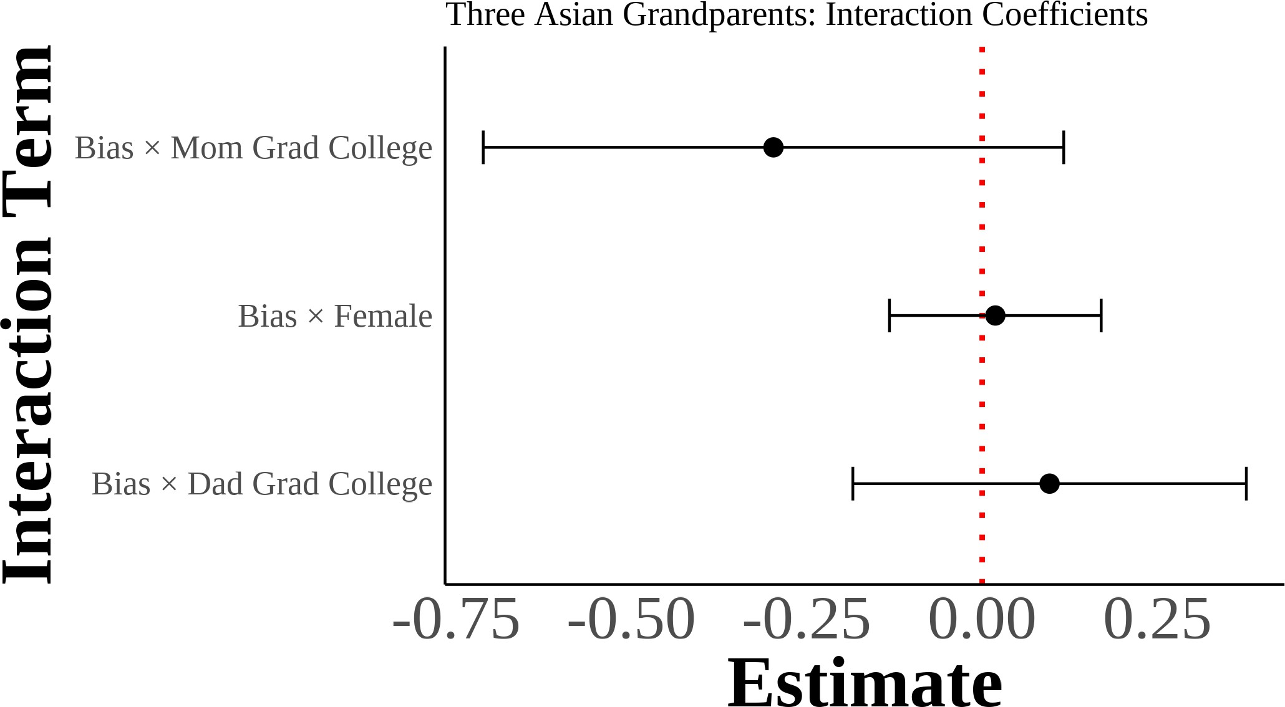

I show interaction coefficients from estimating equation (4) with interaction terms for gender and parental education on third-generation samples. I include region *×* year fixed effects with controls for sex, quartic age, years of education, and the inverse hyperbolic sine of income. The dependent variable is self-reported Asian identity and the independent variables include demeaned state-level bias interacted with gender and parental education indicators. Each panel results from sep-arate regressions on different samples divided by the number of Asian grandparents. Standard errors are clustered on the state level. The samples include third-generation Asian individuals with varying degrees of Asian ancestry through grandparents. Native-born third-generation indi-viduals with at least one grandparent born in an Asian country.

Figure A.8: Multinomial Logit Model: Predicted Probabilities of Racial Identity Choice by Key Covariates (Second-Generation Asian Americans with Asian Fa-thers and White Mothers)

(a) Anti-Asian Bias (b) Female

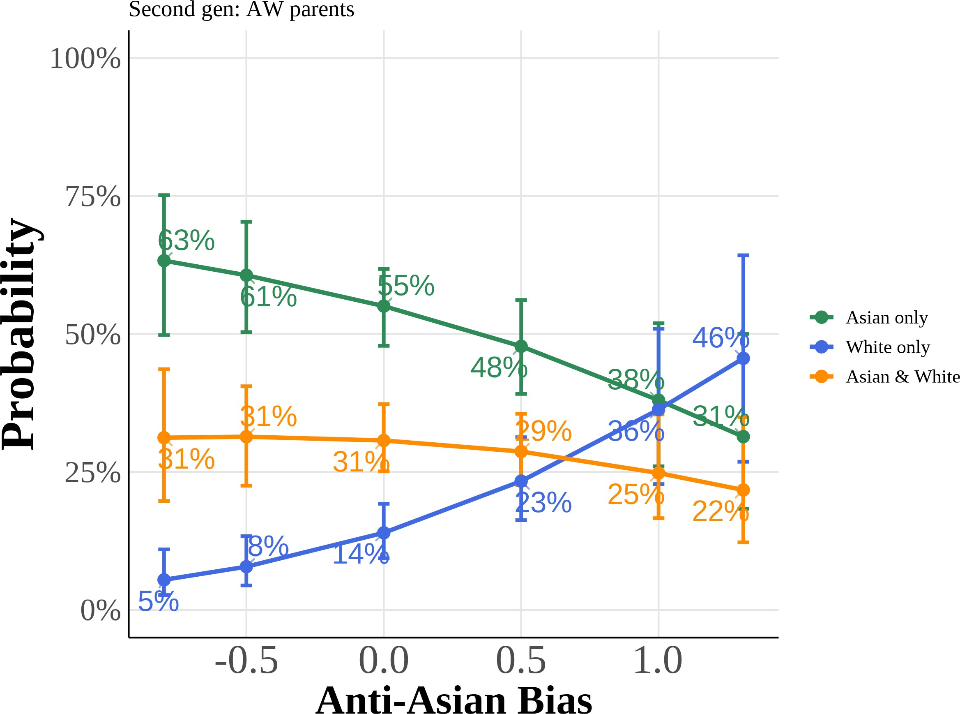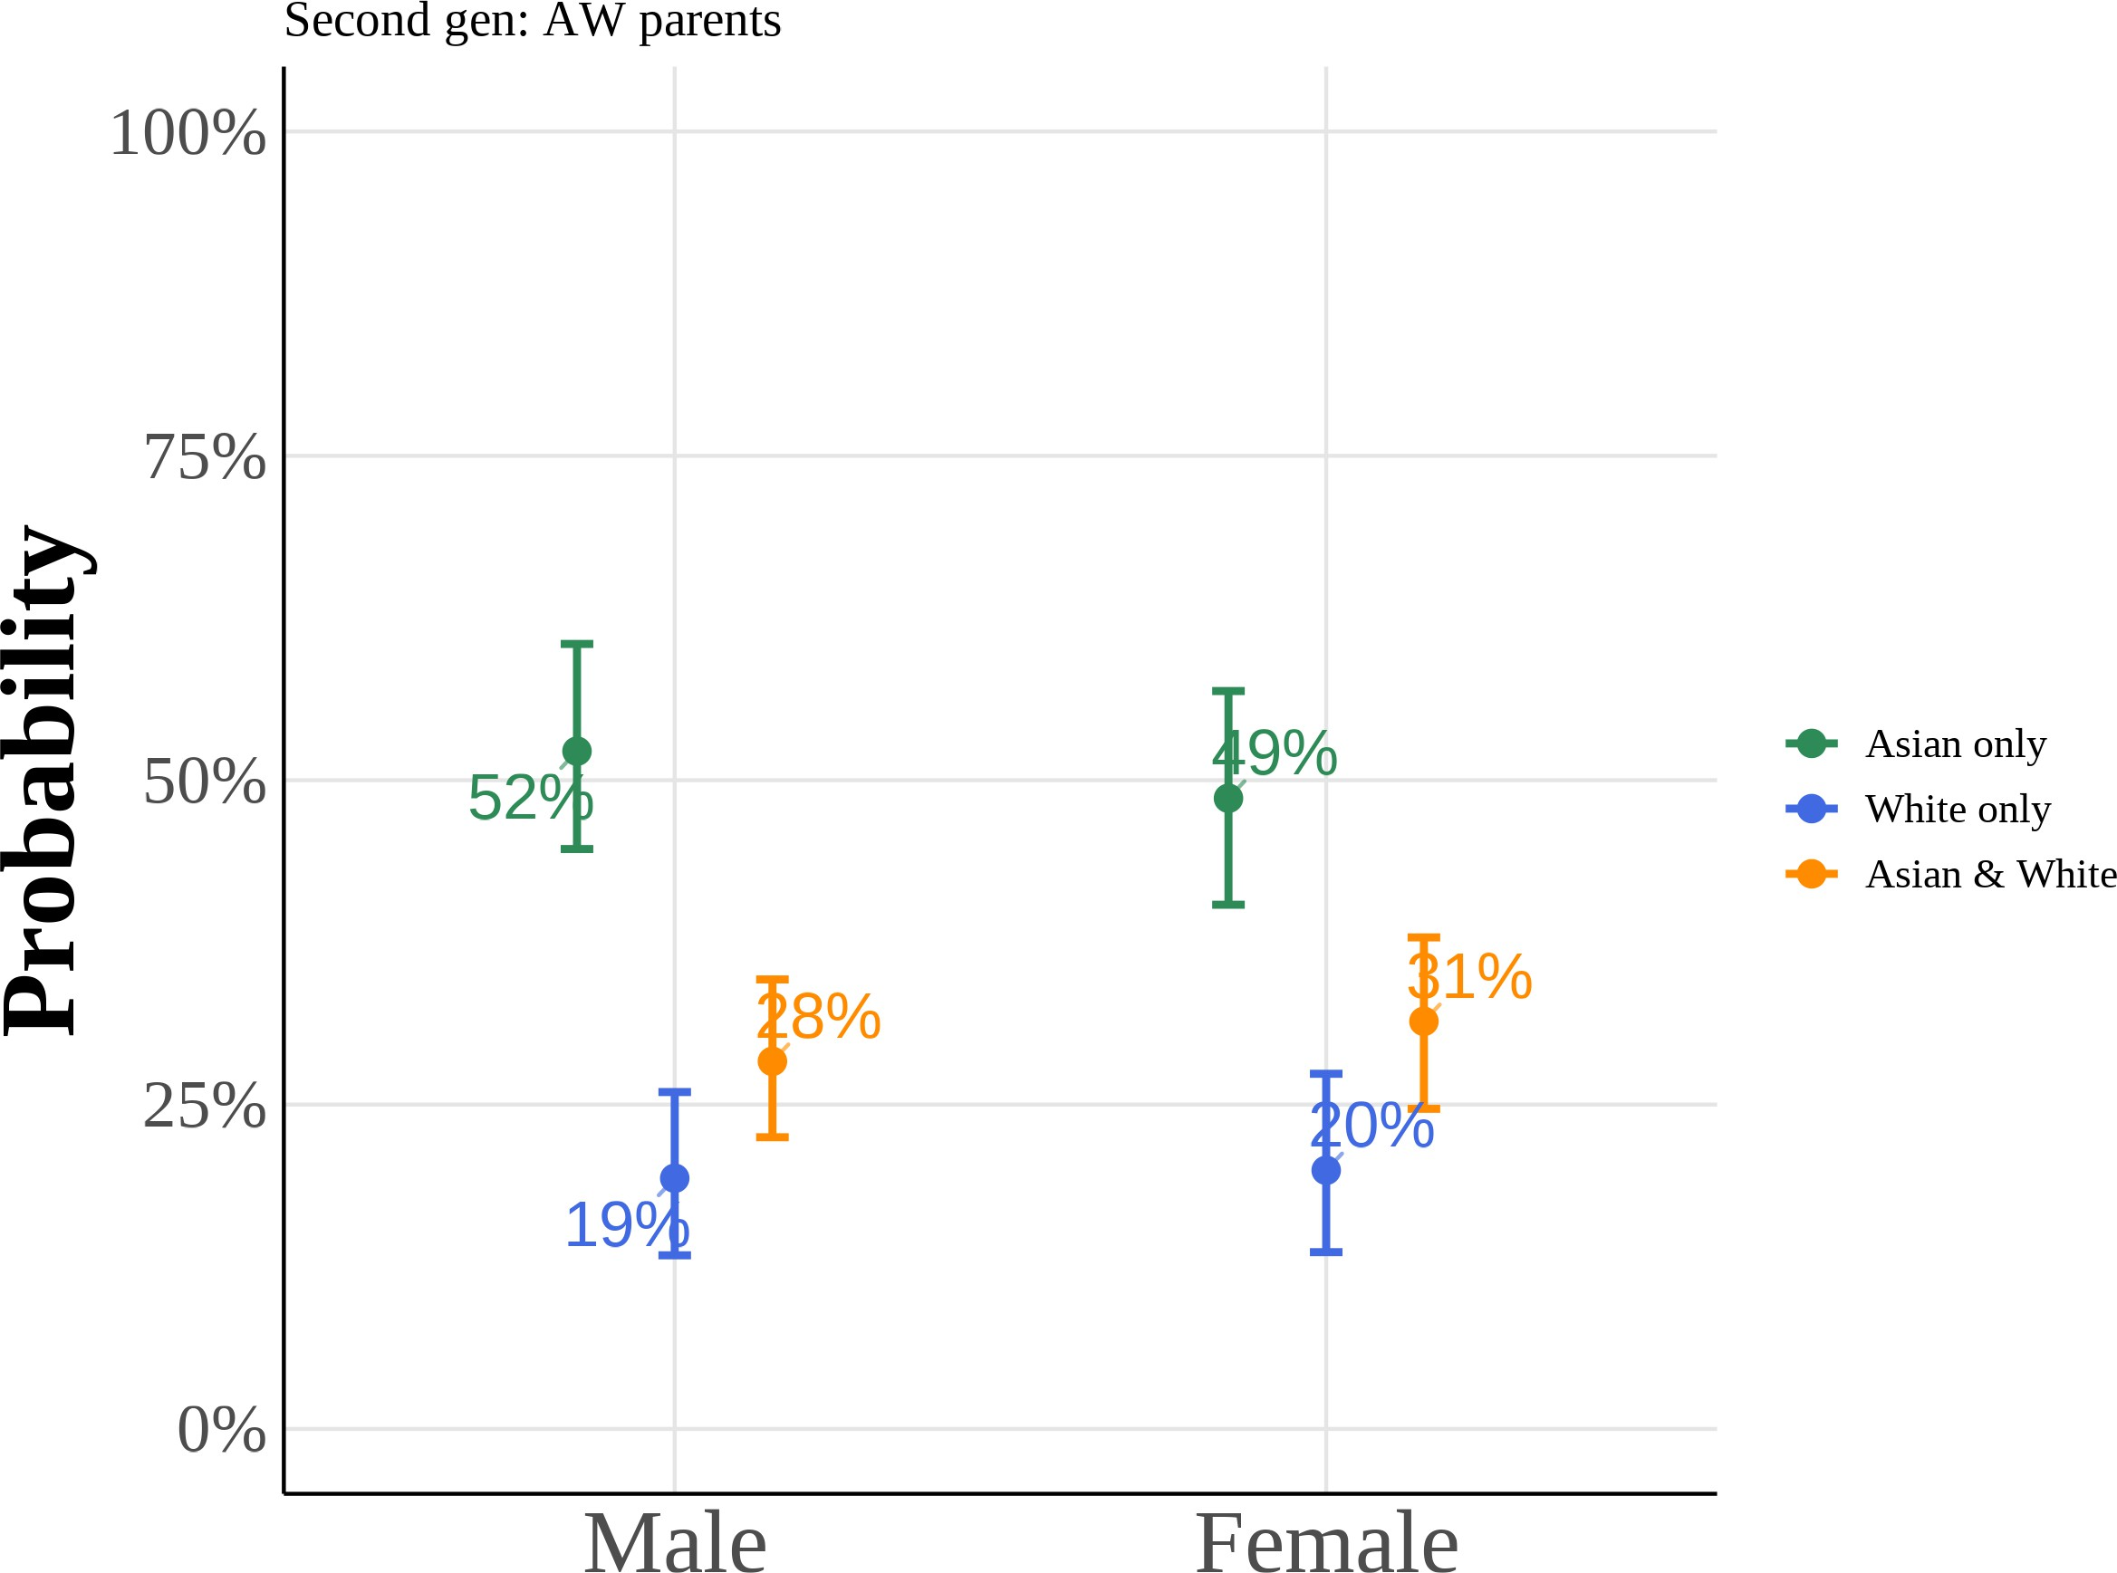

(c) College Graduate: Mother (d) College Graduate: Father

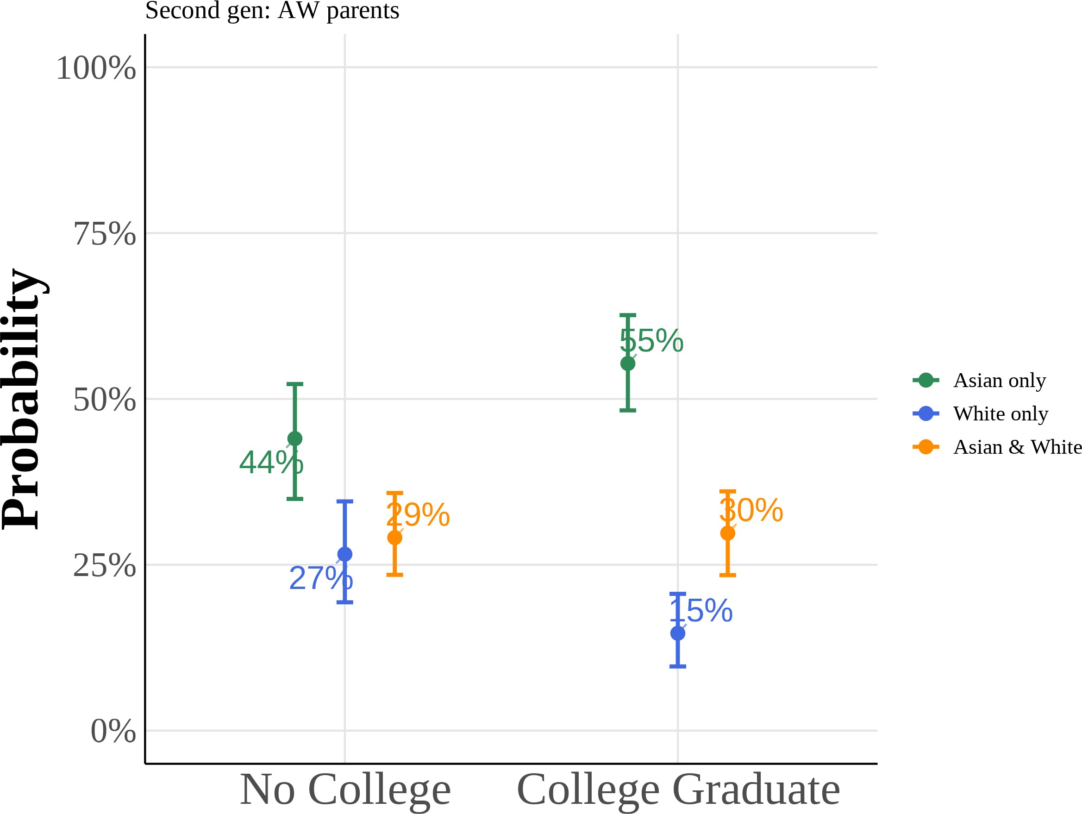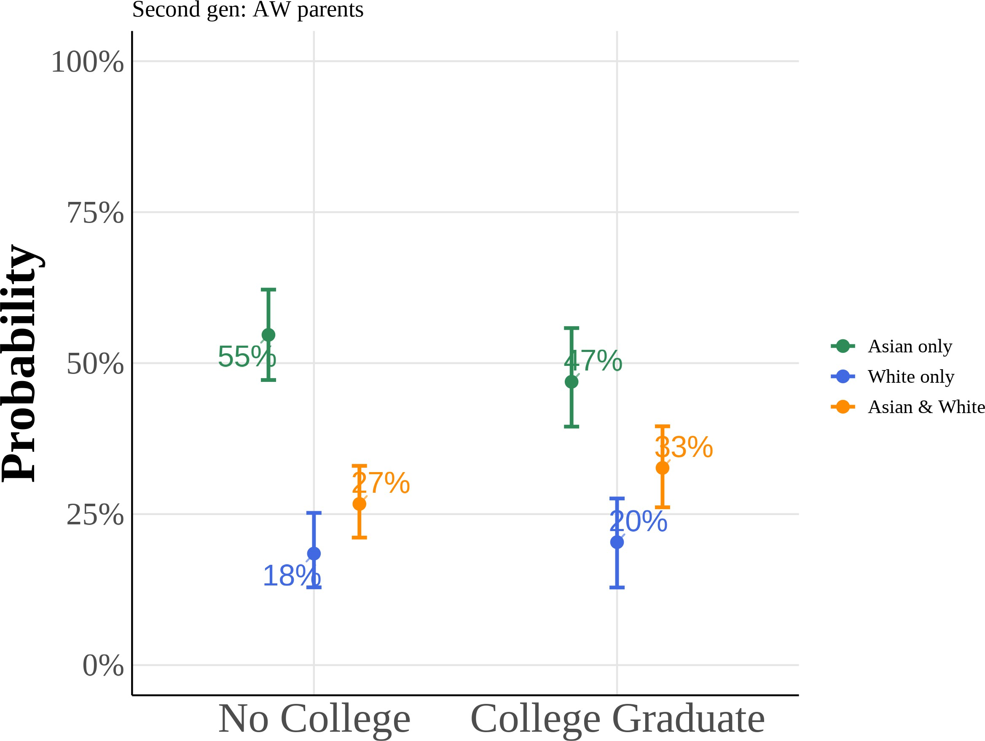

This figure shows predicted probabilities from estimating equation (5) using a multinomial logit model for the subsample of second-generation Asian Americans with Asian fathers and White mothers. The model estimates the probability of choosing “Asian only”, “White only”, or “Asian and White” racial identification as a function of anti-Asian bias, gender, and parental education. I include region *×* year fixed effects with controls for quartic age and local Asian population share. All other variables are held at their sample means. Reported curves depict the median predicted probability across 1,000 bootstrap resamples, and 95% confidence intervals follow the correspond-ing bootstrap percentile limits.

Figure A.9: Multinomial Logit Model: Predicted Probabilities of Racial Identity Choice by Key Covariates (Second-Generation Asian Americans with White Fa-thers and Asian Mothers)

(a) Anti-Asian Bias (b) Female

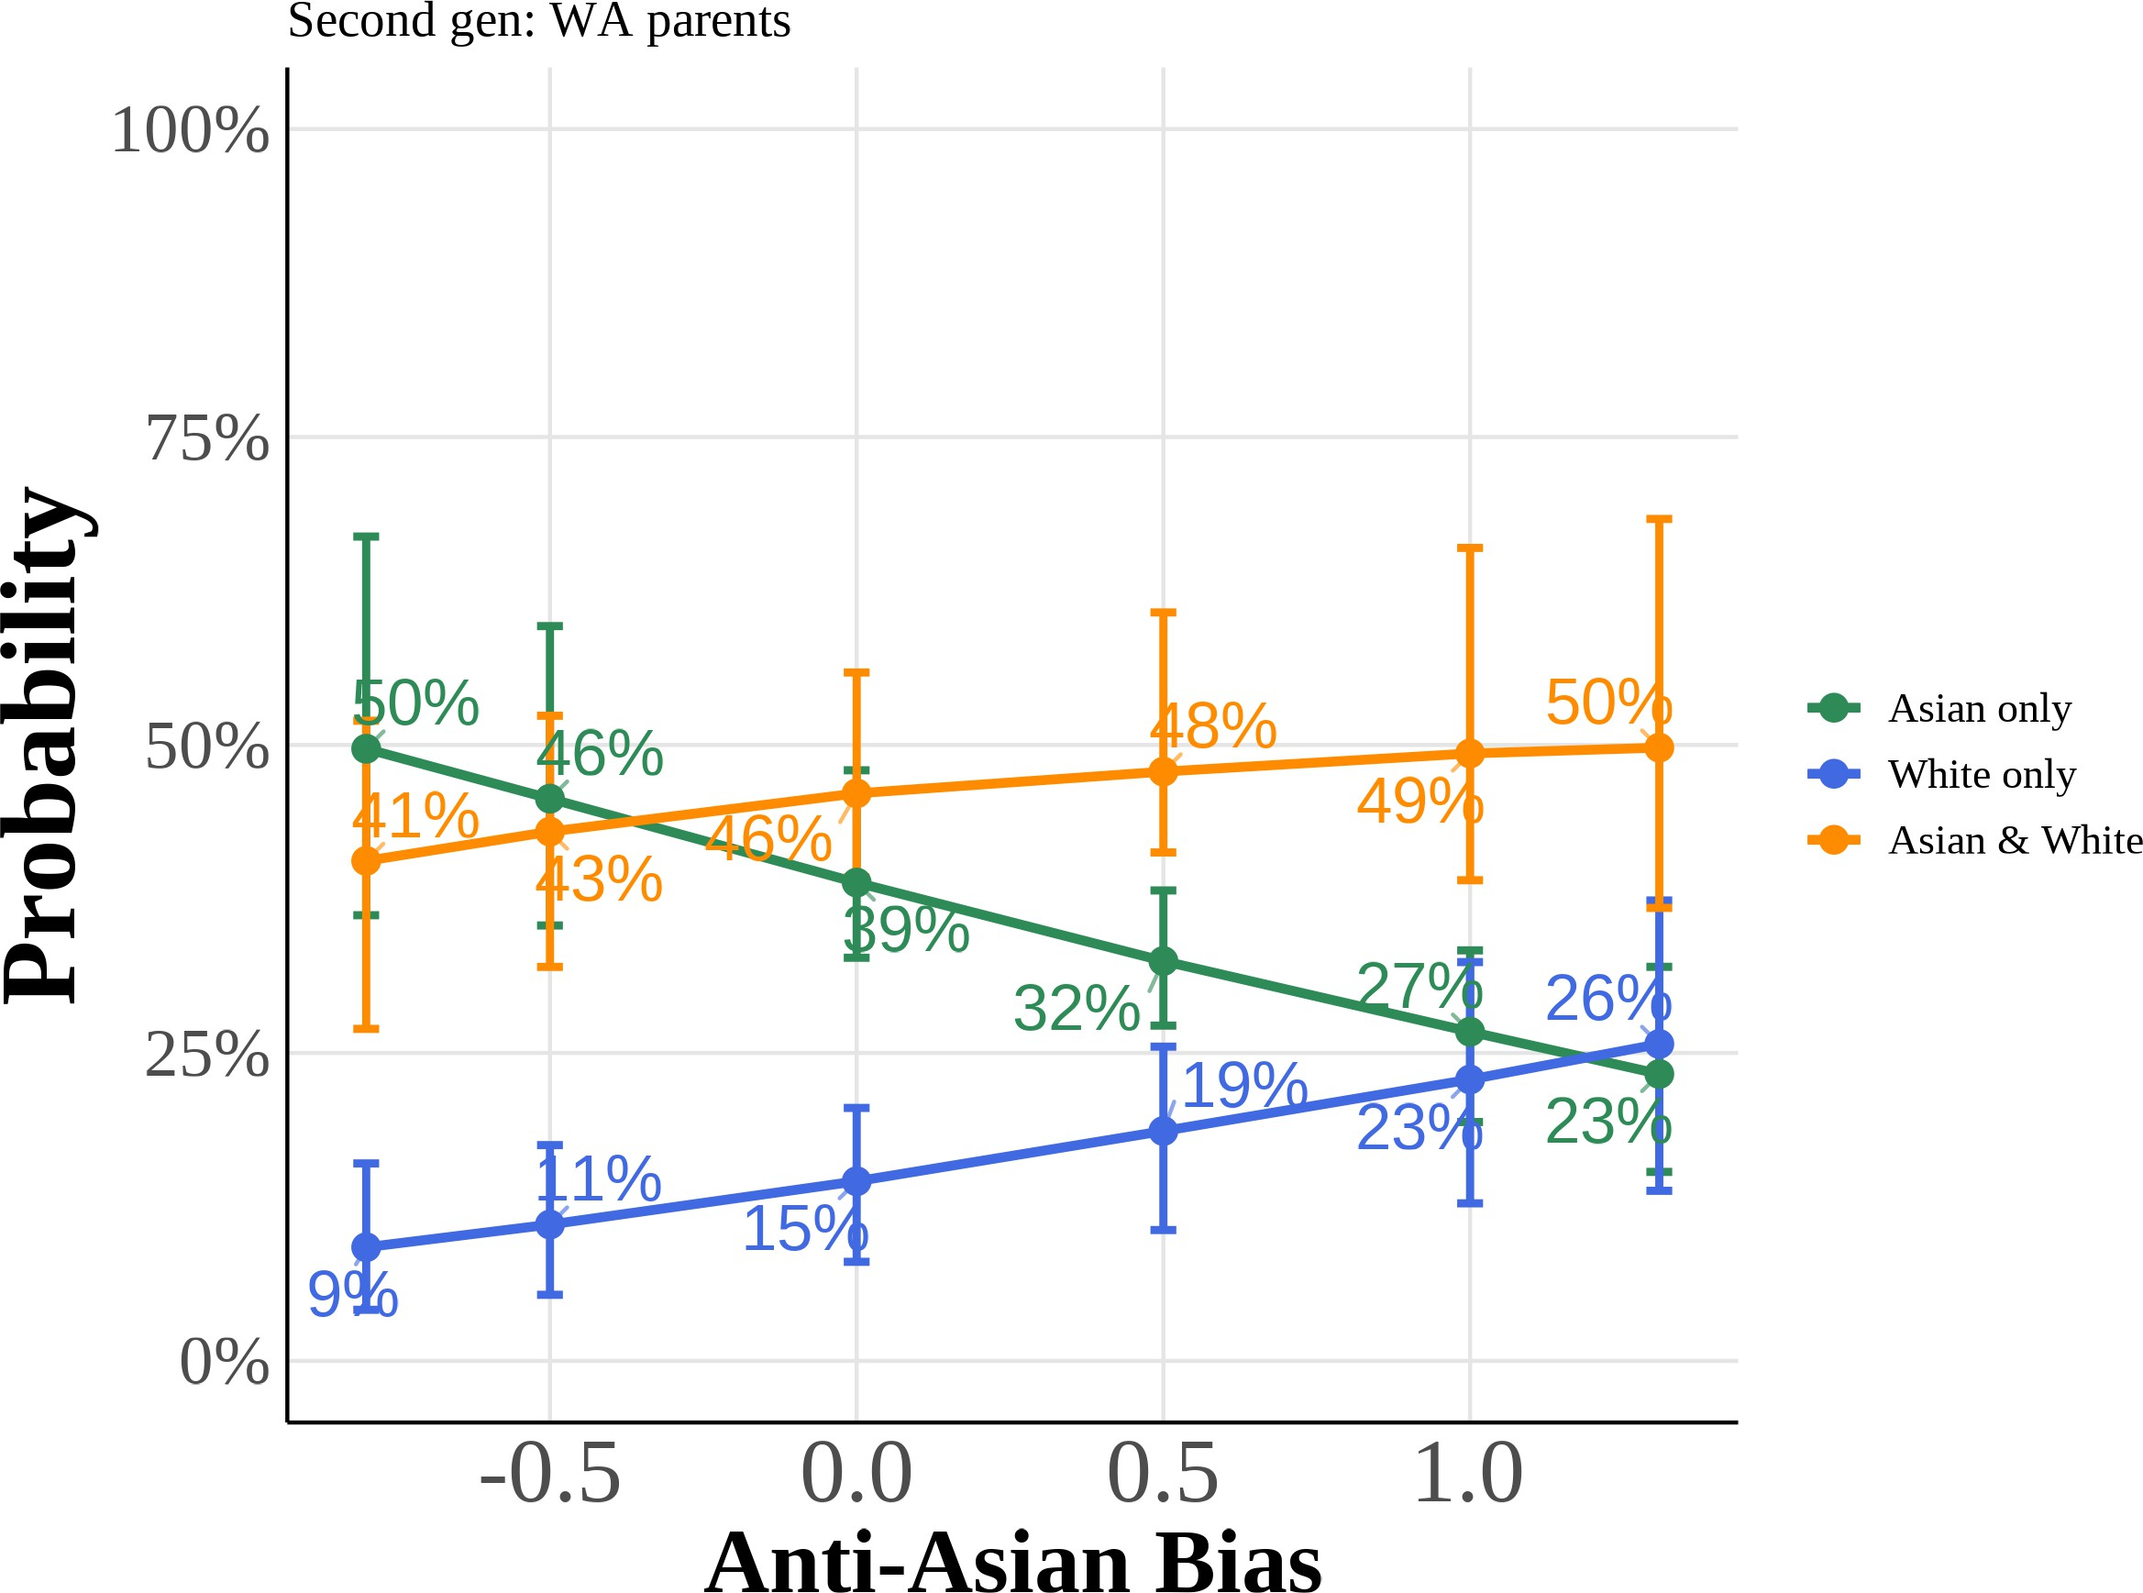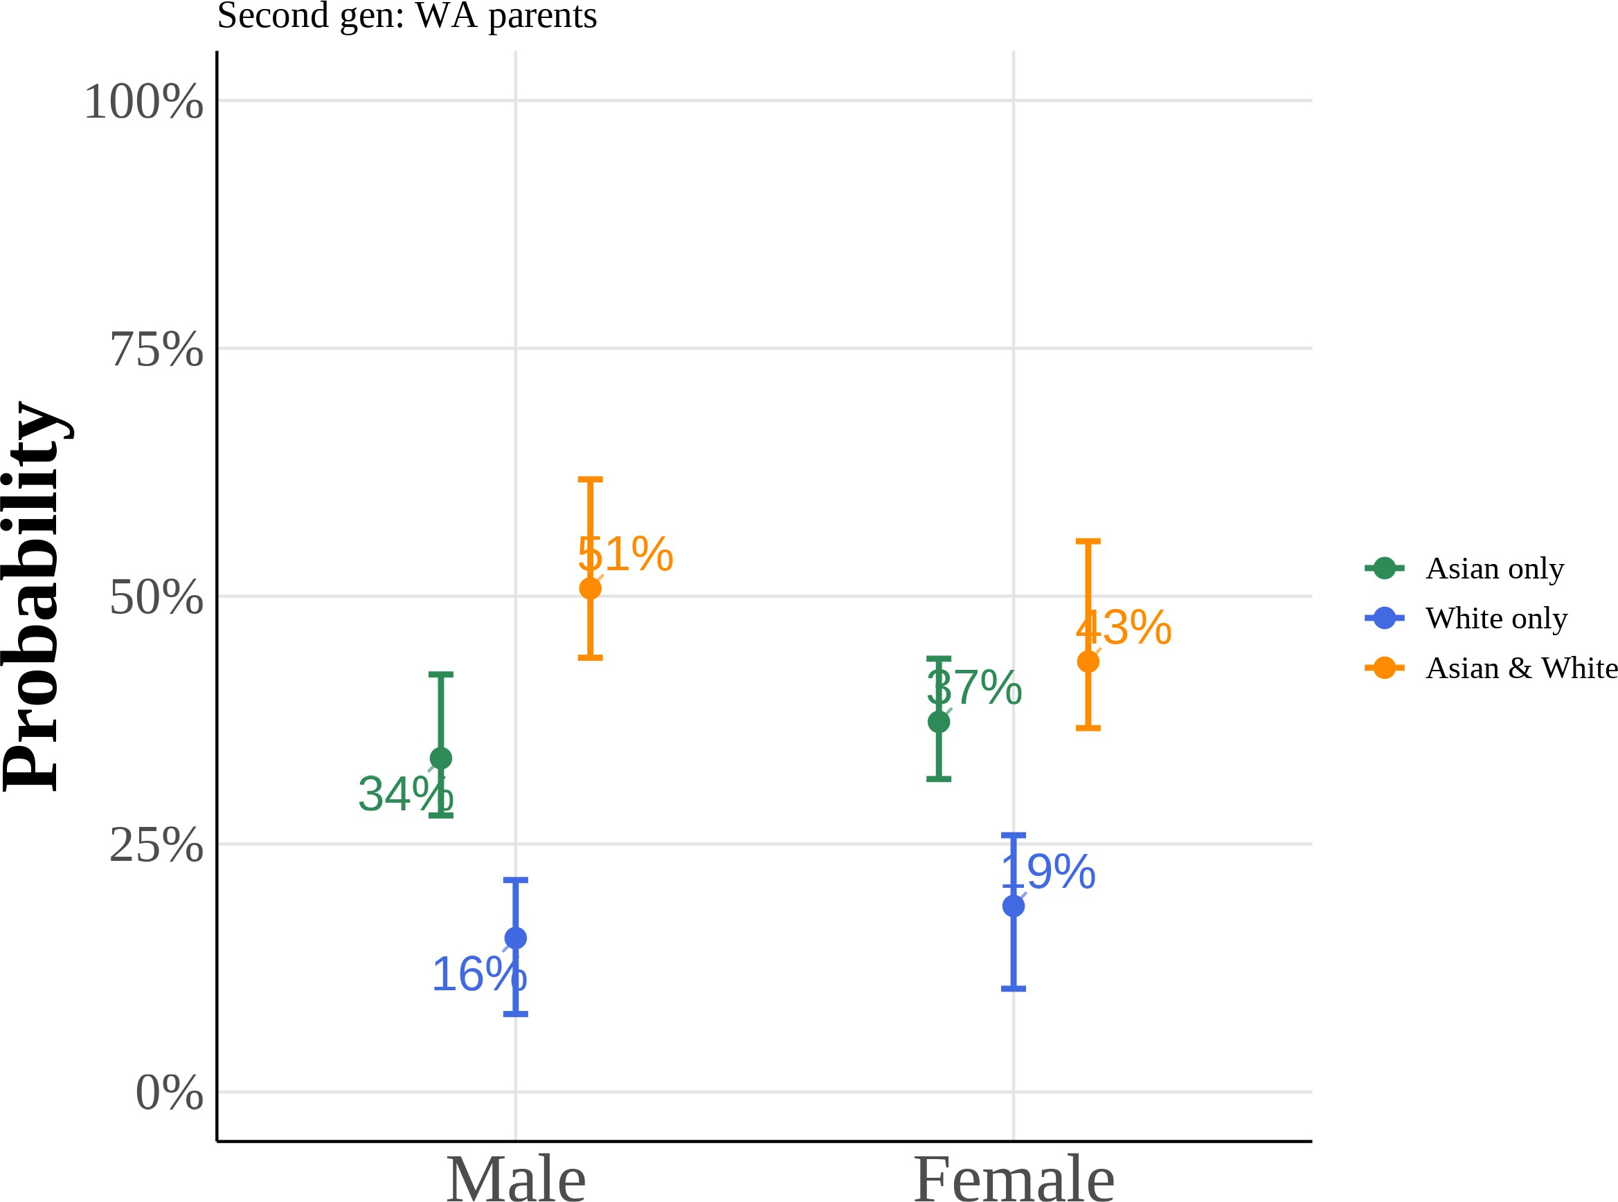

(c) College Graduate: Mother (d) College Graduate: Father

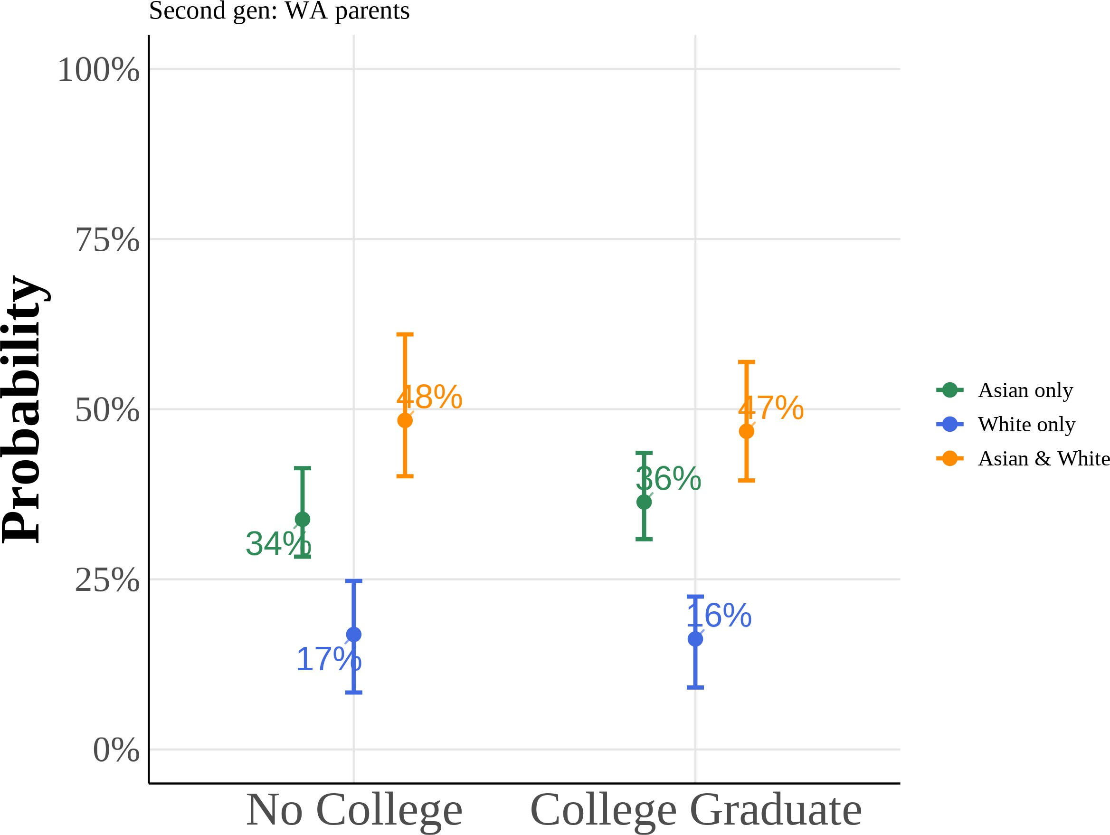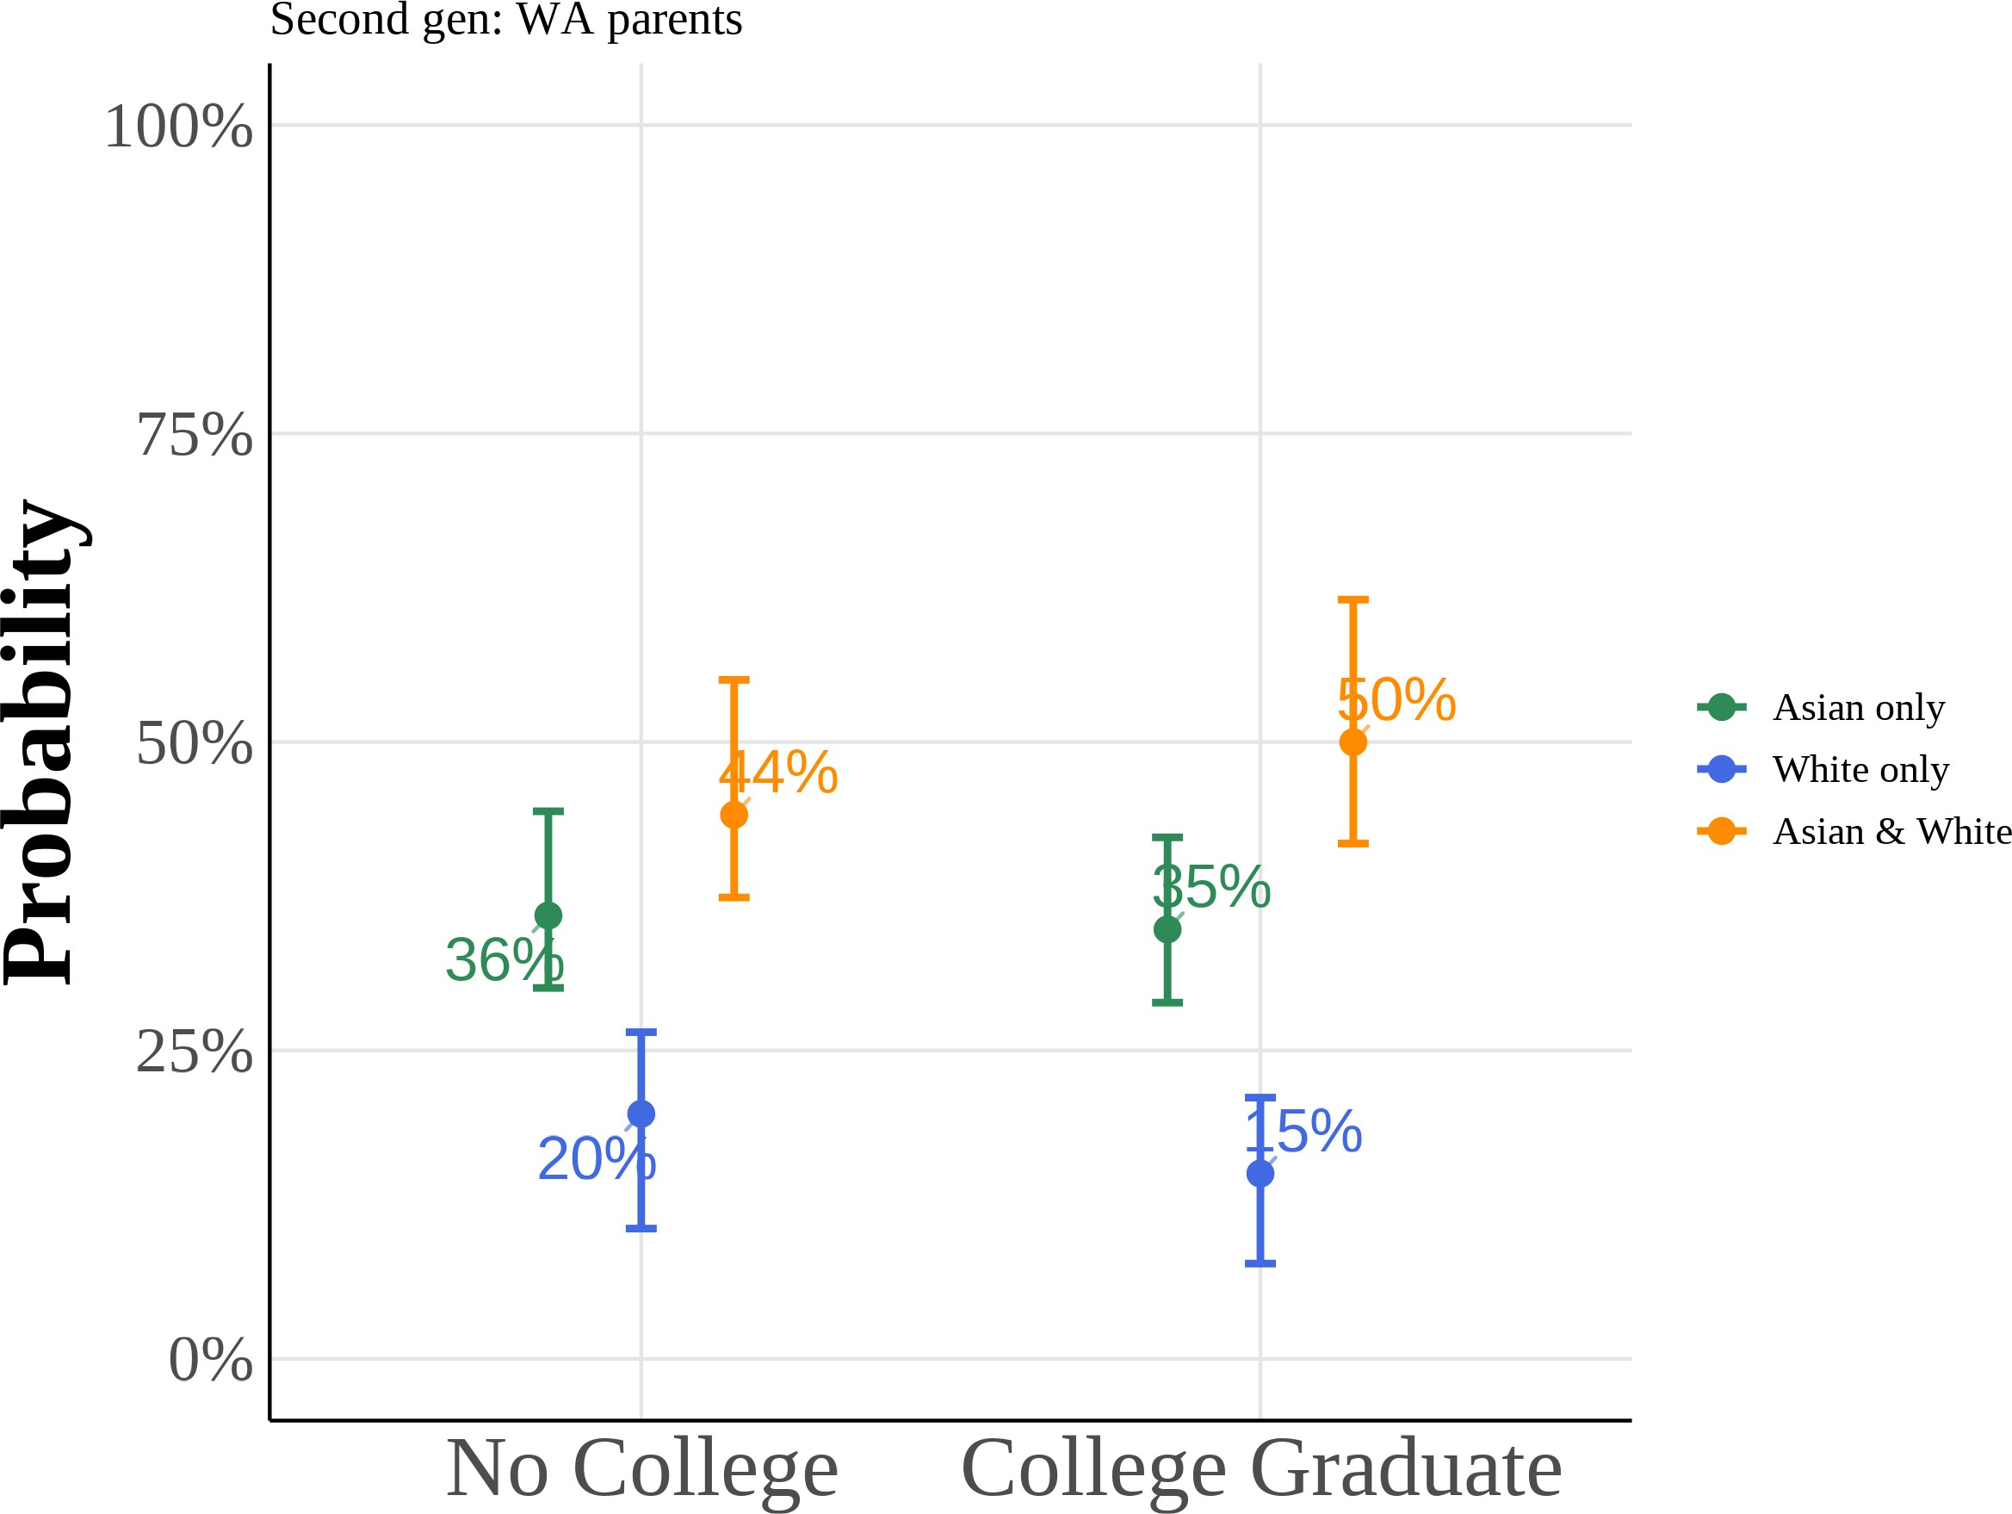

This figure shows predicted probabilities from estimating equation (5) using a multinomial logit model for the subsample of second-generation Asian Americans with White fathers and Asian mothers. The model estimates the probability of choosing “Asian only”, “White only”, or “Asian and White” racial identification as a function of anti-Asian bias, gender, and parental education. I include region *×* year fixed effects with controls for quartic age and local Asian population share. All other variables are held at their sample means. Reported curves depict the median predicted probability across 1,000 bootstrap resamples, and 95% confidence intervals follow the correspond-ing bootstrap percentile limits.

Figure A.10: Multinomial Logit Model: Predicted Probabilities of Racial Identity Choice by Anti-Asian Bias and Gender (Second Generation Adults, AW/WA)

(a) Anti-Asian Bias (AW) (b) Anti-Asian Bias (WA)

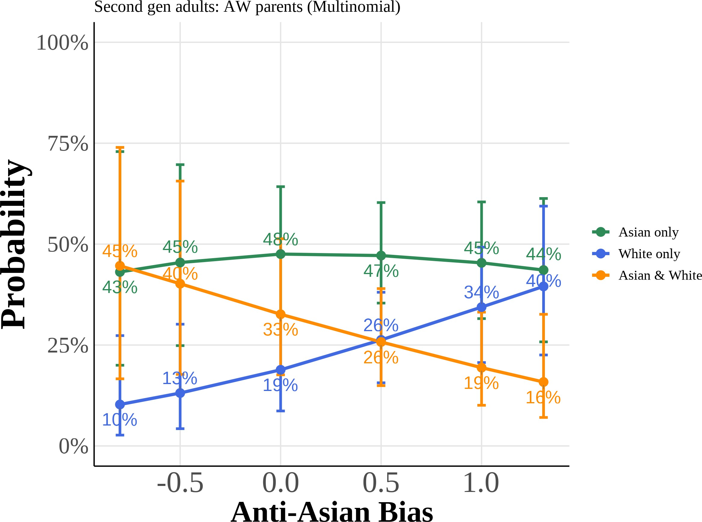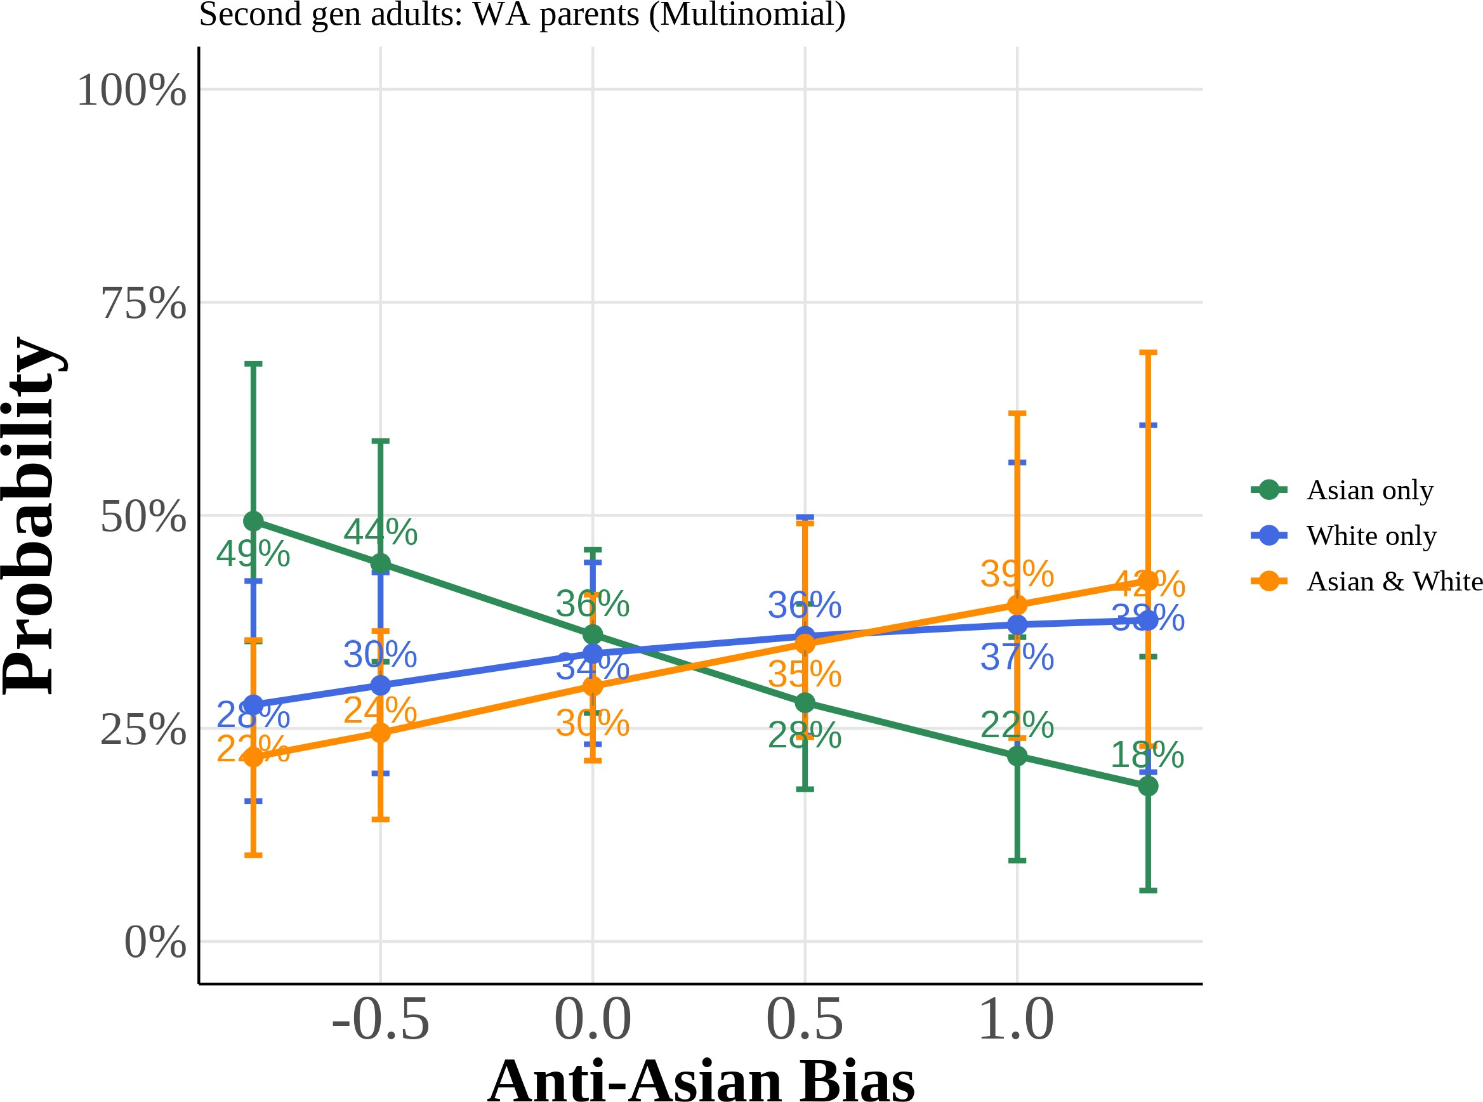

(c) Female (AW) (d) Female (WA)

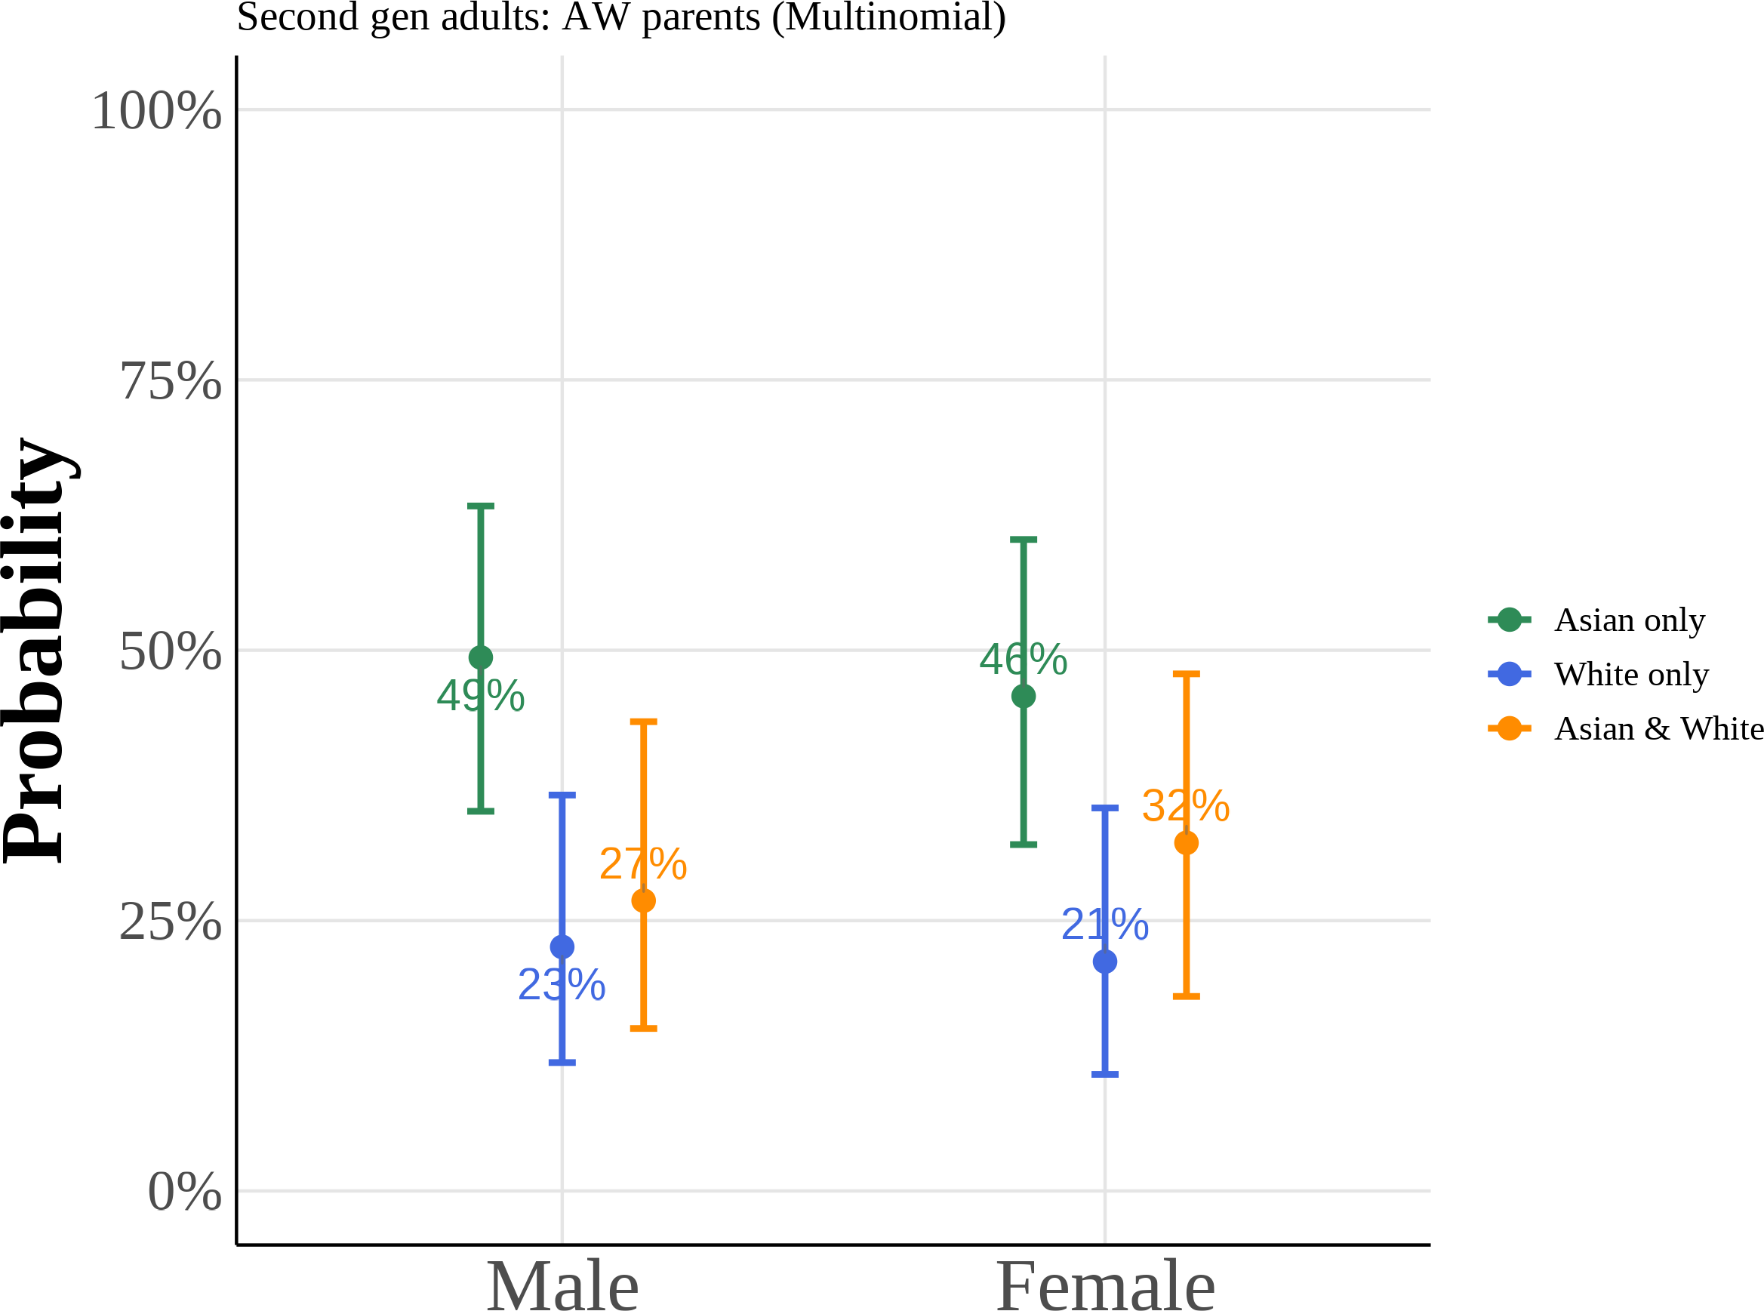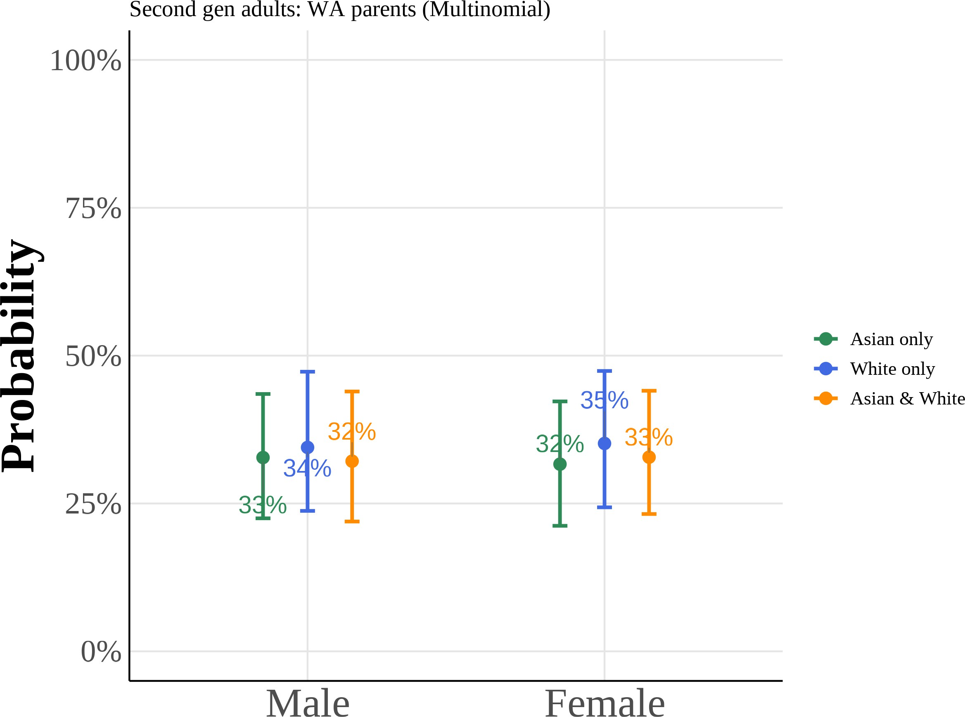

Predicted probabilities from multinomial logit models for second-generation adults with Asian fa-ther/White mother (AW) and White father/Asian mother (WA). Each panel shows the probability of choosing each racial identity as a function of anti-Asian bias or gender, holding other covariates at their means. Curves plot the median predicted probability across 1,000 bootstrap resamples, with 95% confidence intervals given by the bootstrap percentile bounds.

Figure A.11: Multinomial Logit Model: Predicted Probabilities of Racial Identity Choice by Years of Education and Income (Second Generation Adults, AW/WA)

(a) Years of Education (AW) (b) Years of Education (WA)

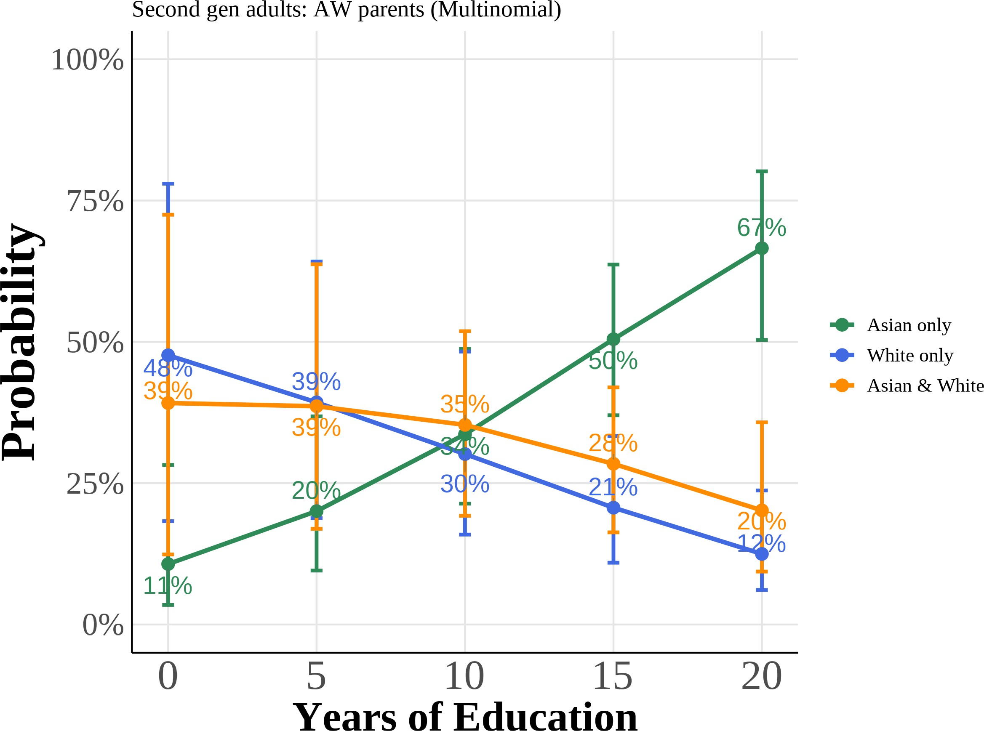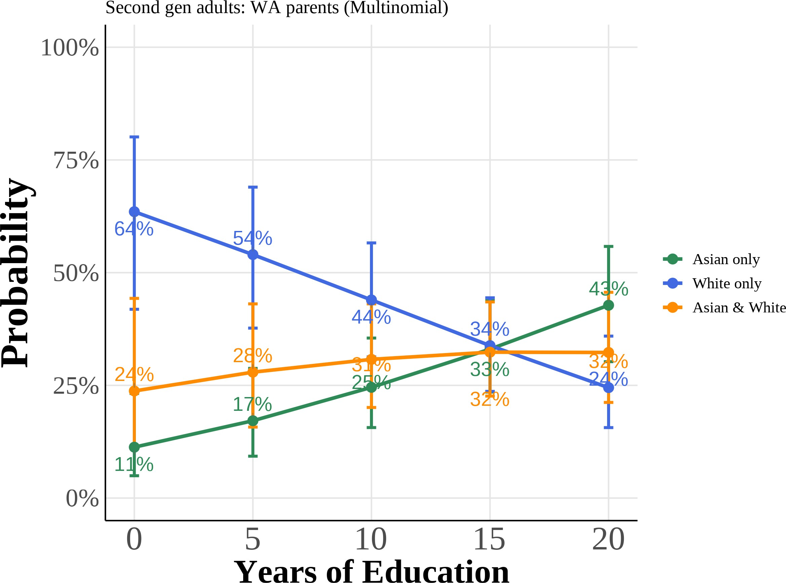

(c) Log Family Income (AW) (d) Log Family Income (WA)

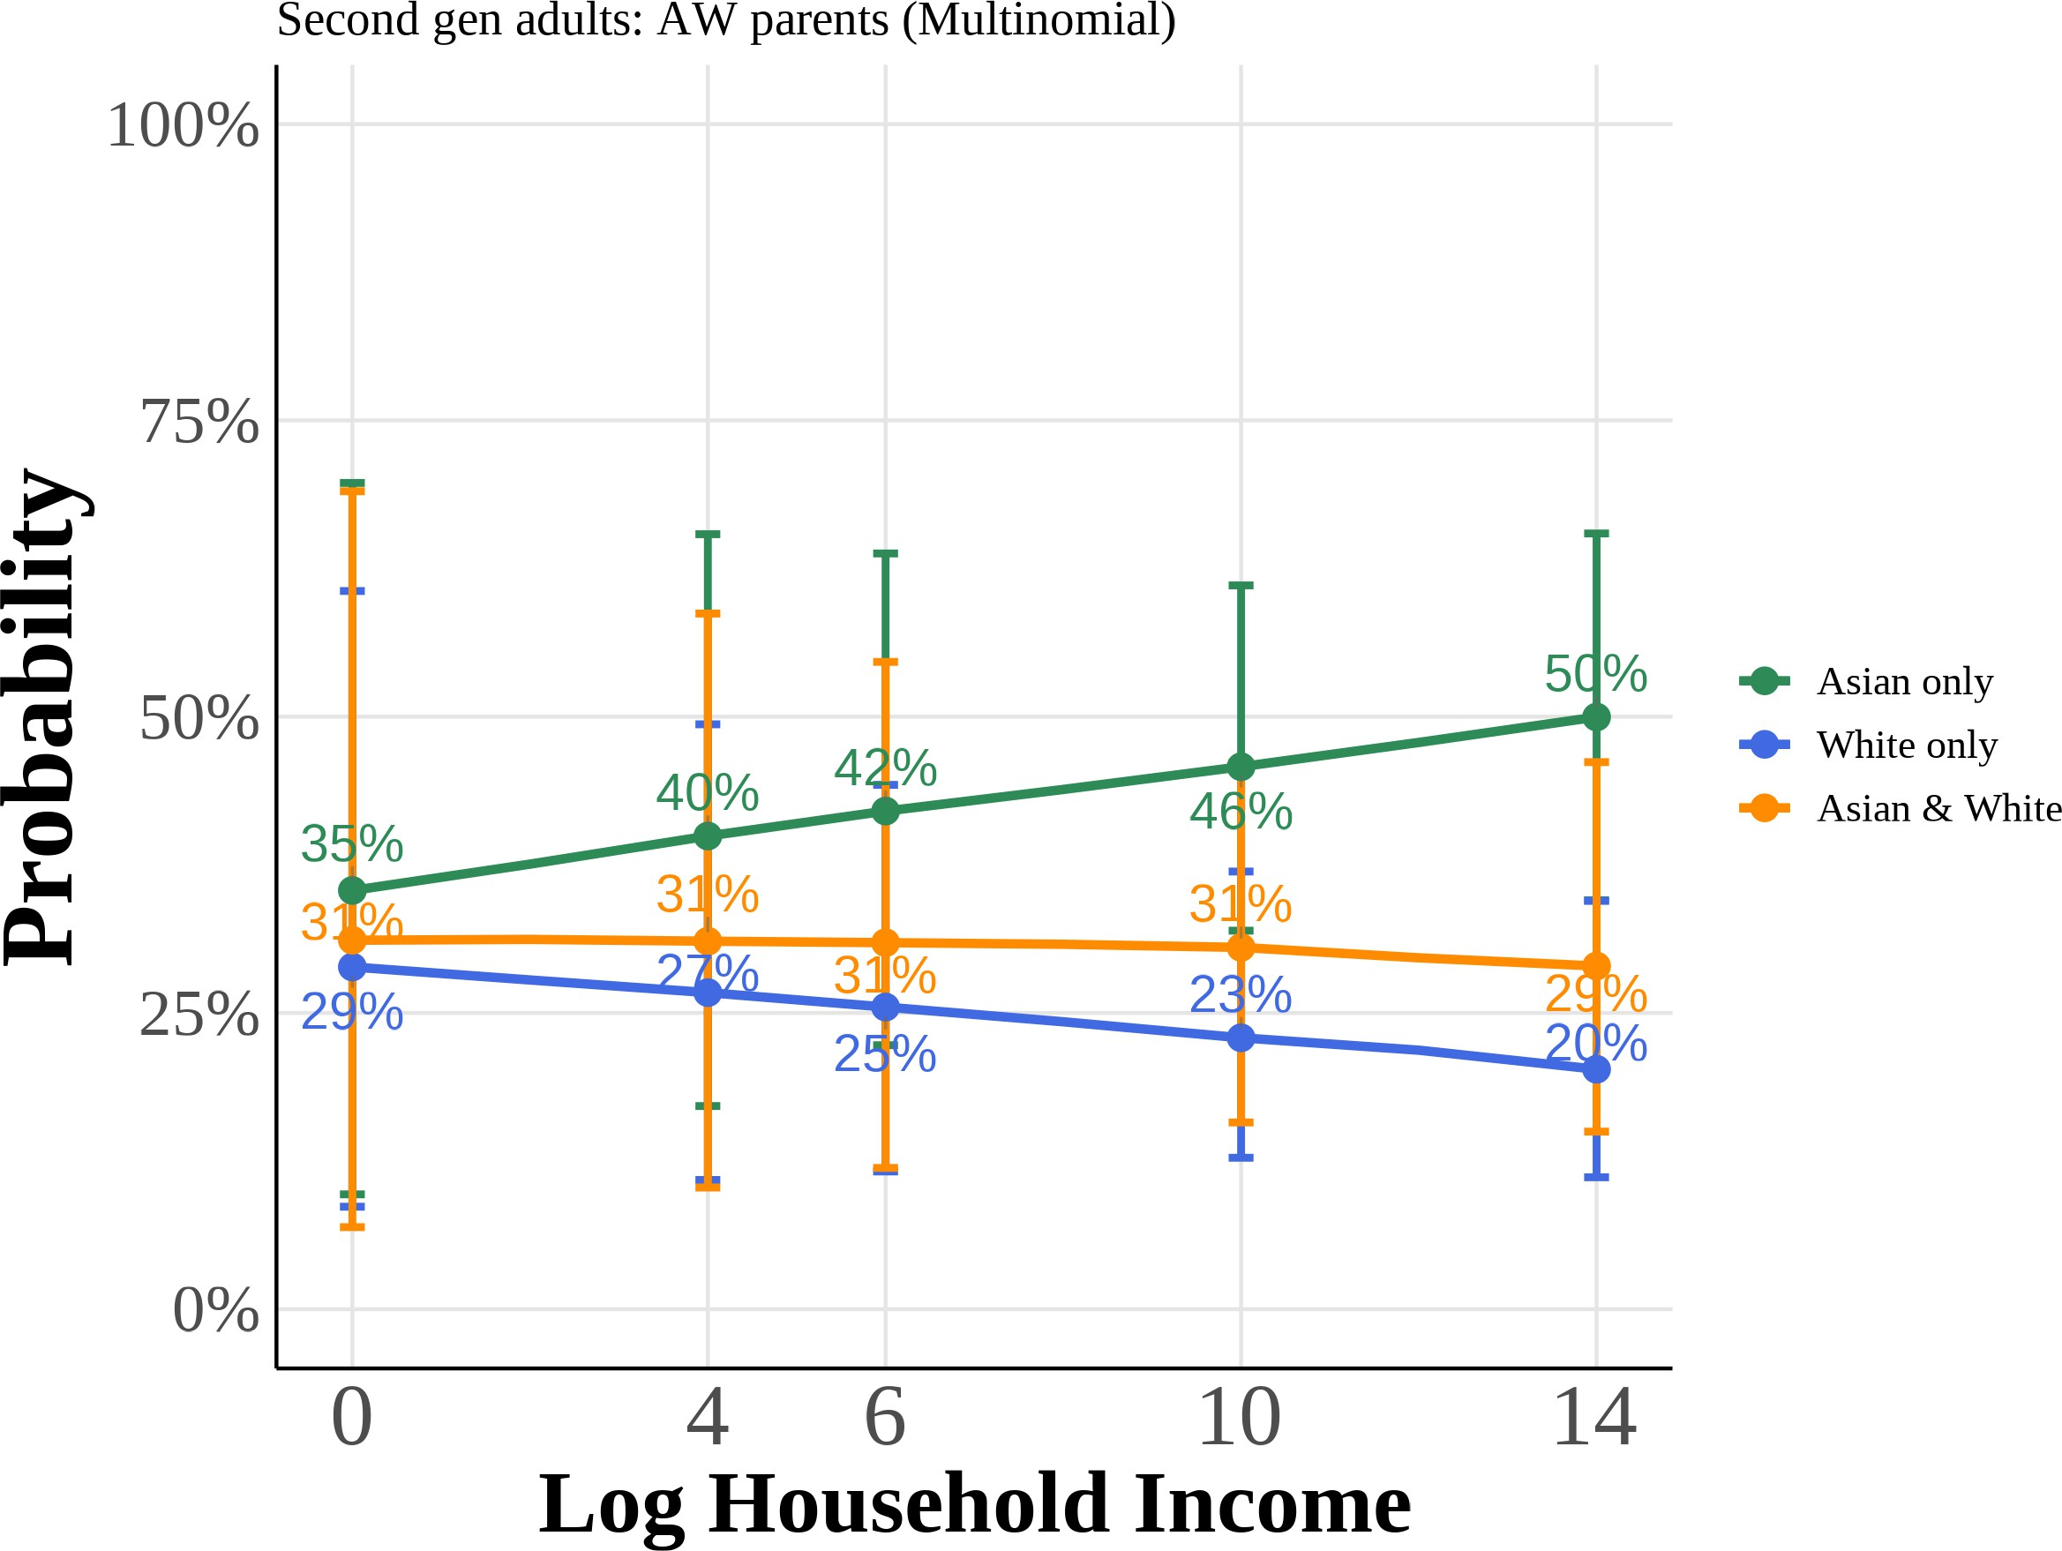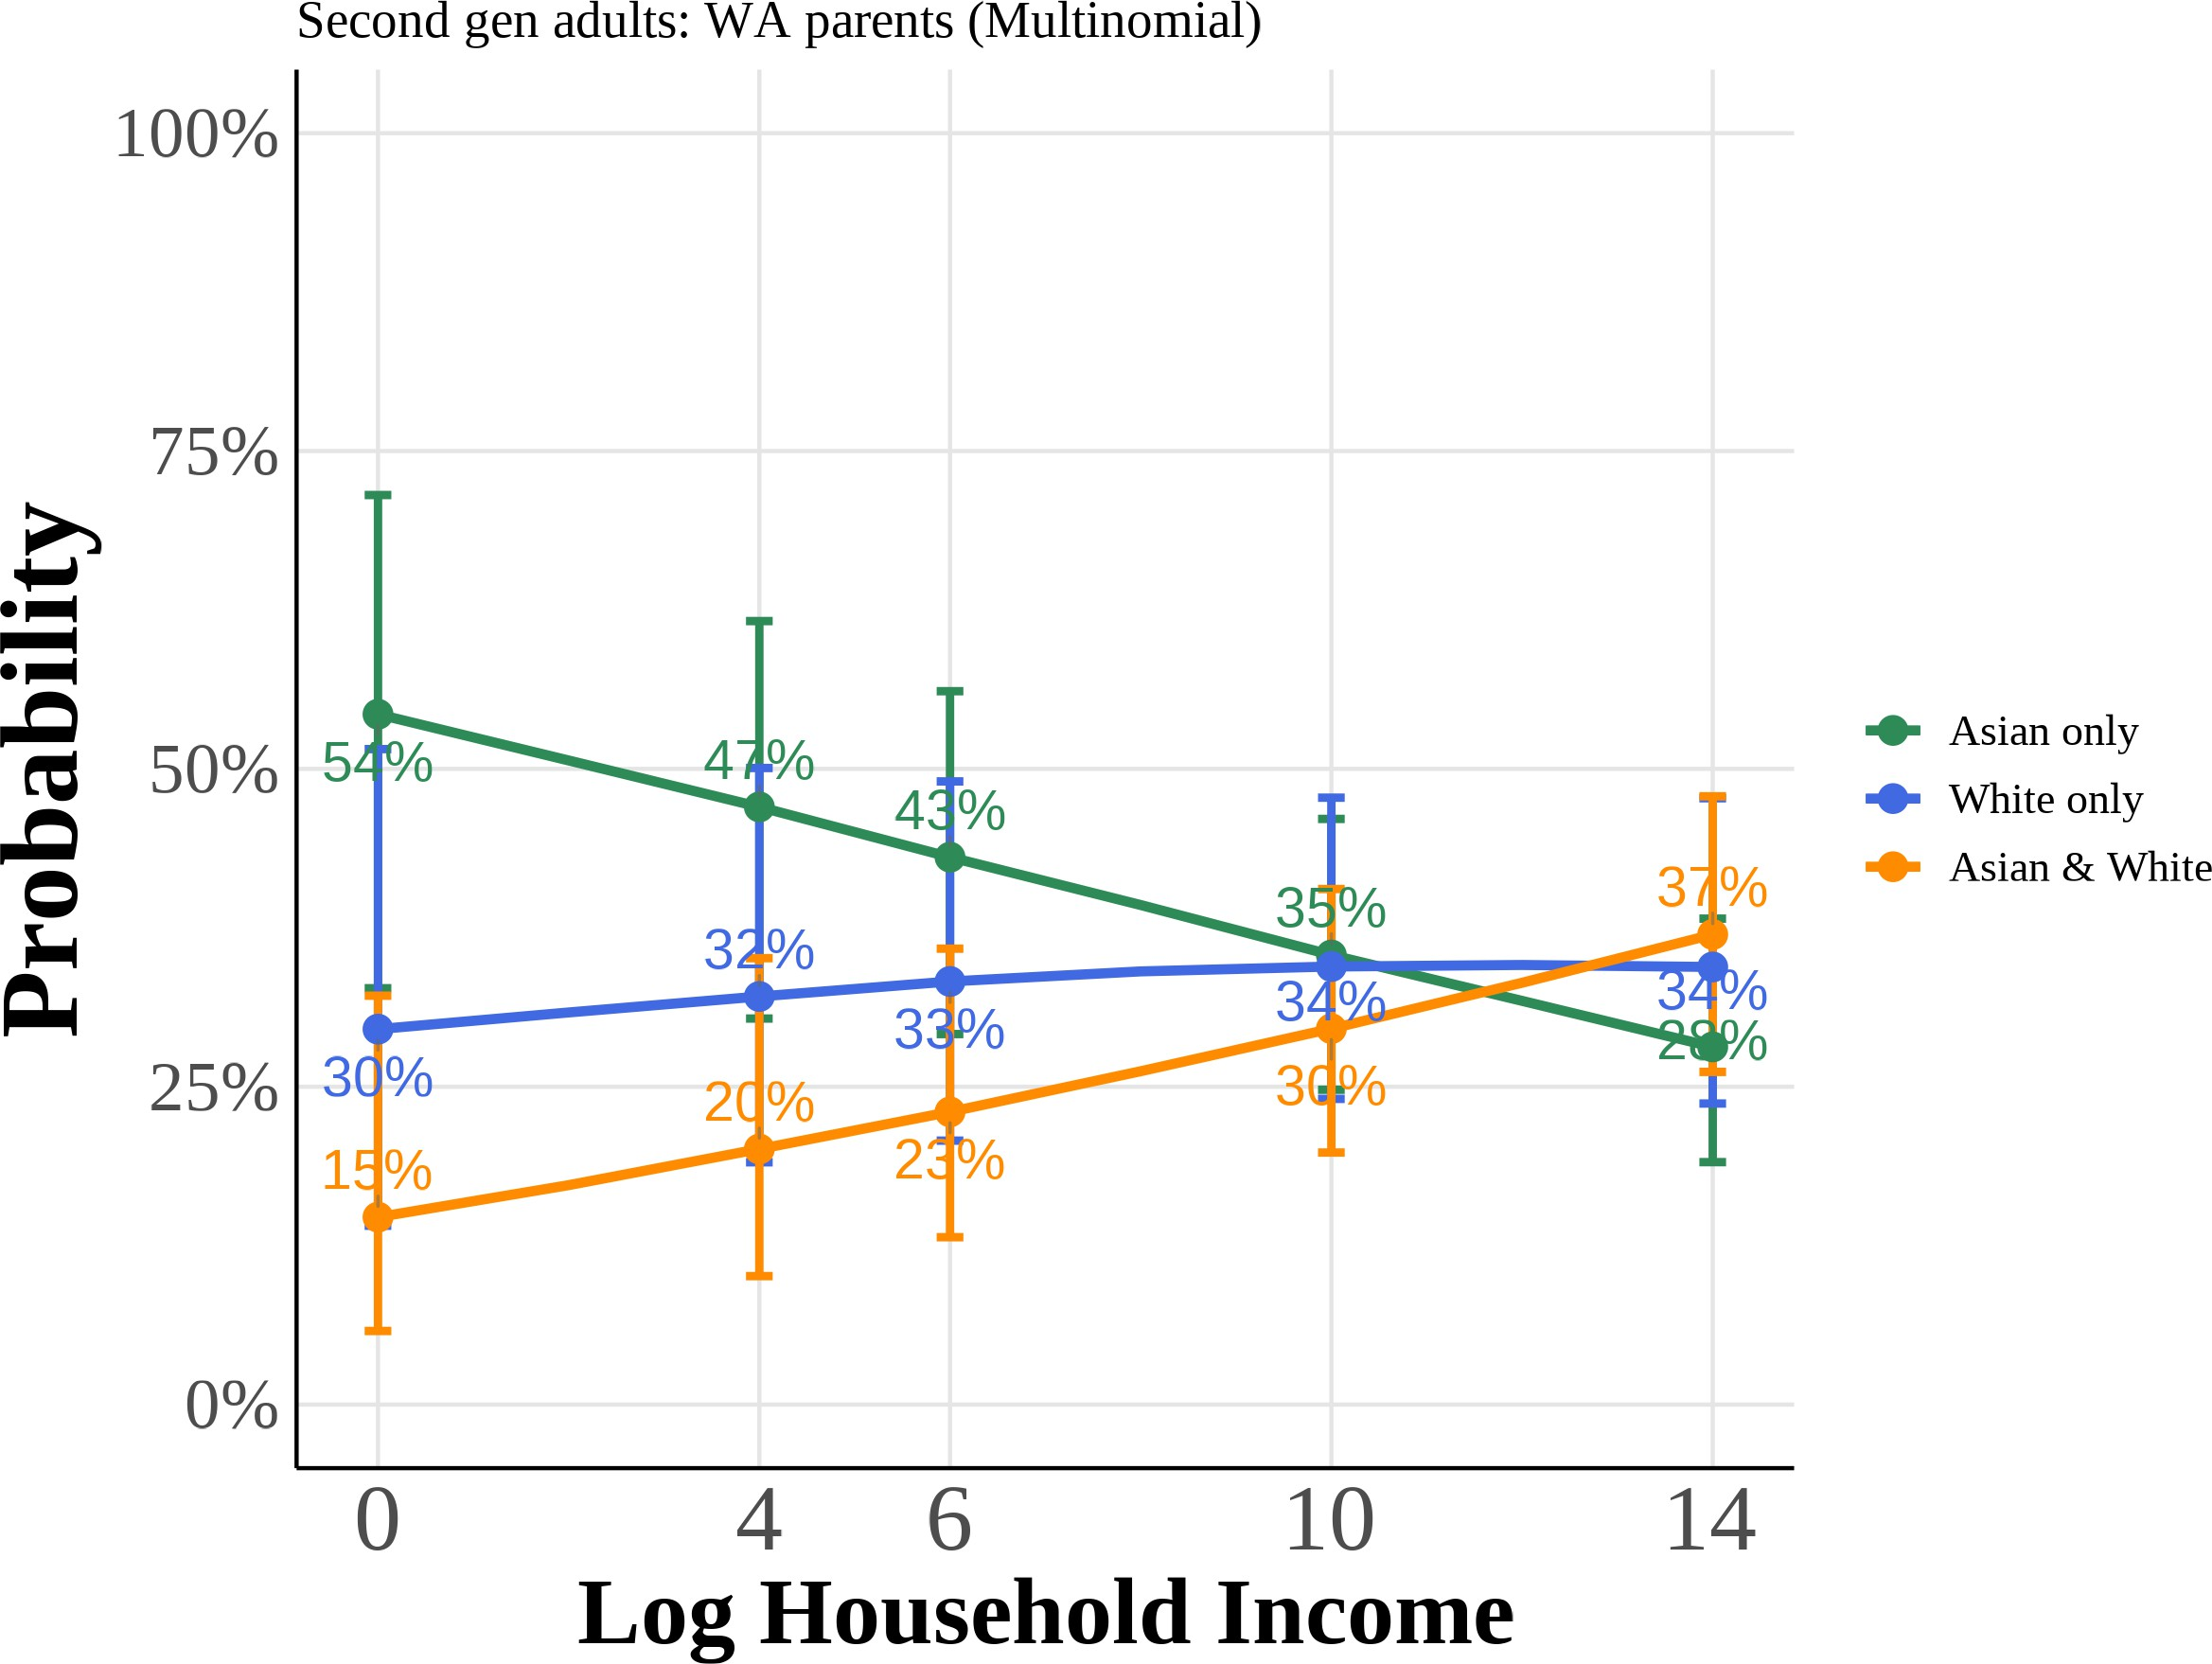

Predicted probabilities from multinomial logit models for second-generation adults with Asian father/White mother (AW) and White father/Asian mother (WA). Each panel shows the probabil-ity of choosing each racial identity as a function of total years of education or log family income, holding other covariates at their means. Curves plot the median predicted probability across 1,000 bootstrap resamples, with 95% confidence intervals given by the bootstrap percentile bounds.

Figure A.12: Multinomial Logit Model: Predicted Probabilities of Racial Identity Choice by Key Covariates (Third-Generation Asian Americans with One Asian Grandparent)

(a) Anti-Asian Bias (b) Female

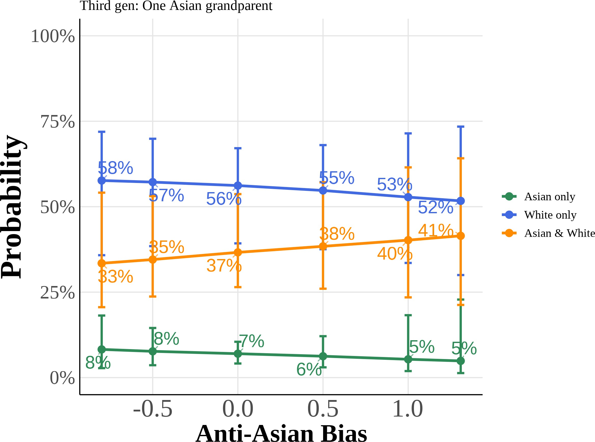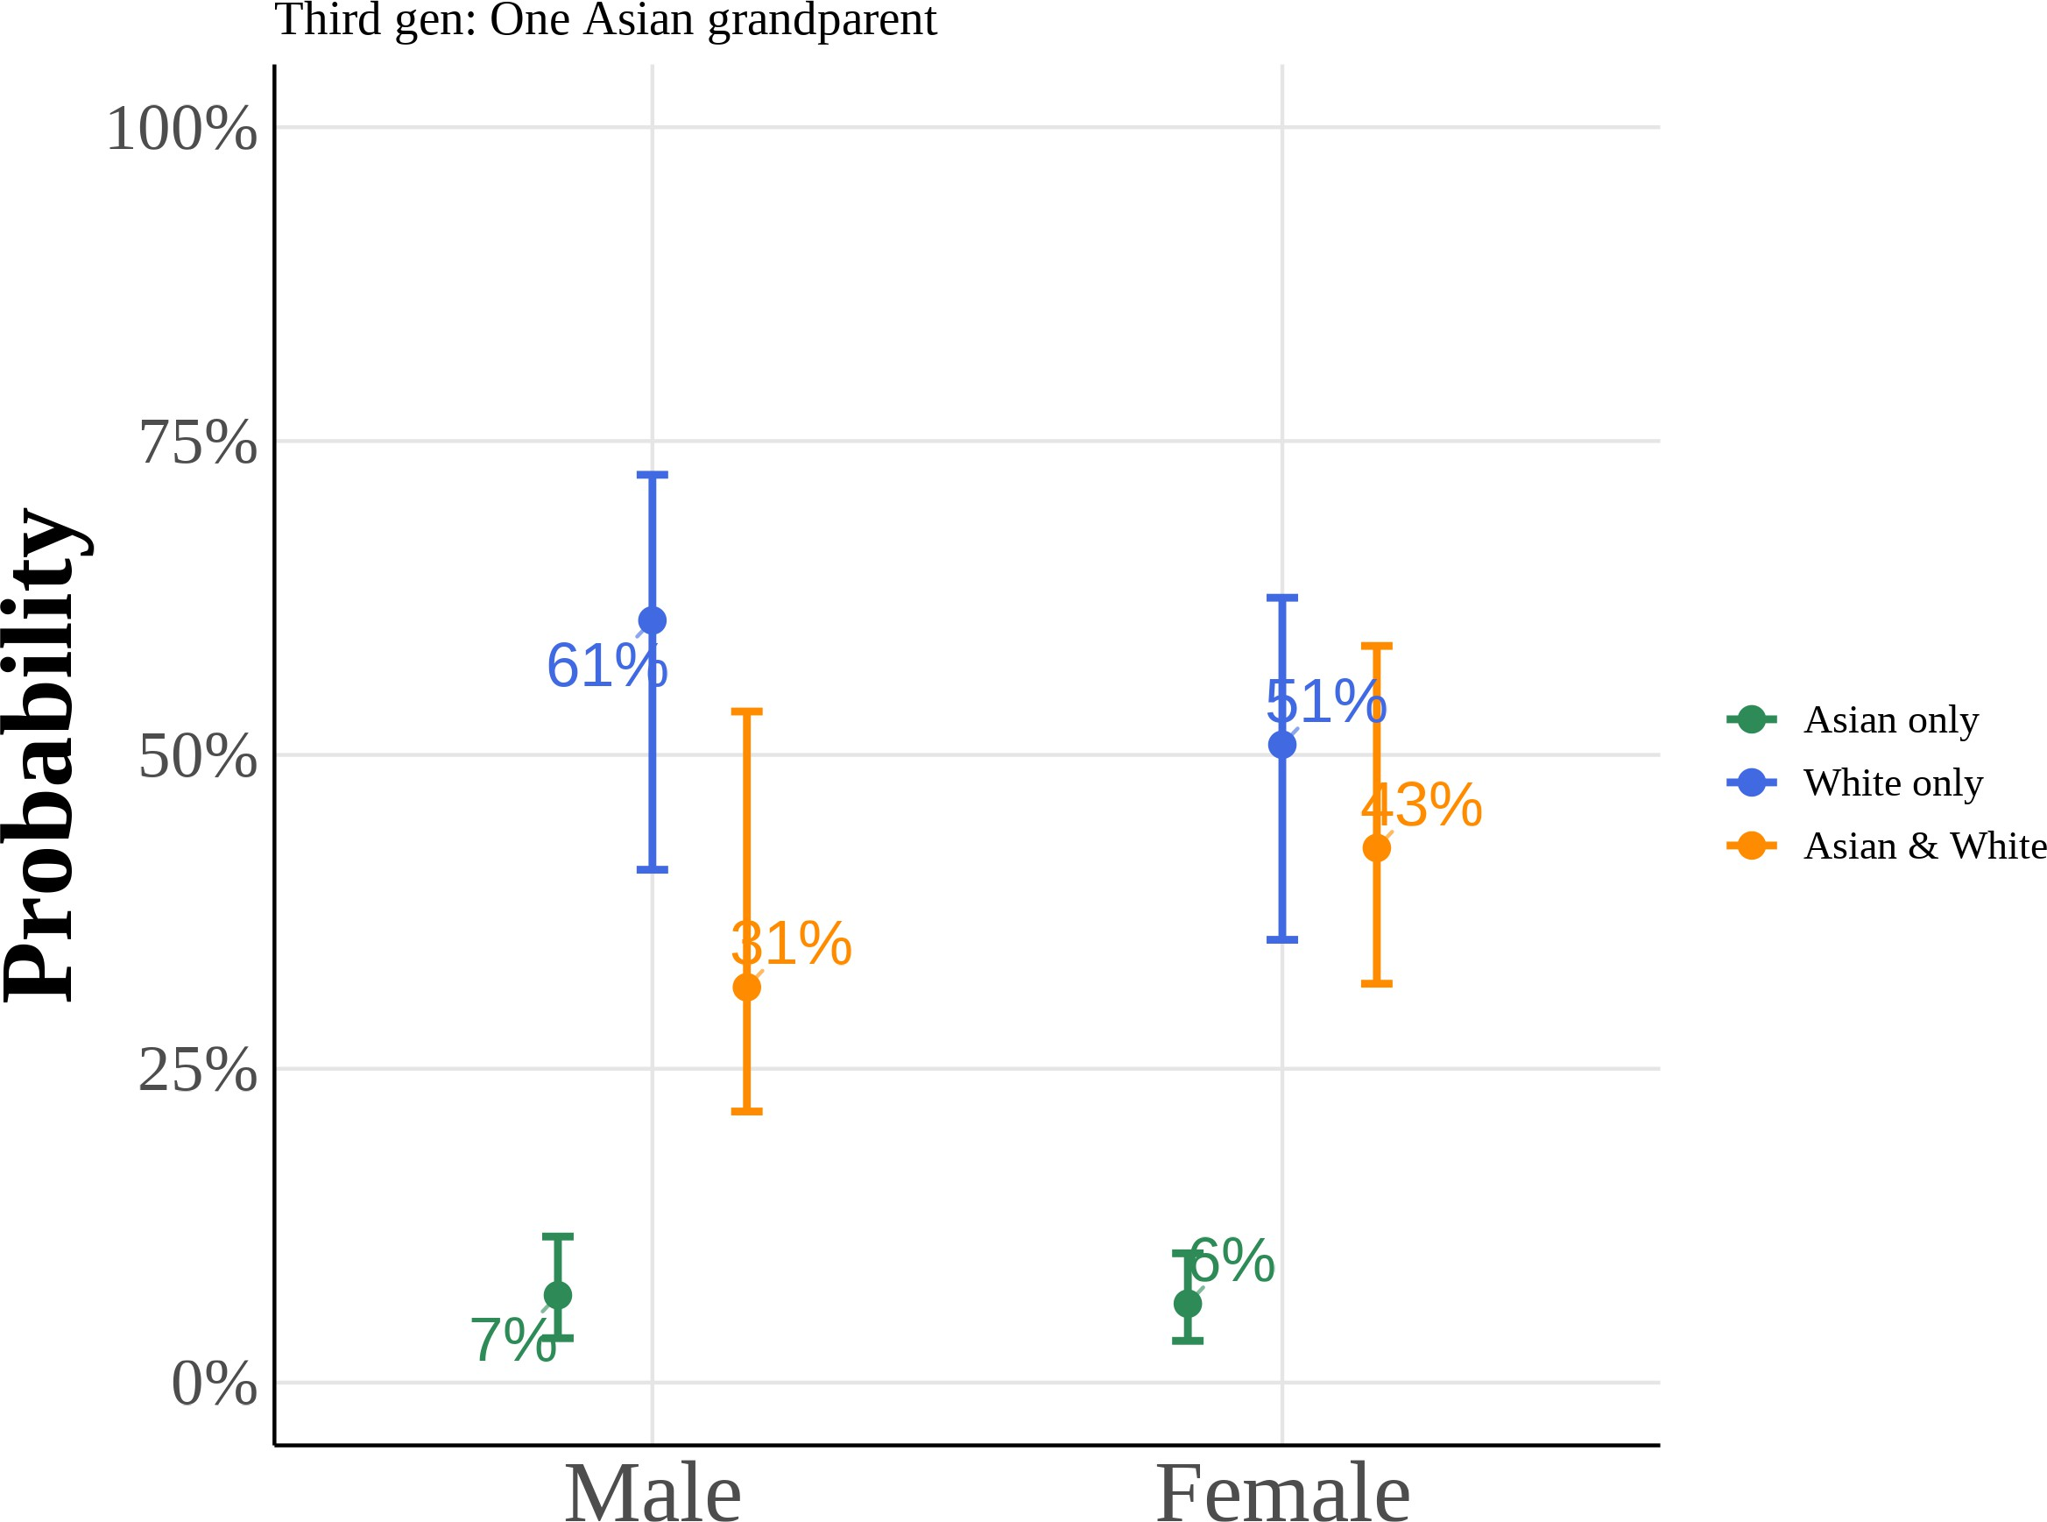

(c) College Graduate: Mother (d) College Graduate: Father

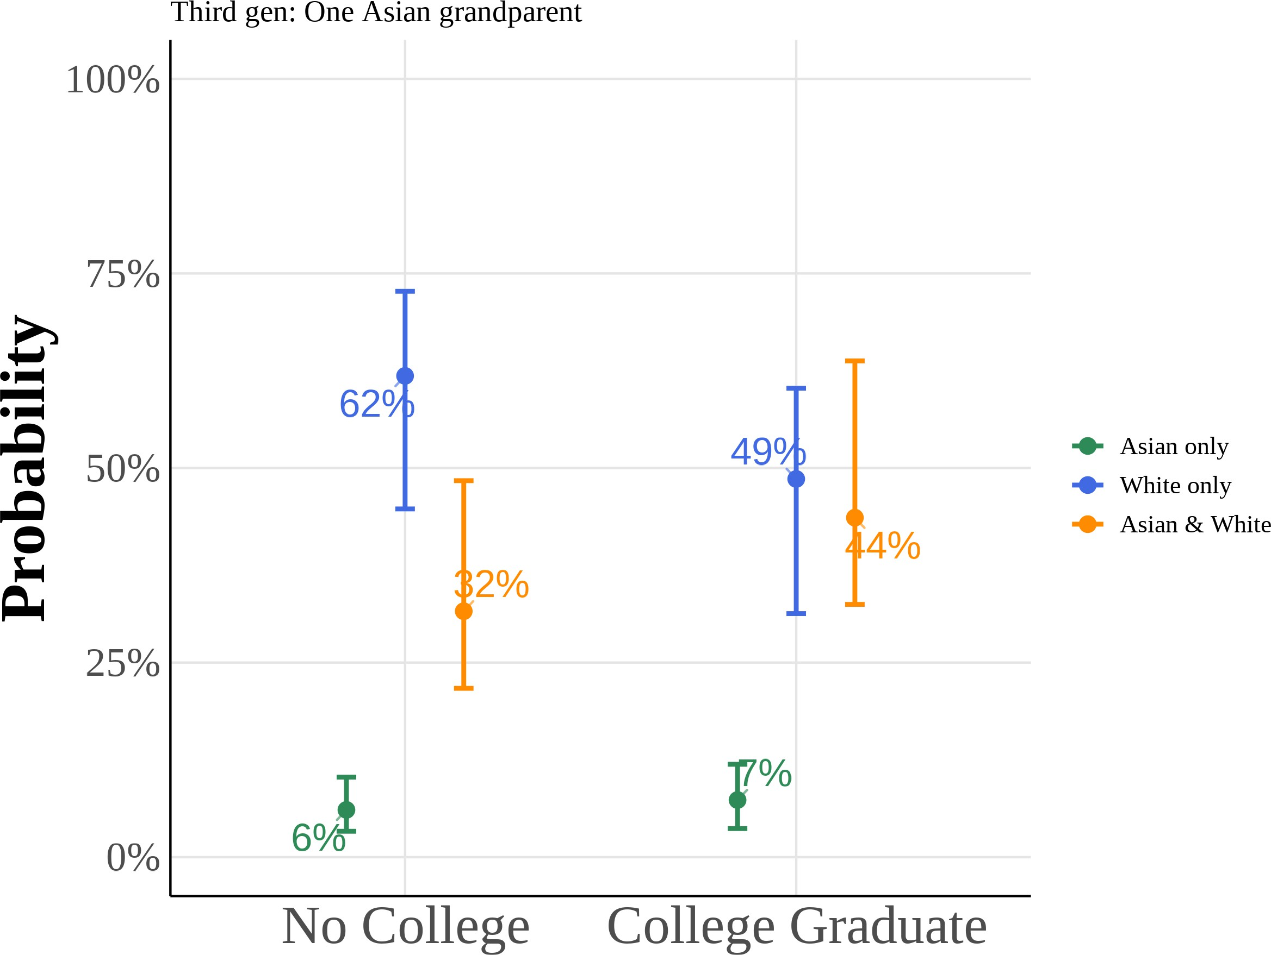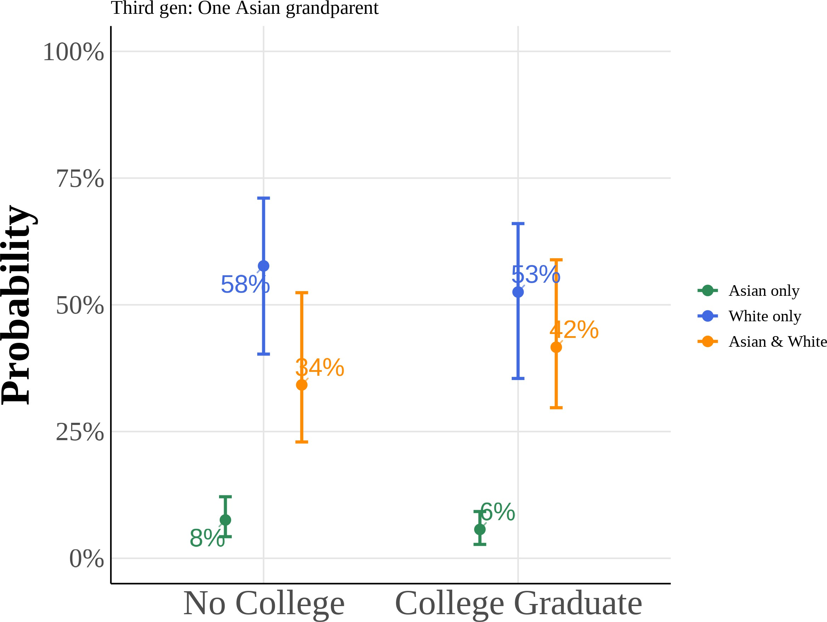

This figure shows predicted probabilities from estimating equation (5) using a multinomial logit model for the subsample of third-generation Asian Americans with one Asian grandparent. The model estimates the probability of choosing “Asian only”, “White only”, or “Asian and White” racial identification as a function of anti-Asian bias, gender, and parental education. I include region *×* year fixed effects with controls for quartic age and local Asian population share. All other variables are held at their sample means. Reported curves depict the median predicted probability across 1,000 bootstrap resamples, with 95% percentile confidence intervals from the same draws.

Figure A.14: Scatter Plot of Proportion Subjectively Asian on Bias

(a) Year < 2015

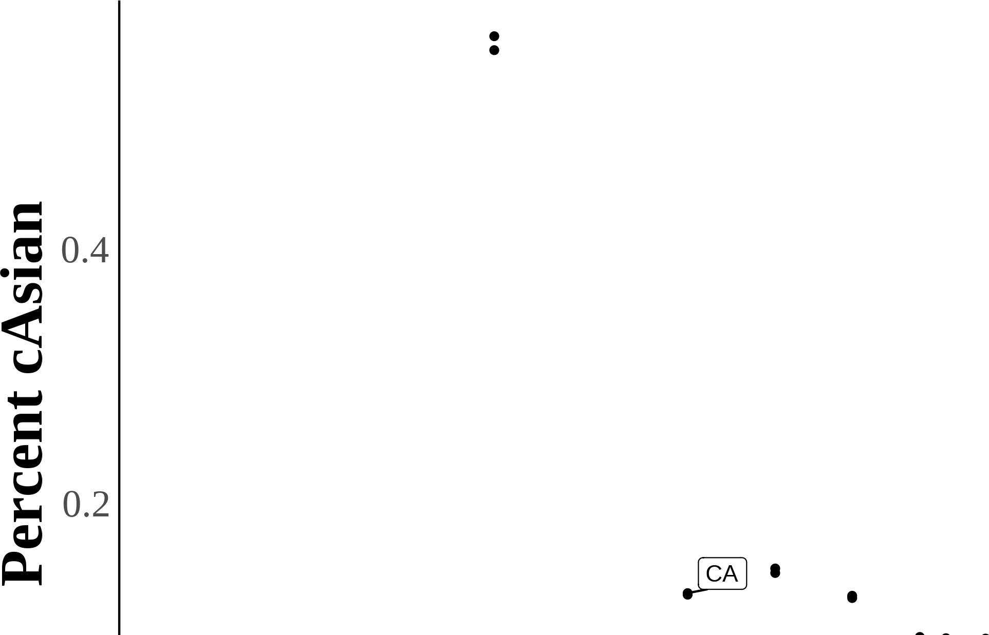

44

Figure A.13: Multinomial Logit Model: Predicted Probabilities of Racial Identity Choice by Key Covariates (Third-Generation Asian Americans with Two Asian Grandparents)

(a) Anti-Asian Bias (b) Female

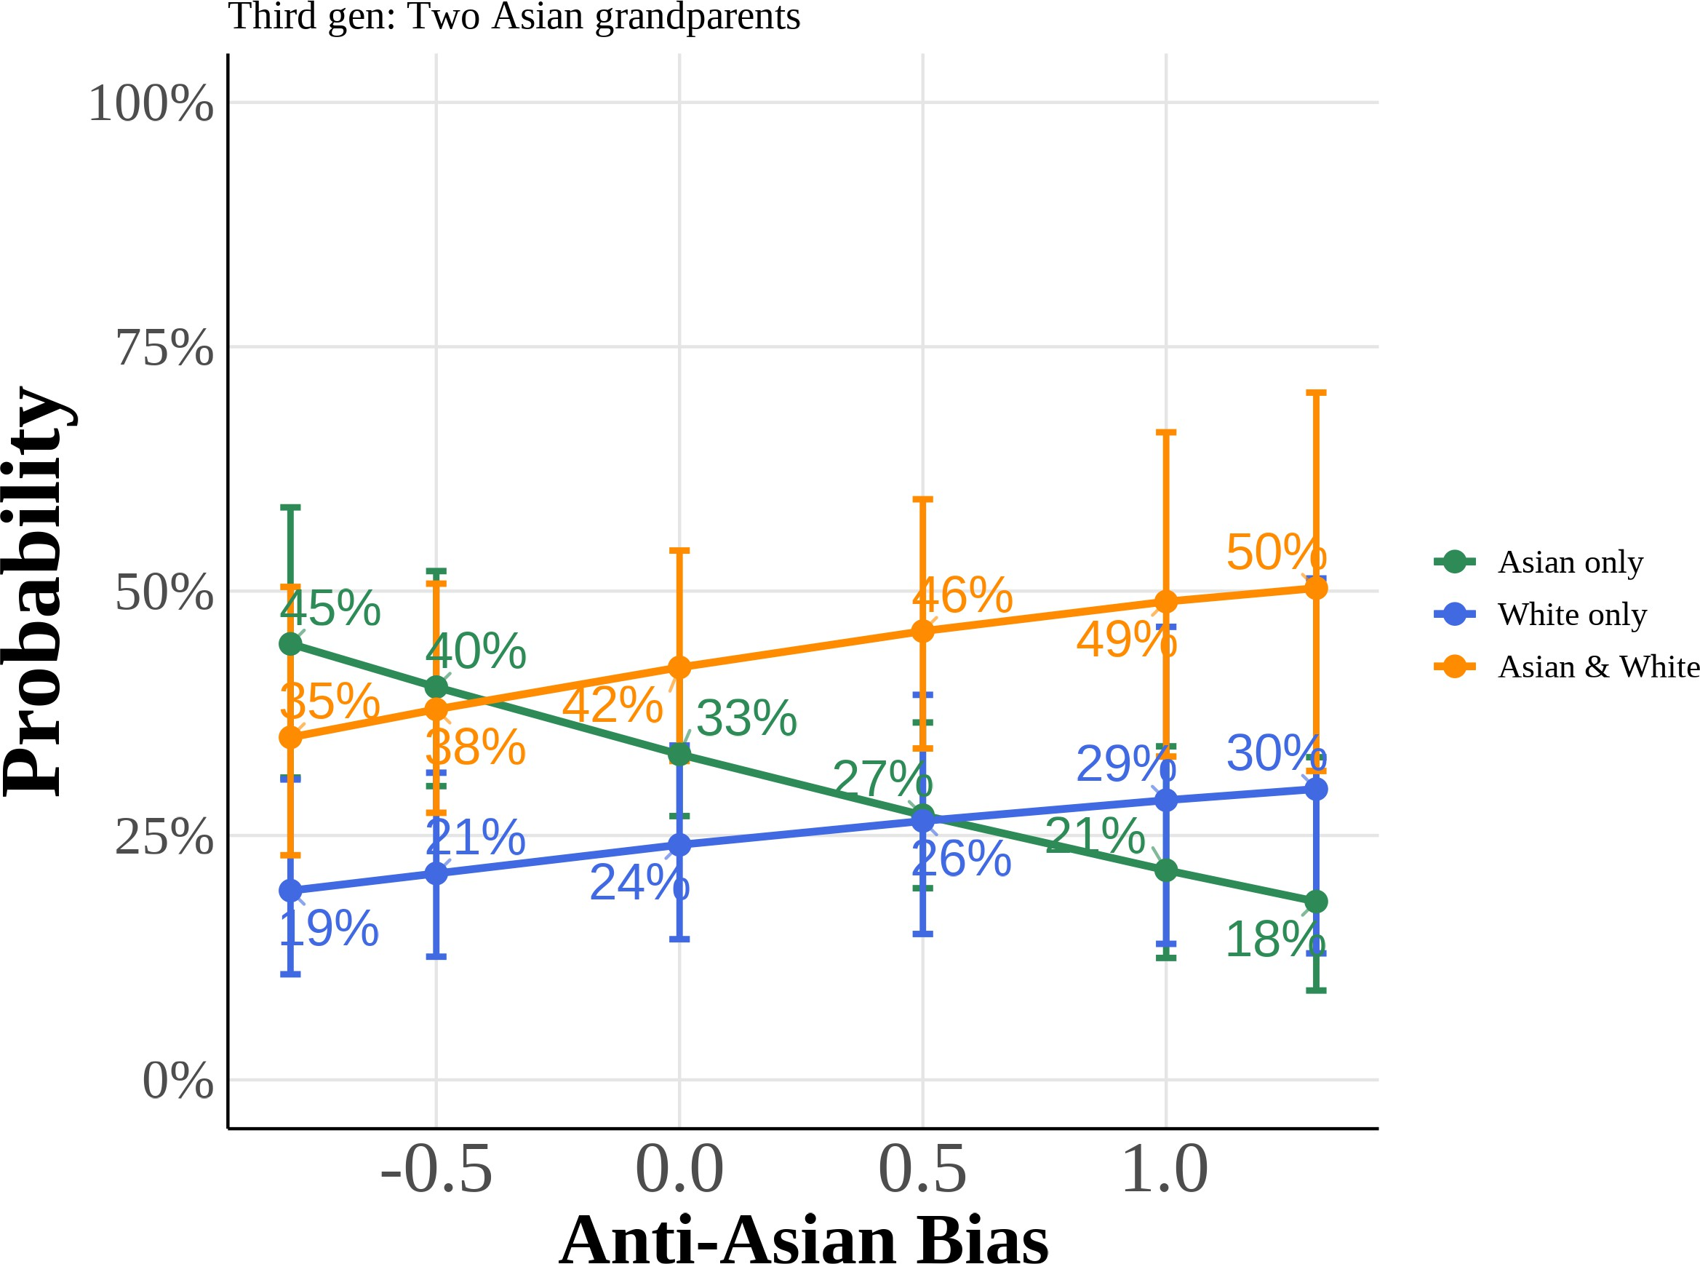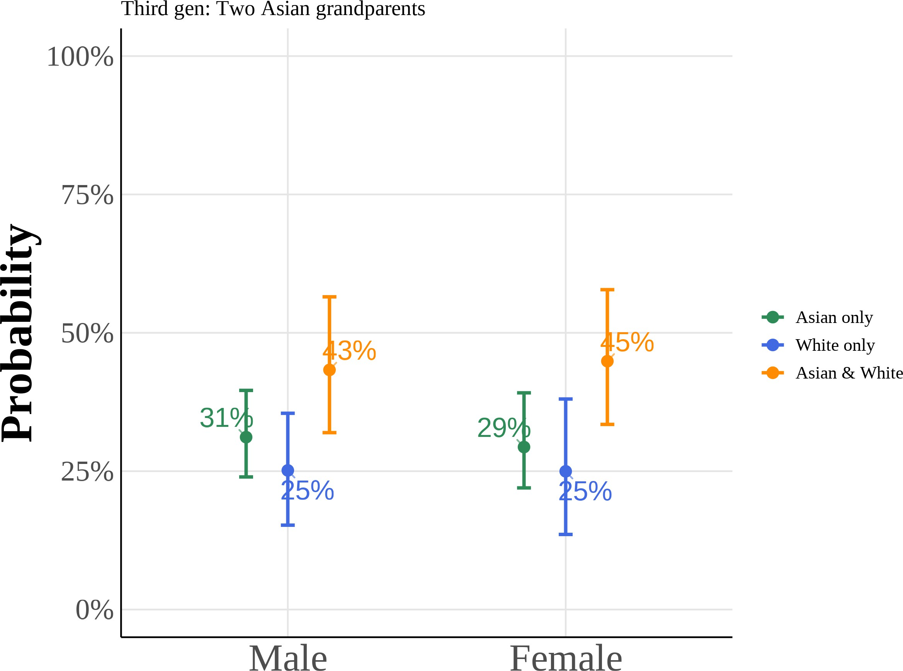

(c) College Graduate: Mother (d) College Graduate: Father

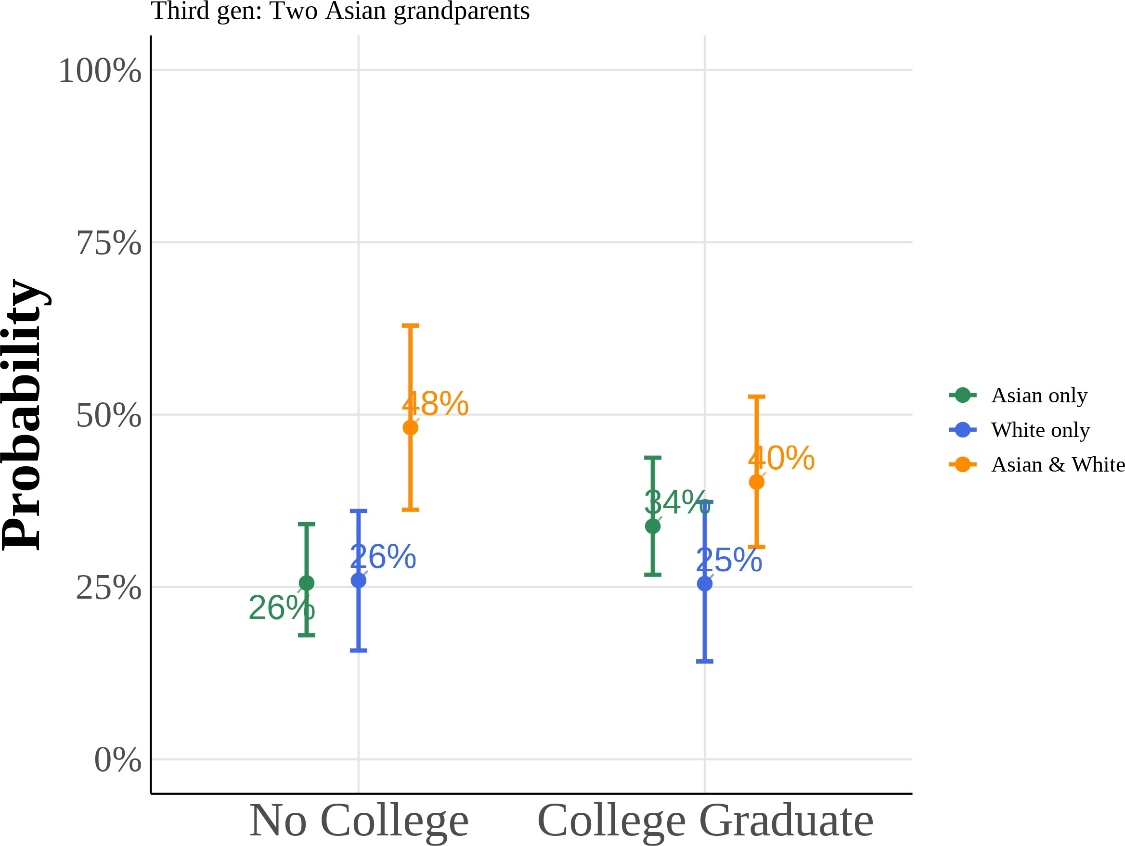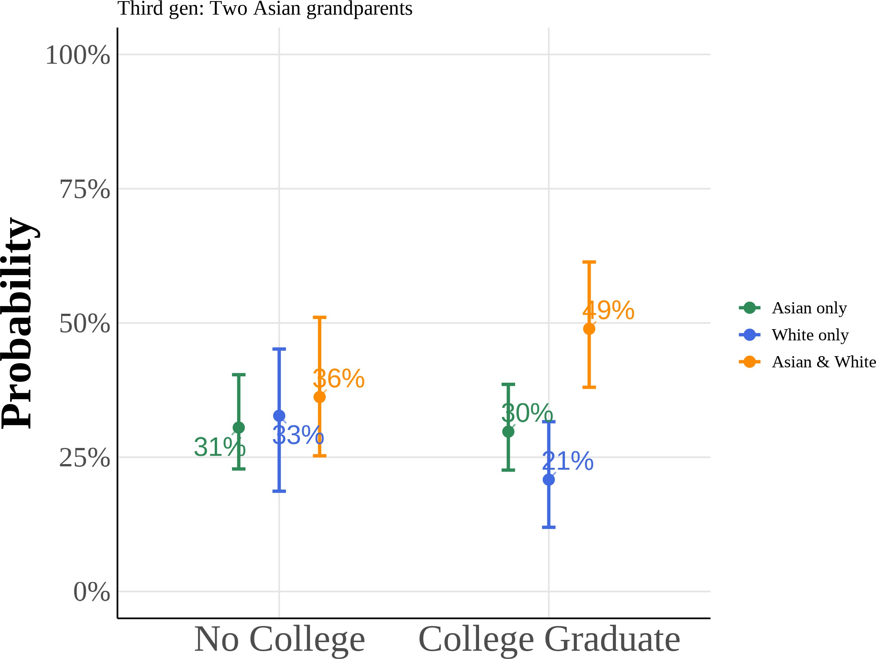

This figure shows predicted probabilities from estimating equation (5) using a multinomial logit model for the subsample of third-generation Asian Americans with two Asian grandparents. The model estimates the probability of choosing “Asian only”, “White only”, or “Asian and White” racial identification as a function of anti-Asian bias, gender, and parental education. I include region *×* year fixed effects with controls for quartic age and local Asian population share. All other variables are held at their sample means. Reported curves depict the median predicted probability across 1,000 bootstrap resamples, with 95% percentile confidence intervals from the same draws.

### Using Lubotsky and Wittenberg (2006) to Construct Bias Index

In Lubotsky and Wittenberg (2006), the authors propose a method to reduce measurement error in proxies by constr4u5cting a composite index. The Lubotsky-

Wittenberg (henceforth LW) consider a model where a covariate is unobserved. Therefore, they use two proxies in its place, which will have measurement error. Thus, the LW method allows researchers to use two proxies that are error-ridden.

LW consider a setup with the following model:

y = α + βx*∗* + ϵ x1 = x*∗* + µ1

x2 = x*∗* + µ2

Where x*∗* is the unobserved covariate, x1i and x2i are the proxies, and the mea-surement errors µ1 and µ2 are assumed to be classical and allowed to covary. The covariance matrix of the errors is given by:

i

 σ2 σ12





Σ = 1

σ12 σ2

2

Replacing the unobserved x*∗* with x1 or x2 yields the following expectations of the OLS estimates:

2

E β1 = β σ

ˆ x*∗*

σ2*∗* + σ2

2

; ˆ x*∗*

E β2 = β σ

σ2*∗* + σ2

x 1 x 2

Both estimates are biased; the one with the smaller variance of the measure-ment error being less biased.

LW then propose defining a new proxy x3 as a weighted average of x1 and x2:

x3 = λx1 + (1 − λ)x2

To minimize the attenuation bias in the OLS estimate of β, they solve for the optimal value of λ:

*∗* σ2 − σ12

λ = 2 2 2

σ1 + σ2 − 2σ12

This optimal value of λ is not directly useful because the variances of the mea-surement errors and their covariance are unobserved. However, if you estimate a bivariate regression using OLS (i.e., regress y on x1 and x2), then the expectation of the sum of the two coefficient estimates is identical to the expectation of the OLS coefficient estimate on x3 in a univariate regression using the optimal choice of λ:

E βˆ 1 + βˆ 2 = E βˆ x3

Thus, OLS produces an estimate of β with the least bias by optimally combin-ing the information in x1 and x2.

## References for Online Appendix

Lubotsky, Darren, and Martin Wittenberg. 2006. “Interpretation of Regressions with Multiple Proxies.” *The Review of Economics and Statistics* 88, no. 3 (Au-gust 1, 2006): 549–562. <https://doi.org/10.1162/rest.88.3.549>.